Microsoft Cloud Workshops

App modernization hackathon

Lab Guide

February 2017

© 2017 Microsoft Corporation. All rights reserved. This document is confidential and proprietary to Microsoft. Internal use only. This document is for informational purposes only. MICROSOFT MAKES NO WARRANTIES, EXPRESS OR IMPLIED, IN THIS SUMMARY.

This document is provided "as-is." Information and views expressed in this document, including URL and other Internet Web site references, may change without notice. You bear the risk of using it.

Some examples are for illustration only and are fictitious. No real association is intended or inferred.

## Contents

App modernization hackathon 1

App modernization hackathon answers 37

# App modernization hackathon

## Overview

The App Modernization Hackathon is a hands-on exercise that will challenge you to implement an end-to-end scenario using a supplied sample that is based on Microsoft Azure App Services and related services. The scenario will include implementing compute, storage, security, and search using various components of Microsoft Azure. The Hackathon can be implemented on your own, but it is highly recommended to pair up with other members at the Hackathon to model a real-world experience and to allow each member to share their expertise for the overall solution.

## Requirements

* Microsoft Azure subscription (non-Microsoft subscription)
* **Global Administrator role** for Azure AD within your subscription
* Local machine or a virtual machine configured with (**complete the day before the lab!**):
  + Visual Studio 2015 Community Edition or greater
  + Xamarin tools, specifically Xamarin.Android
    - Install instructions: <https://developer.xamarin.com/guides/android/getting_started/installation/windows/#download>
    - Download and run the Xamarin Unified Installer: <http://www.xamarin.com/Download>
  + Azure SDK 2.9 (or greater) for Visual Studio
    - <http://go.microsoft.com/fwlink/?linkid=518003&clcid=0x409>
  + SQL Server 2016 Express or greater
    - <https://www.microsoft.com/en-us/download/details.aspx?id=54284>
  + SQL Server Management Studio (SSMS)
    - <https://msdn.microsoft.com/library/mt238290.aspx>
  + (optional) Self-signed certificate for debugging the legacy app environment
  + PowerShell 1.1.0 or higher

## Lab structure

This lab has two sets of instructions. The first is a high-level set of instructions that is designed for attendees who have previous experience with managing and building .NET apps. The second is a traditional hands-on lab guide that is designed for attendees who do not.

## Exercise 1: Environment setup

In this exercise, you will set up your environment for use for the rest of the exercises. This will involve downloading the sample application and creating a Visual Studio Online Team Project.

### Task 1: Setup a Development Environment

If you do not have a machine set up with Visual Studio 2015 Community and Azure SDK 2.9, complete this task.

1. Create a virtual machine (VM) in Azure using the Visual Studio Community 2015 Update 3 and SDK 2.9.1 on Windows Server 2012 R2 image. A Windows 10 image will work as well.

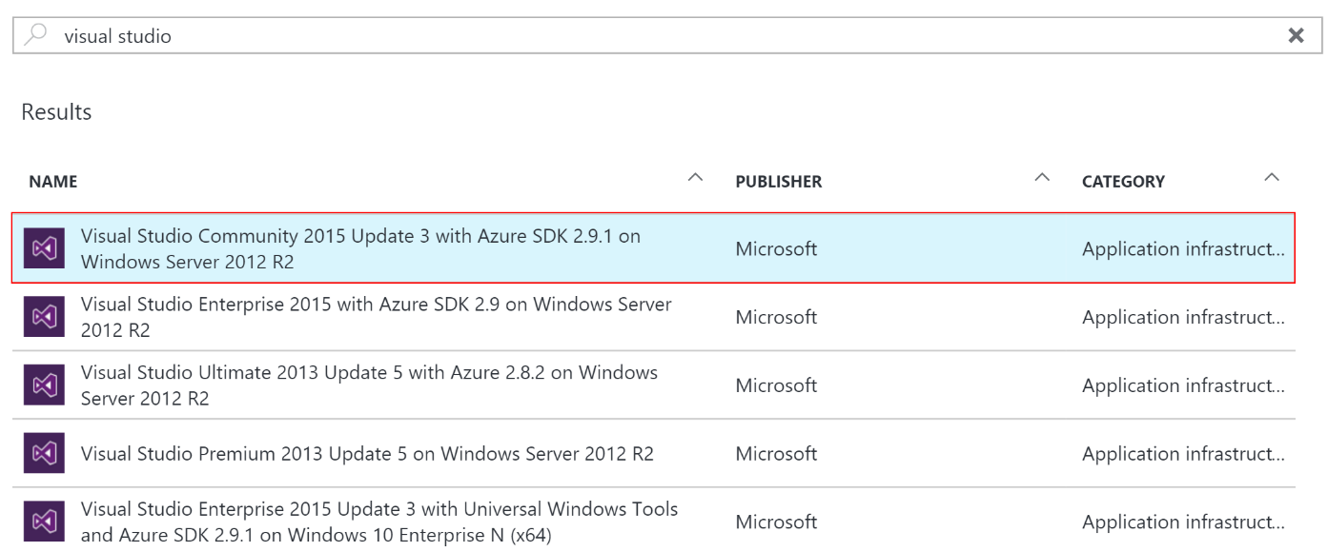

It is highly recommended to use a DS2 or D2 instance size for this VM.

If you decide to use a VM, you will not be able to run the Android emulator in later steps of the lab.

### Task 2: Disable IE Enhanced Security

Note: Sometimes this image has IE ESC disabled. Sometimes it does not.

1. On the new VM you just created, click the Server Manager icon.



1. Click Local Server.

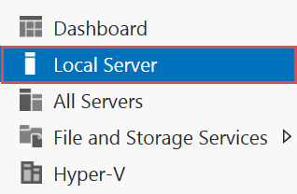

1. On the right side of the pane, click **On** by IE Enhanced Security Configuration.



1. Change to **Off** for Administrators and click **OK**.

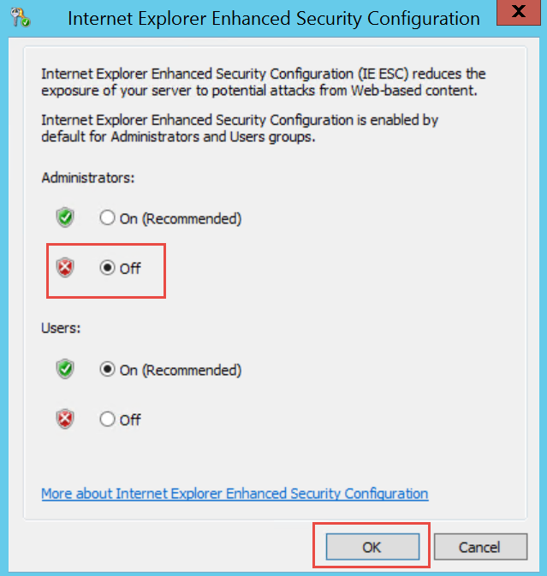

### Task 3: Install Xamarin and Android SDK

1. On the new VM, download and run the Xamarin Unified Installer. Indicate that you already have Visual Studio installed when filling out the download form.  
   <http://www.xamarin.com/Download>
2. Be sure to allot for extra time, since the Android SDK can be in excess of 3.0 GB.

### Task 4: Install SQL Server 2016 Express

1. On the new VM, download and install SQL Server 2016 Express.  
   <https://www.microsoft.com/en-us/download/details.aspx?id=54284>  
     
   **If you are using a machine that already has SQL Server installed**, make sure Mixed Mode authentication is enabled: <https://technet.microsoft.com/en-us/library/ms188670(v=sql.110).aspx>
2. Choose **custom** installation once the install dialog box appears.
3. Select **New SQL Server stand-alone installation**.  
   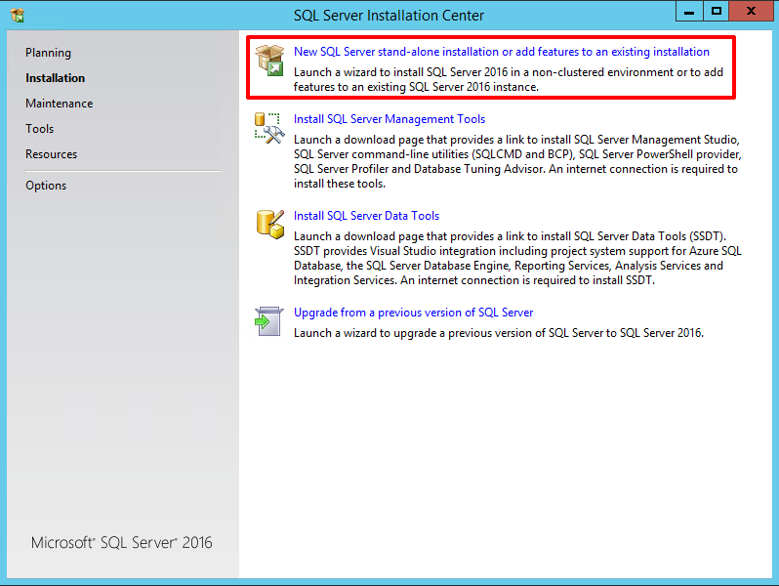
4. Once installation starts, accept the default settings for each step until you reach the **Database Engine Configuration** section. At this step, select the **Mixed Mode** radio button under the Authentication Mode segment of the Server Configuration tab. Enter a password (such as P@ssword) for the SA account, and make sure your username is listed under Specify SQL Server administrators. **Please make note of the password you entered in this step**. This will be used later on when updating the connection strings in the project configuration files.  
   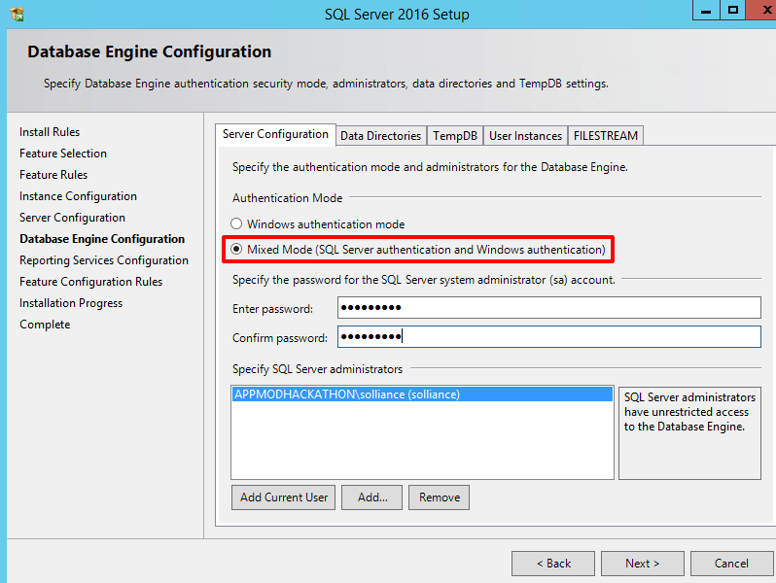
5. Complete the installation, accepting defaults for the remaining steps.

### Task 5: Install SQL Server Management Studio

1. On the new VM, click on Start, then run the **SQL Server 2016 Installation Center**. When it launches, click on **Installation** on the left-hand pane, then **Install SQL Server Management Tools**.  
   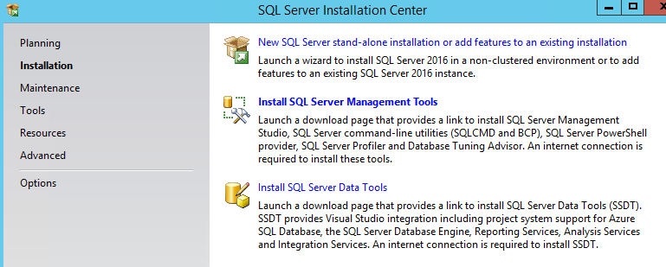
2. This will launch a web browser window, prompting you to download the latest SQL Server Management Studio version. Click on the **Download** link, and then run the executable file on completion.  
   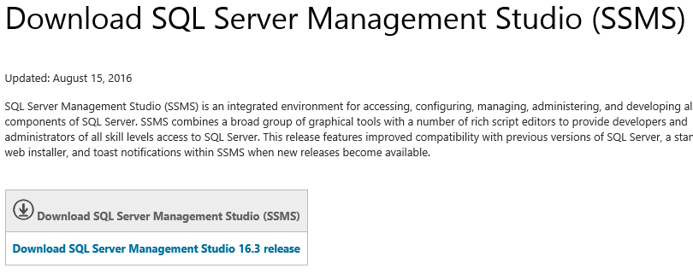
3. Once the SSMS installation begins complete the installation steps, selecting the default settings.

### Task 6: (optional) Create and Configure Self-Signed Certificate

Task 5 is **optional** for users who wish to run the PolicyConnect desktop application within its legacy configuration. SSL is used to encrypt communication between the desktop application and the WCF services, including SQL-based authentication. **This task is not required to complete the lab successfully.**

Subtask 1: Create self-signed certificate

1. On the new VM, run the **Developer Command Prompt** for VS2015 as an administrator from the Start menu.
2. Browse to a folder location you wish to store the certificate files, taking note of the path.
3. Run the following command to create the root CA, and execute:

makecert -n "CN=RootCATest" -r -sv RootCATest.pvk RootCATest.cer

By default, no **makecert** tool installed on Windows 10 PC. To install, you need to download Windows 10 SDK from here:

<https://developer.microsoft.com/en-us/windows/downloads/windows-10-sdk>

1. In the **Create Private Key Password** dialog box, click **None** without entering the password. Normally this is not recommended for security reasons, but is acceptable for test purposes only.
2. Now we will install the certificate in the Trusted Root Certification Authorities container.
3. Click **Start**, then type **MMC** and then click **OK**.
4. In the Microsoft Management Console (MMC), on the **File** menu, click **Add/Remove Snap-in**.
5. In the **Add Remove Snap-in** dialog box, click **Add**.
6. In the **Add Standalone Snap-in** dialog box, select **Certificates** and then click **Add**.
7. In the **Certificates snap-in** dialog box, select the **Computer account** radio button because the certificate needs to be made available to all users, and then click **Next**.
8. In the **Select Computer** dialog box, leave the default **Local computer: (the computer this console is running on)** selected and then click **Finish**.
9. In the **Add Standalone Snap-in** dialog box, click **Close**.
10. In the **Add/Remove Snap-in** dialog box, click **OK**.
11. In the left pane, expand the **Certificates (Local Computer)** node, and then expand the Trusted Root Certification Authorities folder.
12. Under **Trusted Root Certification Authorities**, right-click the Certificates subfolder, select **All Tasks**, and then click **Import**.
13. On the **Certificate Import Wizard** welcome screen, click **Next**.
14. On the **File to Import** screen, click **Browse**.
15. Browse to the location of the signed Root Certificate Authority RootCATest.cer file copied in Step 3, select the file, and then click **Open**.
16. On the **File to Import** screen, click **Next**.
17. On the **Certificate Store** screen, accept the default choice and then click **Next**.
18. On the **Completing the Certificate Import Wizard** screen, click **Finish**.  
    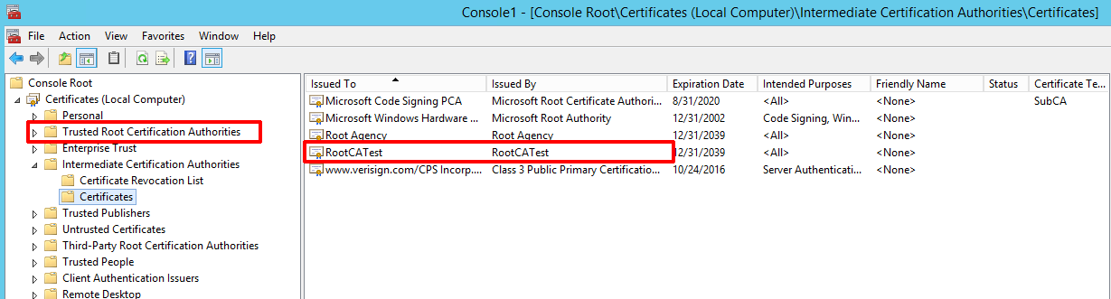

### Subtask 2: Create and install your temporary service certificate

1. On the new VM, run the **Developer Command Prompt** for VS2015 as an administrator from the Start menu, or switch over to the command prompt if you had left it open from the previous steps.
2. Browse to the folder location you stored the certificate files.
3. Type in the following command, replacing the <<YOUR MACHINE NAME>> with your machine name, and execute:  
     
   makecert -sk ContosoInsurance -iv RootCATest.pvk -n "CN=<<YOUR MACHINE NAME>>" -ic RootCATest.cer -sr localmachine -ss my -sky exchange -pe
4. Keep the command prompt open.
5. We must now associate this certificate with all SSL transactions within IIS Express. To do this, **re-open the Certificates MMC snap-in** from the previous section.
6. Expand the Personal certificates node on the Certificates tree to the left. You should see a certificate issued to your machine name, and issued by RootCATest. **Double-click your certificate**, then select the **Thumbprint** field under the Details tab. **Copy the Thumbprint value**.  
   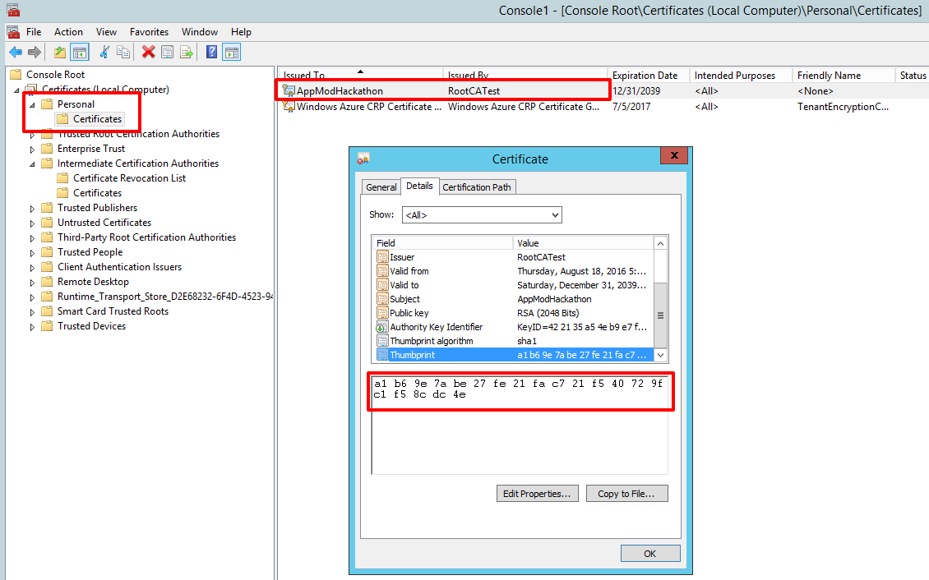
7. Launch PowerShell from the start menu. We will run a command to remove the spaces from the Thumbprint value we copied on the previous step. We will also execute a command to generate a new Guid value.
8. From the PowerShell command prompt, paste your certificate’s thumbprint between double quotes, executing the following command (replacing the thumbprint value with your own):  
     
   "a1 b6 9e 7a be 27 fe 21 fa c7 21 f5 40 72 9f c1 f5 8c dc 4e" -replace " "
9. Copy the output value, which is your thumbprint with the spaces removed.
10. Go back to the Visual Studio command prompt you left open on step 4. Type in the following command, but **do not execute yet**:  
      
    netsh http add sslcert ipport=0.0.0.0:44321 appid={c19c7312-ffe4-48da-85e3-f302ad80a625} certhash=a1b69e7abe27fe21fac721f540729fc1f58cdc4e  
      
    Replace the **certhash** value with the thumbprint you copied in the previous step. Replace the **appid** value with a newly generated Guid. To generate a Guid, switch pack to PowerShell and execute the following command:  
      
    [guid]::NewGuid()  
      
    Paste the output Guid value in between the curly braces next to **appid** in the Visual Studio command prompt.
11. Execute the netsh command. If you receive an error stating that the “SSL Certificate add failed”, you may ignore it. The certificate is now associated with https communications over port 44321.

### Subtask 3: Configure the IIS Express self-signed certificate

On the new VM, verify that the IIS Express developer certificate bound to localhost is present:

1. Click **Start**, then type **MMC** and then click **OK**.
2. In the Microsoft Management Console (MMC), on the **File** menu, click **Add/Remove Snap-in**.
3. In the **Add Remove Snap-in** dialog box, click **Add**.
4. In the **Add Standalone Snap-in** dialog box, select **Certificates** and then click **Add**.
5. In the **Certificates snap-in** dialog box, select the **Computer account** radio button because the certificate needs to be made available to all users, and then click **Next**.
6. In the **Select Computer** dialog box, leave the default **Local computer: (the computer this console is running on)** selected and then click **Finish**.
7. In the **Add Standalone Snap-in** dialog box, click **Close**.
8. In the **Add/Remove Snap-in** dialog box, click **OK**.
9. In the left pane, expand the **Certificates (Local Computer)** node, and then expand the **Personal** folder.
10. You should see a certificate issued to and issued by “localhost”.  
      
    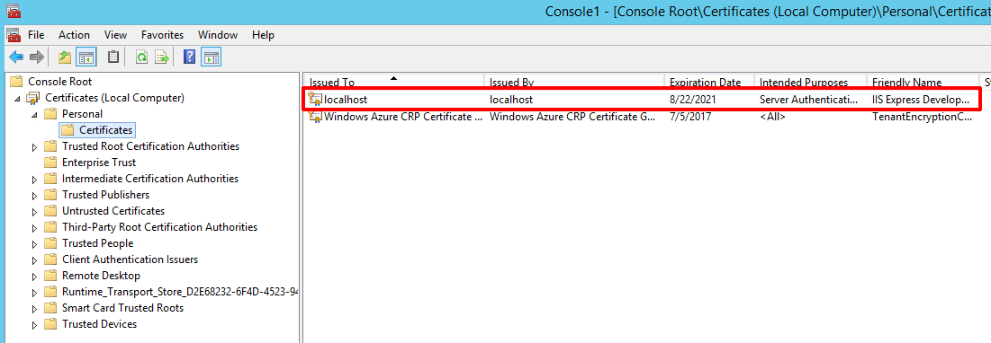
11. If this certificate is not present, you will need to run a repair command for the IIS Express application. If it is present, continue to step 12.  
    1. Click on Start, then type in **Programs and Features**. Click on the Programs and Features application link.
    2. Find and right-click on the IIS Express application listing, then select **Repair**.  
       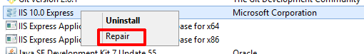
    3. Once the repair has completed, go back to the Certificates MMC snap-in and verify that the localhost certificate is now present under the Personal folder.
12. From the Certificates MMC snap-in, right-click on the localhost certificate within the Personal certificates container, then choose All Tasks 🡪 Export…  
      
    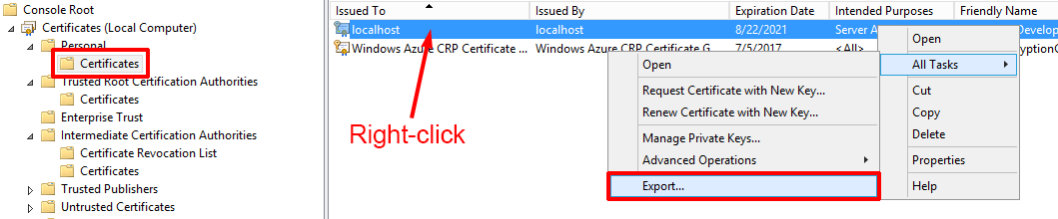
13. When the Certificate Export Wizard dialog appears, click on Next. Under **Export Private Key**, select **Yes, export the private key**, and then click Next.  
      
    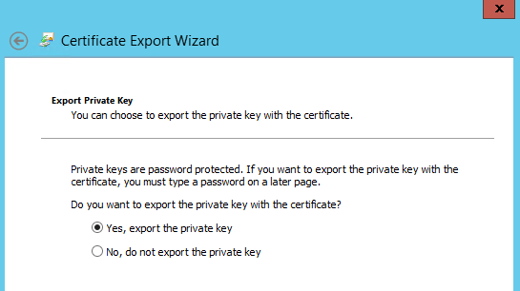
14. Make sure the **Personal Information Exchange – PKCS #12 (.PFX)** file format is selected, and that the first checkbox (Include add certificates in the certification path if possible) is checked, leaving the other two unchecked. Click Next.  
    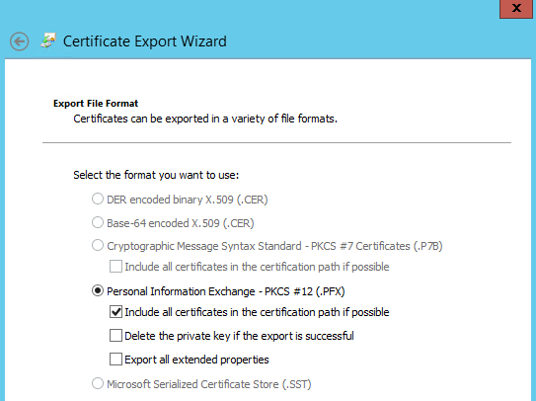
15. Enter and confirm a password on the next step. **Make note of the password** for the certificate import process. Click Next.
16. Specify the name of your exported file by browsing to a folder and typing in the name of the file (such as localhost). Click Next.
17. Click **Finish** on the confirmation screen.
18. After the export is complete, expand the **Trusted Root Certification Authorities** folder, then right-click on the Certificates subfolder and select **All Tasks…** 🡪 **Import**.
19. Click Next, and then browse to the exported certificate location. You may need to select **Personal Information Exchange (*.pfx,*.p12)** from the file types dropdown next to the File name field in order to see your certificate listed. Select the certificate, click Open, then Next.
20. Type the password you entered while exporting the certificate in step 15, then click Next.
21. Make sure that the **Trusted Root Certification Authorities** certificate store is selected, then click Next, then Finish.

### Task 7: Validate Connectivity to Azure

1. From within the virtual machine, Launch Visual Studio 2015 and validate that you can log in with your Microsoft Account when prompted.
2. Validate connectivity to your Azure subscription. Launch Visual Studio, open Server Explorer from the View menu, and ensure that you can connect to your Azure subscription.

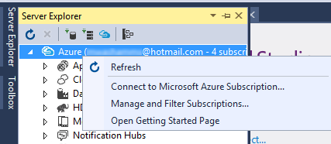

### Task 8: Download and explore the ContosoInsurance sample

1. Create a new folder on your C: drive named **Hackathon**.
2. Download the sample application from here: <http://bit.ly/2j78DLy> and extract to the **Hackathon** folder.

Note: The link above is case sensitive.

1. From the **Contoso.Apps.Insurance.Data** folder under **Hackathon**, open the Visual Studio Solution file: **Contoso.Apps.Insurance.Data.sln**.
2. The solution contains the following projects:

|  |  |
| --- | --- |
| PolicyConnectDesktop | Contoso Insurance PolicyConnect desktop application |
| PolicyConnectDataService | Contoso Insurance data access WCF middle-tier service (legacy environment) |
| PolicyConnectManagementService | Contoso Insurance application management WCF middle-tier service (legacy) |
| Contoso.Apps.Insurance.Data | Data tier |
| Contoso.Apps.Common | Library containing methods common to the application tiers |
| CIMobile | Xamarin-based base mobile app (shared) |
| CIMobile.Droid | Xamarin-based Android app |
| Contoso.Apps.Insurance.Web | Modern PolicyConnect web application |
| Contoso.Apps.Insurance.WebAPI | Web API service |

### Task 9: Attach ContosoInsurance Database

1. Go to the Start menu and launch **SQL Server Management Studio** (SSMS) as an Administrator (right-click, **Run as administrator**).
2. Log in to the local SQLEXPRESS instance using default credentials.
3. Right-click on **Databases** on the left-hand menu, then select **Attach…**
4. In the Attach Databases dialog, click the **Add…** button and browse to C:\Hackathon\Database and select ContosoInsurance.mdf. Click OK, then OK once again.  
   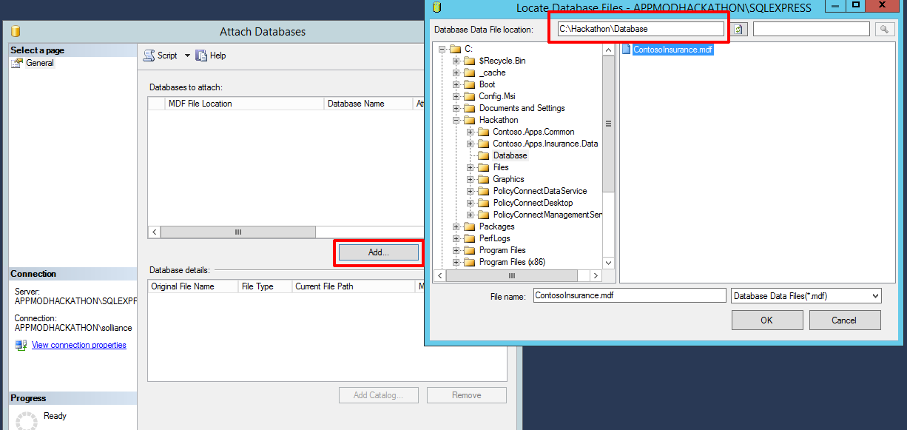
5. You should now see the ContosoInsurance database listed underneath the Databases folder.
6. Now we need to create the ContosoUser account. Click on the New Query button on the top tool bar, and paste the following command:  
     
   USE [master]

GO

CREATE LOGIN [ContosoUser] WITH PASSWORD=N'P@ss4now', DEFAULT_DATABASE=[master], DEFAULT_LANGUAGE=[us_english], CHECK_EXPIRATION=OFF, CHECK_POLICY=OFF  
  
Click the Execute button, or hit F5

1. You should now see a ContosoUser listed underneath the Security 🡪 Logins section of the left-hand menu.
2. Run another query to re-associate the ContosoUser login with the existing database user:  
     
   Use ContosoInsurance

EXEC sp_change_users_login 'Report'

EXEC sp_change_users_login 'Auto_Fix', 'ContosoUser'

EXEC sp_change_users_login 'Report'

### Task 10: Create a new Azure Resource Group

1. Within the Azure Management Portal, open the **Resource groups** tile and   
   click **Add**.

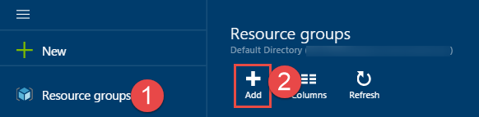

1. Specify the name of the resource group as **ContosoInsuranceHackathon**, and choose the Azure region you want to deploy the lab to. This resource group will be used throughout the rest of the lab. Click **Create** to create the resource group.

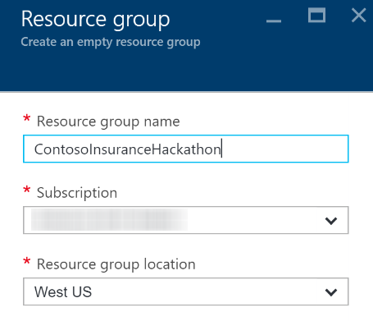

## Exercise 2: Azure data, storage, and app environment setup

### Overview

Contoso Insurance has asked you to provision the Web API, storage, and data services to Microsoft Azure, and then migrate their on-premises SQL database to Azure SQL Database. Ensure all resources use the same resource group that was created for the App Service Environment.

### Help references

|  |  |
| --- | --- |
| SQL firewall | https://azure.microsoft.com/en-us/documentation/articles/sql-database-configure-firewall-settings/ |

### Task 1: Create web app, SQL database, and storage instances and migrate SQL

In this exercise, you will provision a website via the Azure Web App template using the Microsoft Azure Portal. You will then provision storage instances for storing the PDF files. Next, you will migrate the on-premises SQL database to new Azure SQL instance you created.

### Tasks to complete

* Create web, API app, storage, and SQL Server instances from within Azure.
* Migrate the on-premises SQL database to Azure.

### Exit criteria

* Azure App Service instances should be created for the web application and the Web API.
* Note the URLs of the provisioned web and API app services for future reference.
* Save the new database connection string for later.
* The database and all of its data should be hosted in Azure and accessible through SQL Server Management Services (SSMS).

## Exercise 3: Identity and security

### Overview

Azure Active Directory will be used to allow users to authenticate to the web app, PolicyConnect desktop app, mobile apps, and PowerApps solutions. Azure AD will also be used to manage application access to Key Vault secrets. You have been asked to create a new Azure AD Tenant and secure the application so only users from the tenant can log on.

### Help references

|  |  |
| --- | --- |
| What is Azure AD? | <https://azure.microsoft.com/en-us/documentation/articles/active-directory-whatis/> |
| Azure Web Apps authentication | <http://azure.microsoft.com/blog/2014/11/13/azure-websites-authentication-authorization/> |
| View your access and usage reports | <https://msdn.microsoft.com/en-us/library/azure/dn283934.aspx> |

Note: Tasks 1 and 2 require global admin permissions on the Azure AD Tenant. Task 3 requires the permission to create an app in the Azure AD tenant. Task 1 and 2 cannot be completed if you use Microsoft’s Azure AD tenant.

### Tasks to complete

1. Create a new Contoso user in your Azure AD tenant and set the password to **demo@pass123**.
2. Add the Web API application to your AAD tenant.
3. Expose the Web API to other applications by updating the manifest to enable **oauth2AllowImplicitFlow** and adding an **oauth2Permissions** entry that allows applications to read-write the Contoso Web API on behalf of the signed-in user.
4. Add the Contoso Insurance Desktop app to your AAD tenant and grant permissions to the Web API application.
5. Add the Contoso Insurance mobile app to your AAD tenant and grant permissions to the Web API application.
6. Modify the PolicyConnect website authentication settings to use AAD.
7. Grant permissions for the website to the Web API within AAD and update the manifest to enable **oauth2AllowImplicitFlow**.

### Exit criteria

* The Web API, website, desktop, and mobile apps should have entries as applications within AAD that allow them to restrict access to only users who are in the AAD tenant.
* The website, desktop, and mobile apps must be granted access to the Web API.

## Exercise 4: Configure blob storage and search indexing

### Overview

Contoso Insurance is currently storing all of their scanned PDF documents on a local network share. They have asked to enable full-text searching on the documents, and to be able to store them automatically from a workflow. We have already provisioned a storage instance that we will use to store the files in a blob container. First, we need a way to bulk upload their existing PDFs, then configure search indexing on that container.

### Help references

|  |  |
| --- | --- |
| Transfer data with the AzCopy command-line utility | [https://azure.microsoft.com/en-us/documentation/articles/storage-use-azcopy/#blob-upload](https://azure.microsoft.com/en-us/documentation/articles/storage-use-azcopy/%23blob-upload) |
| Download AzCopy | <http://aka.ms/downloadazcopy> |
| Create an Azure Search service using the Azure Portal | <https://azure.microsoft.com/en-us/documentation/articles/search-create-service-portal/> |
| Indexing Documents in Blob Storage | <https://azure.microsoft.com/en-us/documentation/articles/search-howto-indexing-azure-blob-storage/> |
| Portal support for Azure Search blob and table indexers | <https://azure.microsoft.com/en-us/blog/portal-support-for-azure-search-blob-and-table-indexers-now-in-preview/> |

### Task 1: Bulk upload PDFs to blob storage

### Tasks to complete

* Download and use the AzCopy command line utility to bulk upload the PDFs to a new blob container named **policies**.

### Exit criteria

* Verify that all of the PDFs have been uploaded to the container.

### Task 2: Create an Azure search service

#### Tasks to complete

* Provision a new search service, making sure to add it to the **ContosoInsuranceHackathon** resource group. Select the Basic tier when provisioning.

### Task 3: Configure full-text search indexing

#### Tasks to complete

* Use the import data feature of the newly provisioned search service to connect to your blob storage container (policies) which contain the PDF files.
* Name the new index **policies**, using the detected metadata_storage_path as the key.
* Make most of the fields retrievable, and the **content** field both filterable and searchable.
* Create an indexer for the new index that has a 5-minute interval (for testing only).
* Configure CORS to allow all origins.

#### Exit criteria

* All ~650 PDFs should be indexed.
* Use the Search explorer to validate functionality. You should be able to search by full policy number, or partial file content matches.

## Exercise 5: Configure Key Vault

### Overview

Key Vault will be used to protect sensitive information, such as database connection strings and storage account keys. Our application services that we have registered within Azure Active Directory will be granted access to the Key Vault secrets we create in this section. We have selected to use secrets instead of keys, due to the small size of the strings we are storing, as well as how often we need to retrieve the values. Retrieving secrets from Key Vault is a lower latency operation than retrieving keys, due to the real-time encryption and decryption involved.

### Help references

|  |  |
| --- | --- |
| What is Key Vault? | <https://azure.microsoft.com/en-us/documentation/articles/key-vault-whatis/> |
| About Keys and Secrets | <https://msdn.microsoft.com/library/dn903623.aspx> |
| Get Started with Azure Key Vault | <https://azure.microsoft.com/en-us/documentation/articles/key-vault-get-started/> |
| Use Azure Key Vault from a Web Application | <https://azure.microsoft.com/en-us/documentation/articles/key-vault-use-from-web-application/> |

### Task 1: Create a new Key Vault

#### Tasks to complete

* Use the New-AzureRmKeyVault PowerShell cmdlet to create the Key Vault within the ContosoInsuranceHackathon resource group.
* Make note of the Vault URI for later reference.

### Task 2: Create a new secret to store the SQL connection string

#### Tasks to complete

* Save the full (including username and password) SQL connection string as a new secret named SQLConnectionString by using the Set-AzureKeyVaultSecret cmdlet.
* Obtain the URI to the secret for later reference.
* Use the Set-AzureRmKeyVaultAccessPolicy cmdlet to grant the Web API application Get access to the secret.

### Task 3: Add Client Id, Client Secret, and Secret URL to Web API’s app settings

#### Tasks to complete

* Modify the Web API app service Application settings to add the following keys and values:
  + Key: **ClientId** Value: <AAD web app Client Id for Web API>
  + Key: **ClientSecret** Value: <AAD web app Key for Web API>
  + Key: **SecretUri** Value <Key Vault Uri for the SQLConnectionString secret>

## Exercise 6: Configure and Deploy the Contoso Insurance apps

### Overview

The developers at Contoso Insurance have been working toward migrating their apps to the cloud. As such, most of the pieces are already in place to deploy the apps to Azure, as well as configure them to communicate with the new app services, such as Web API. Since the required services have already been provisioned on Azure up to this point, what remains is applying application-level configuration settings, and then deploying any hosted apps and services from the Visual Studio Starter Project solution.

### Task 1: Deploy the Web API

#### Tasks to complete

* Apply application settings using the Microsoft Azure Portal:
  + Key: **ida:Tenant** Value: <AAD tenant name>
  + Key: **ida:Audience** Value: <App ID URI within AAD application settings>
* Deploy the Web API from the **Contoso.Apps.Insurance.WebAPI** Starter Project in Visual Studio.

#### Exit criteria

* Validate the Web API by typing in /swagger to the end of its URL in your browser (e.g. http://contosoinsurancewebapi.azurewebsites.net/swagger). You should see a list of the available REST APIs. However, you will not be able to execute them from here, as they are protected by AAD application permissions, accepting only token-based calls from registered apps.  
  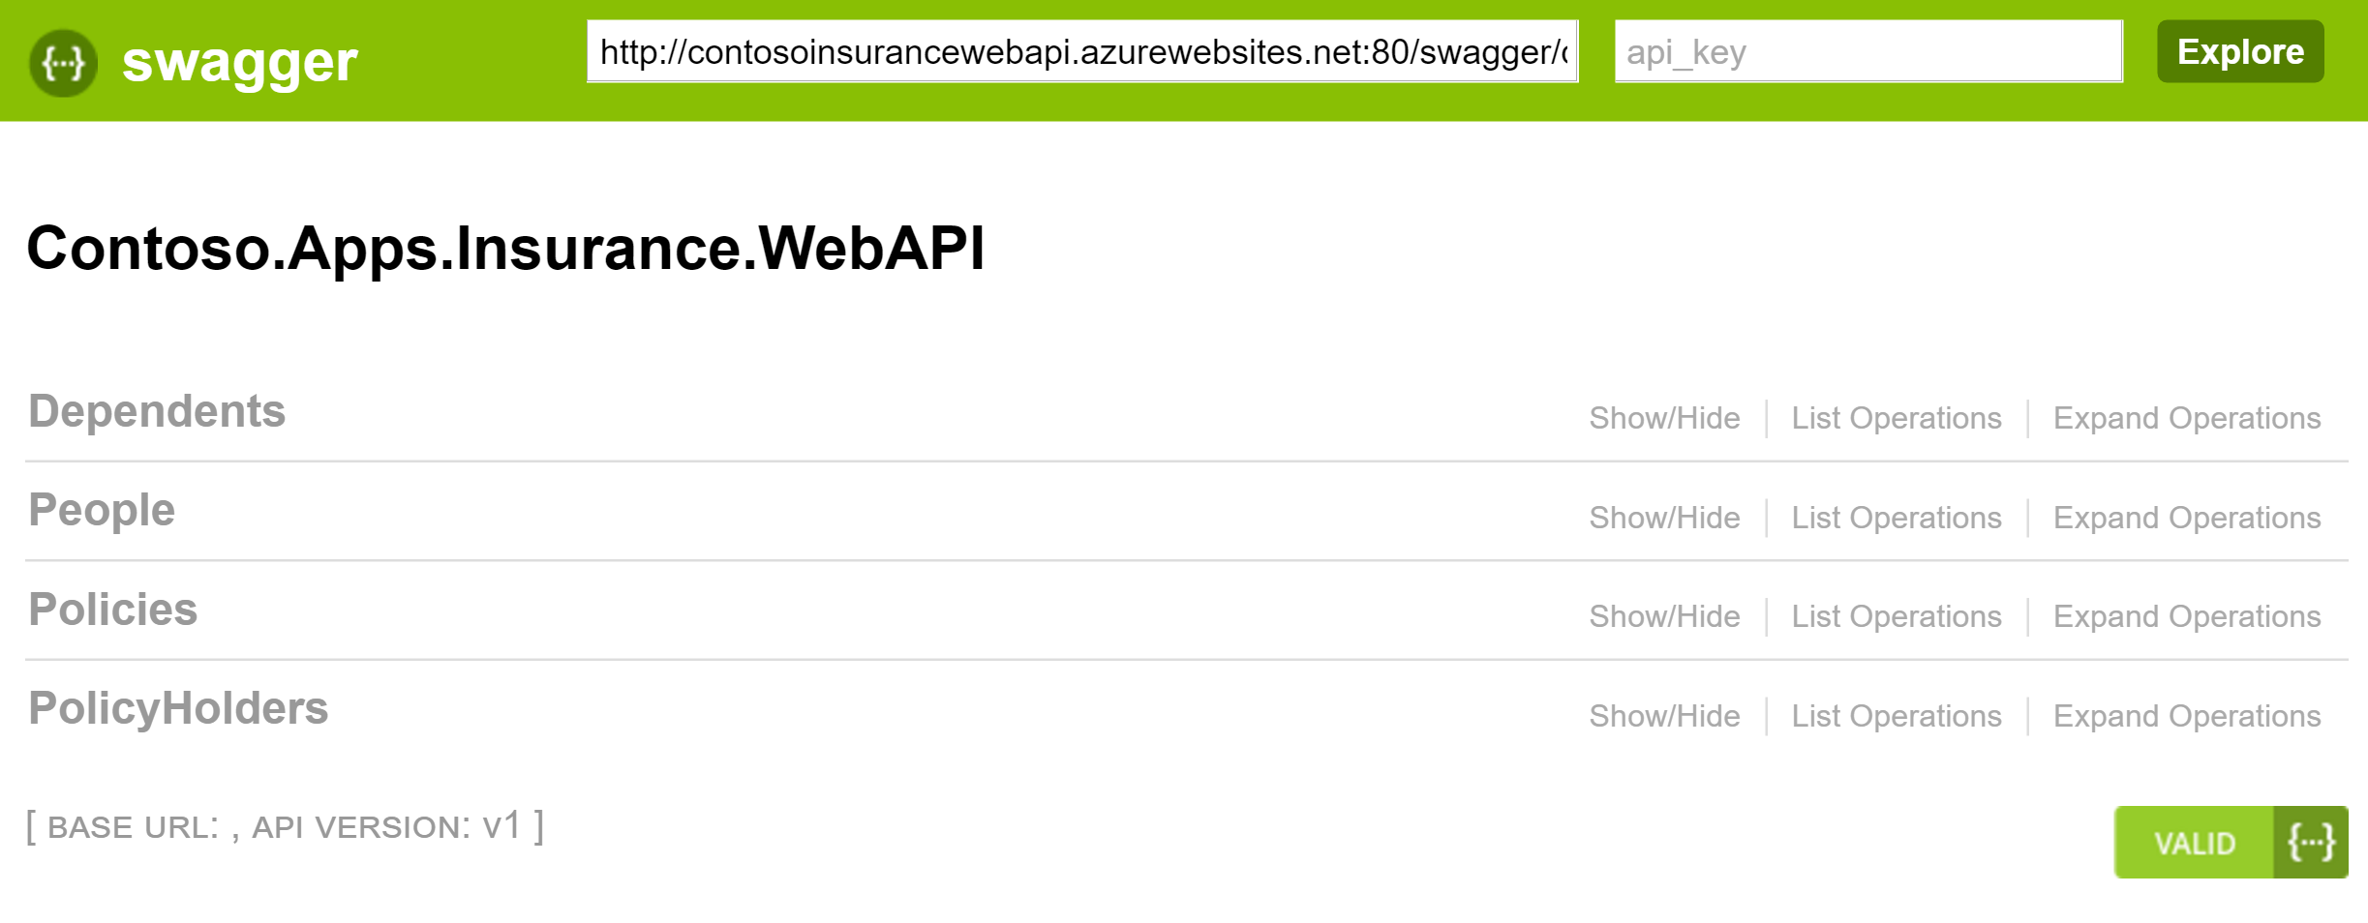

### Task 2: Deploy the Contoso Insurance web app

#### Tasks to complete

* Apply application settings using the Microsoft Azure Portal:
  + Key: **RootWebApiPath** Value: <URL to published Web API>
  + Key: **Tenant** Value: <AAD tenant name>
  + Key: **WebClientId** Value: <App’s AAD Client Id>
  + Key: **WebApiAppId** Value: <Web API’s APP ID URI from AAD>
* Modify the **app.js file** in the Scripts > app folder the file where you see the line (126) that begins with **var endpoints = {**. Change the URL in quotes to the same URL you entered for the RootWebApiPath application variable, which is the root location of your Web API, (e.g. https://contosoinsurancewebapi.azurewebsites.net)
* Deploy the web app from the **Contoso.Apps.Insurance.Web** Starter Project in Visual Studio.

#### Exit criteria

* Validate the website by browsing to it, if it did not automatically launch after publishing.  
  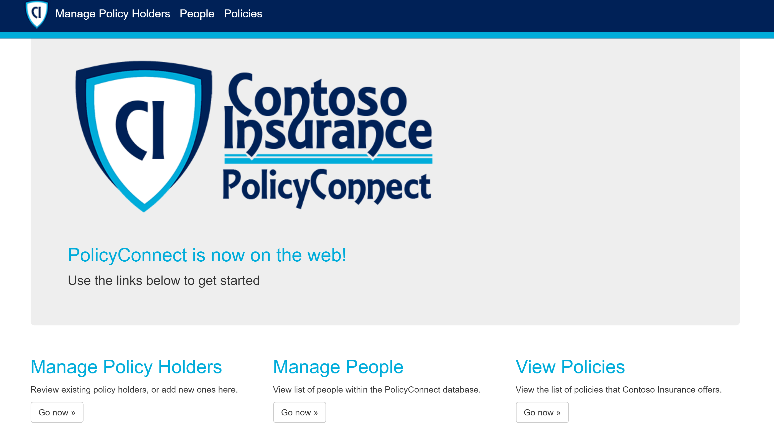
* Click on the **Policies** link. You will likely be prompted to log in to AAD if you do not already have a cached authentication token. When you log in, do so with the **Contoso User** account you created earlier. Username is **contosouser@<your tenant>.onmicrosoft.com** and the password is **demo@pass123**. After authentication is complete, you should see a list of policies, and you should have a Logout link on the upper-left.  
  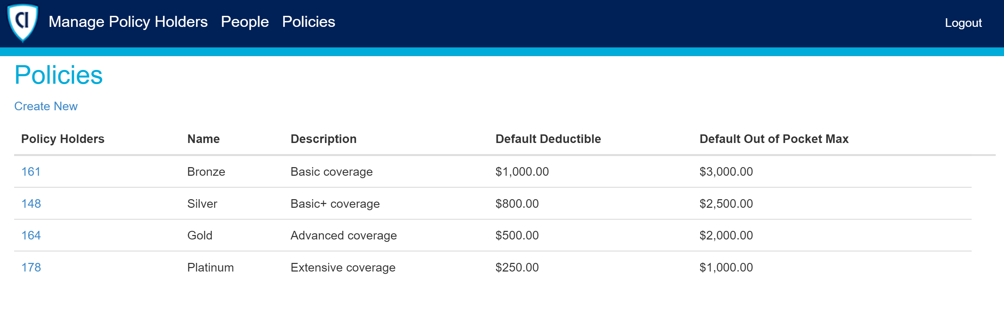

### Task 3: Configure and run the legacy desktop (Windows Forms) application

#### Tasks to complete

* Modify the application settings within the App.config file of the **PolicyConnectDesktop** Starter Project in Visual Studio.
* Make sure to set the **UseWebApi** value to **true** in order to have it pull data from the newly published Web API instead of the legacy WCF services. This also tells the application to authenticate via AAD instead of the legacy SQL authentication method.

#### Exit criteria

* Successfully run the desktop application by debugging it in Visual Studio.
* Click the **Log in…** button to begin.
* You will be presented with an AAD login window. Enter the login credentials for the Contoso User account you created in your AAD directory. Username is **contosouser@<your tenant>.onmicrosoft.com** and the password is **demo@pass123**. After authentication is complete, you should see a list of policyholders, and you should see a label on the upper-right saying you are logged in as your Contoso User account. Feel free to explore the different capabilities of the application. Some functionality is intentionally left out. To open a policyholder record, simply double-click on any of the rows.  
  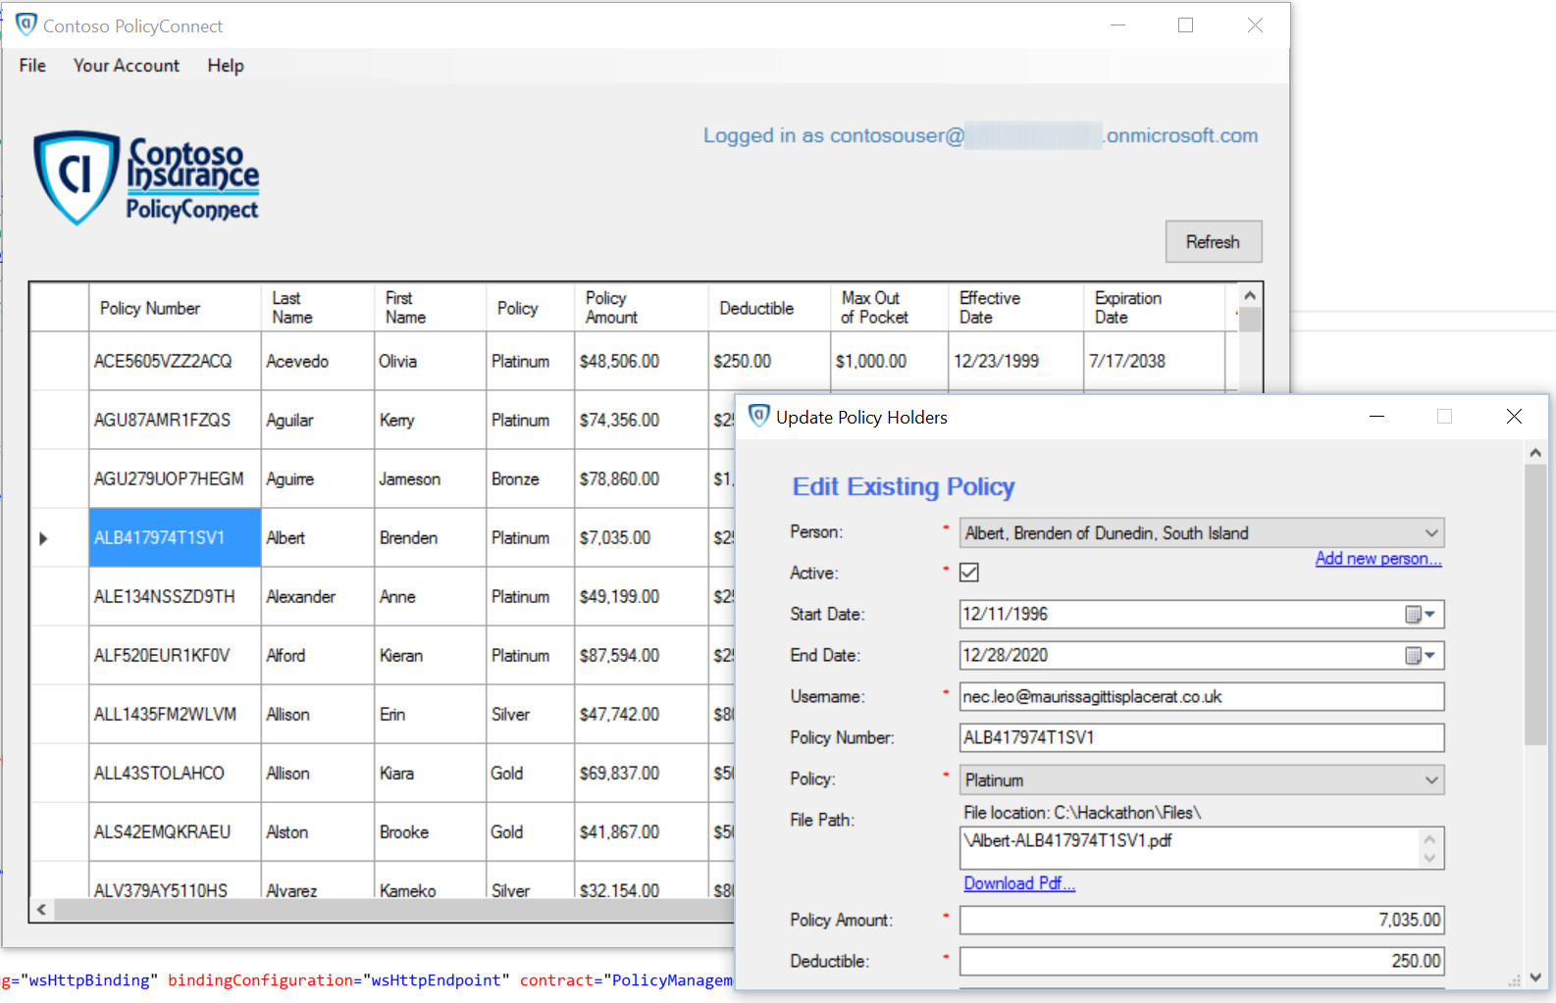

### Task 4: Configure and run the mobile application

#### Tasks to complete

* Modify the properties within the **ApplicationSettings.cs** file of the **PolicyConnectDesktop** Starter Project in Visual Studio.
* Debug the **CIMobile.Droid** project within the Android emulator.   
  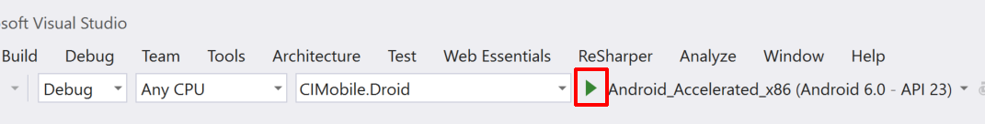

#### Exit criteria

* The Android emulator should appear, and then launch the PolicyConnect app within.  
  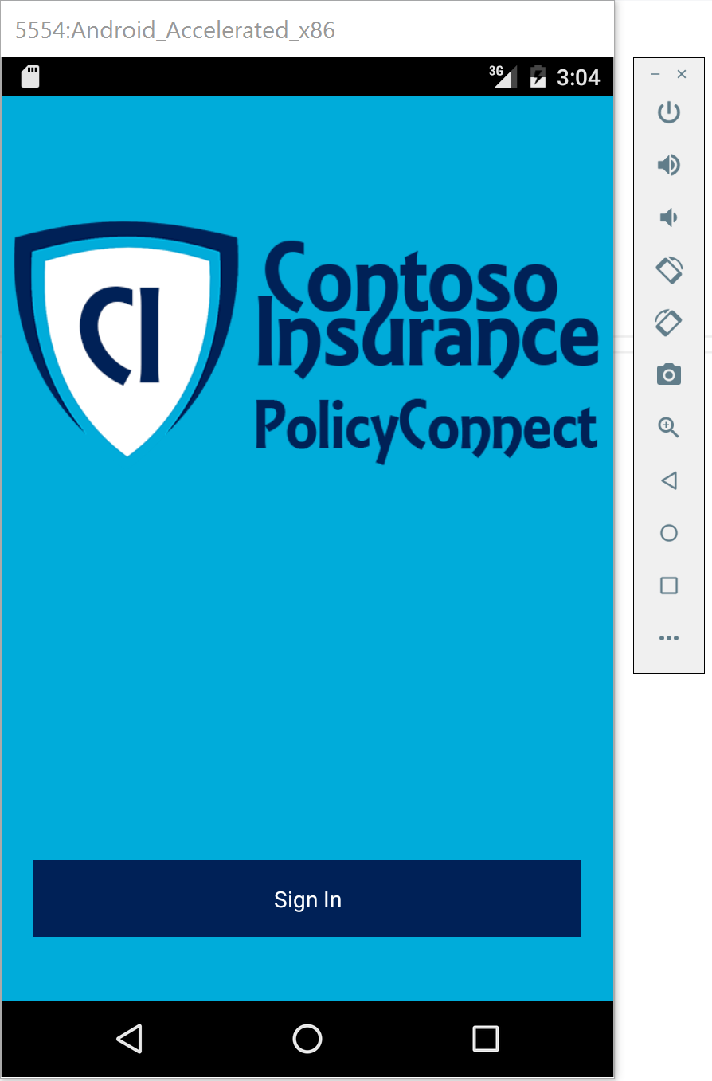
* Click the **Sign In…** button to begin.
* You will be presented with an AAD login window. Enter the login credentials for the Contoso User account you created in your AAD directory. Username is **contosouser@<your tenant>.onmicrosoft.com** and the password is **demo@pass123**. After authentication is complete, you should see a list of policyholders. You cannot interact with the records in any way for this demo.  
    
  Click on the menu button on the upper-left to explore other parts of the app.  
  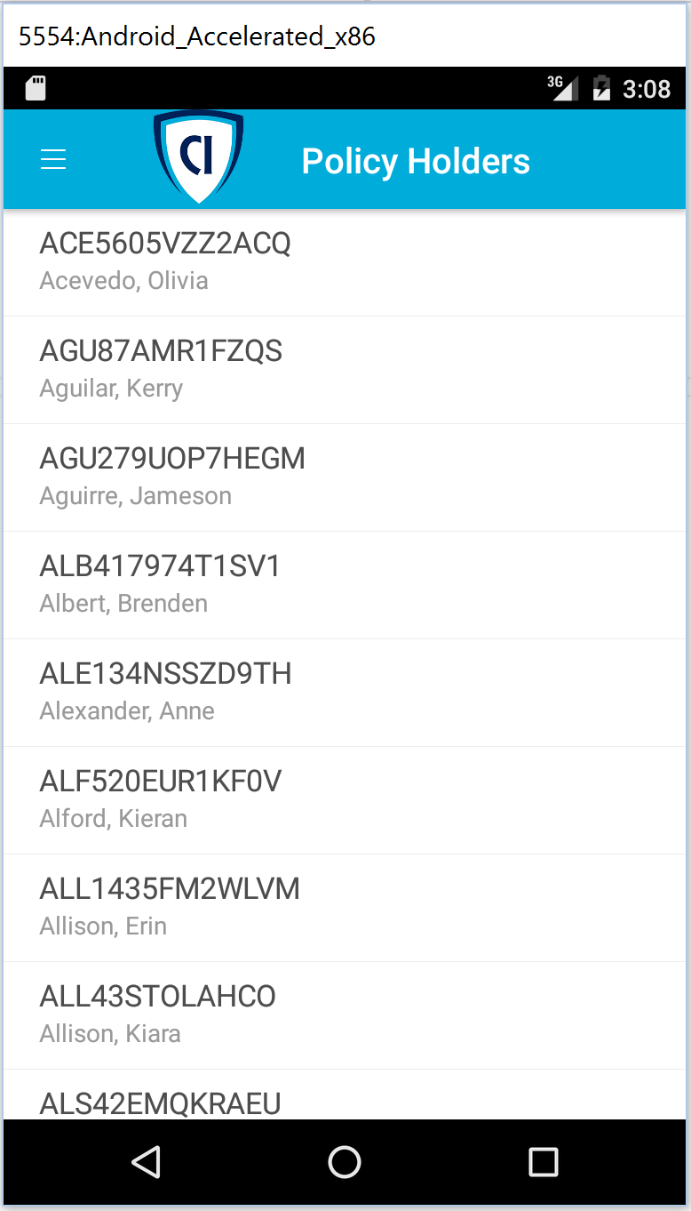
* Click on the menu and choose **Search Policy #**.  
    
  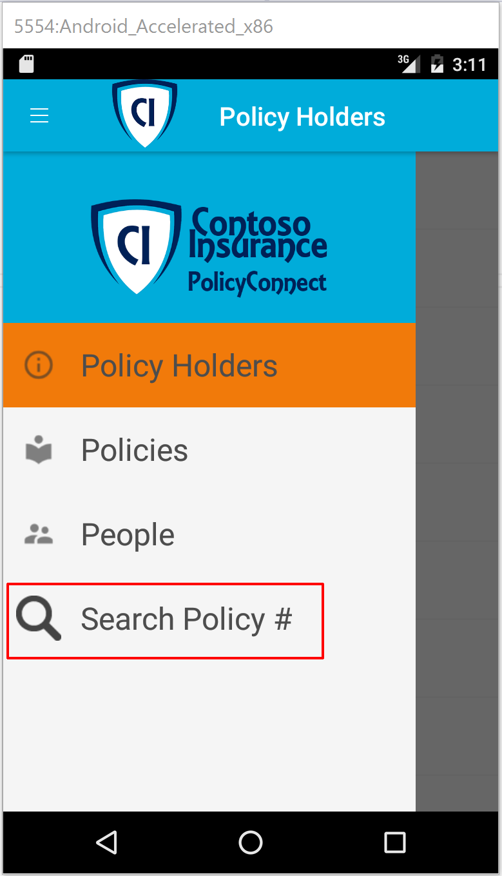
* You can either enter a full policy #, or perform a partial search of all content and metadata fields within the search field. Type in at least 3 characters to activate the search button. Try searching with the letters **MON**. The most relevant search results will appear first. Now try searching by an exact policy number, such as **DOW586IJCG493F**. You should see a single result matching that policy number.  
  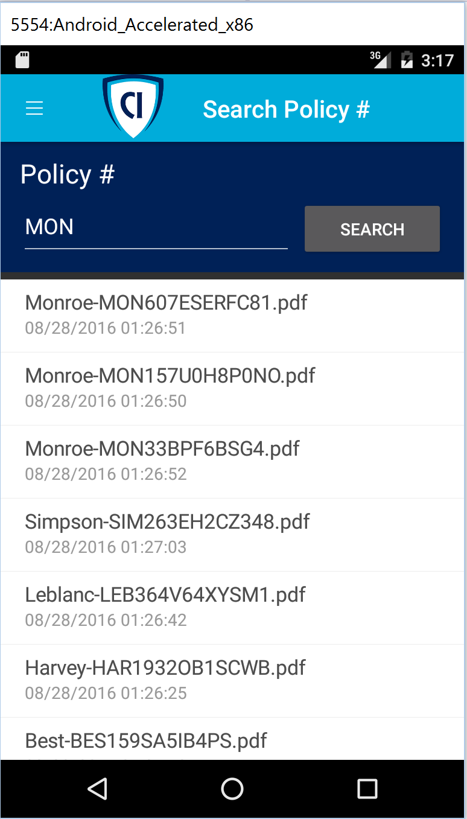
* Click on a search result to view the content that was extracted by the Azure Search indexer. There is a link to download the actual PDF at the bottom of the result page. This will display the file that is stored in Blob storage.  
  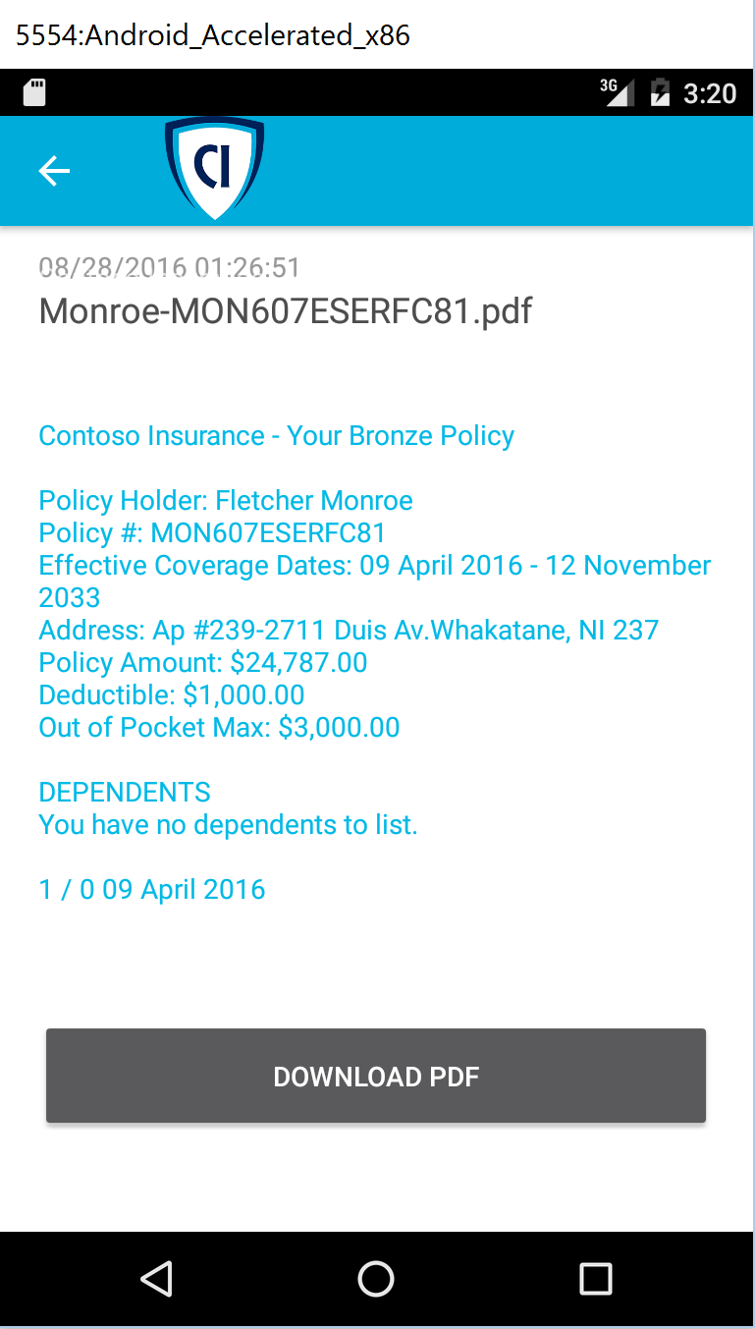  
  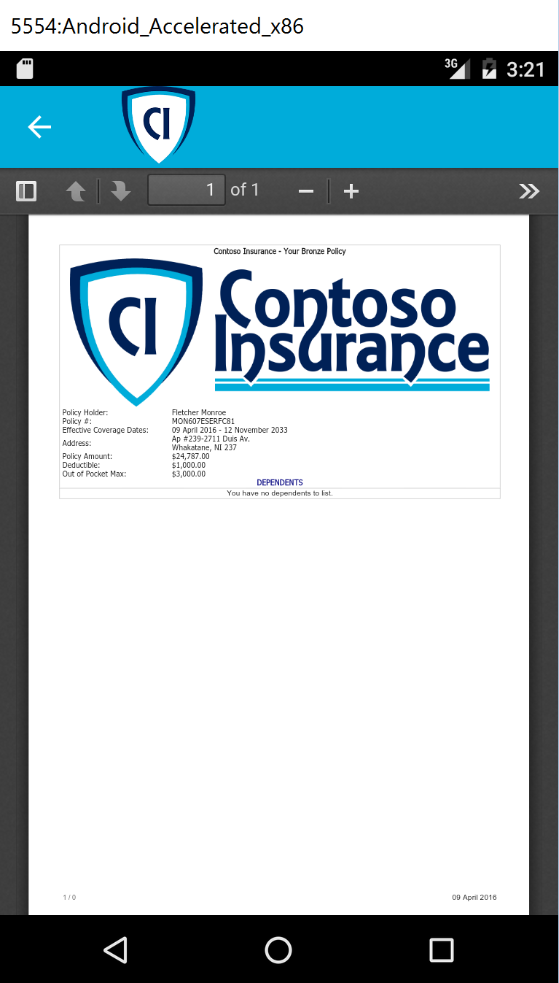

## Exercise 7: Create a Flow app that sends push notifications when important emails arrive

### Overview

Contoso wants to receive push notifications when important emails arrive, since any newly scanned policies that are emailed to the data entry employees are marked as important. Since they use Office 365 for their email services, you can easily meet this requirement with Flow.

### Task 1: Sign up for a Flow account

#### Tasks to complete

* Visit <https://flow.microsoft.com> to create an account if you do not already have one.
* Download the Flow mobile app.

### Task 2: Create new flow

#### Tasks to complete

* Create a new trigger that connects to Office 365 Outlook, watching for any that is of high importance and have an attachment.
* Execute a push notification if an email with the preferred criteria arrives in the user’s inbox. Make sure that the subject is part of the notification title.

### Task 3: Test your flow

#### Tasks to complete

* Send a new email to the linked email account that will trigger the notification.

#### Exit criteria

* If you have installed the Flow mobile app that supports push notifications, you should have received one after the message has been sent.
* Alternately, check the status of your flow by going to My flows, then clicking on the information icon to the right of your flow. The resulting page will display a log of each time it was executed. When you click on the log entry, you will see which of the steps, the email trigger or the push notification, were successful.  
  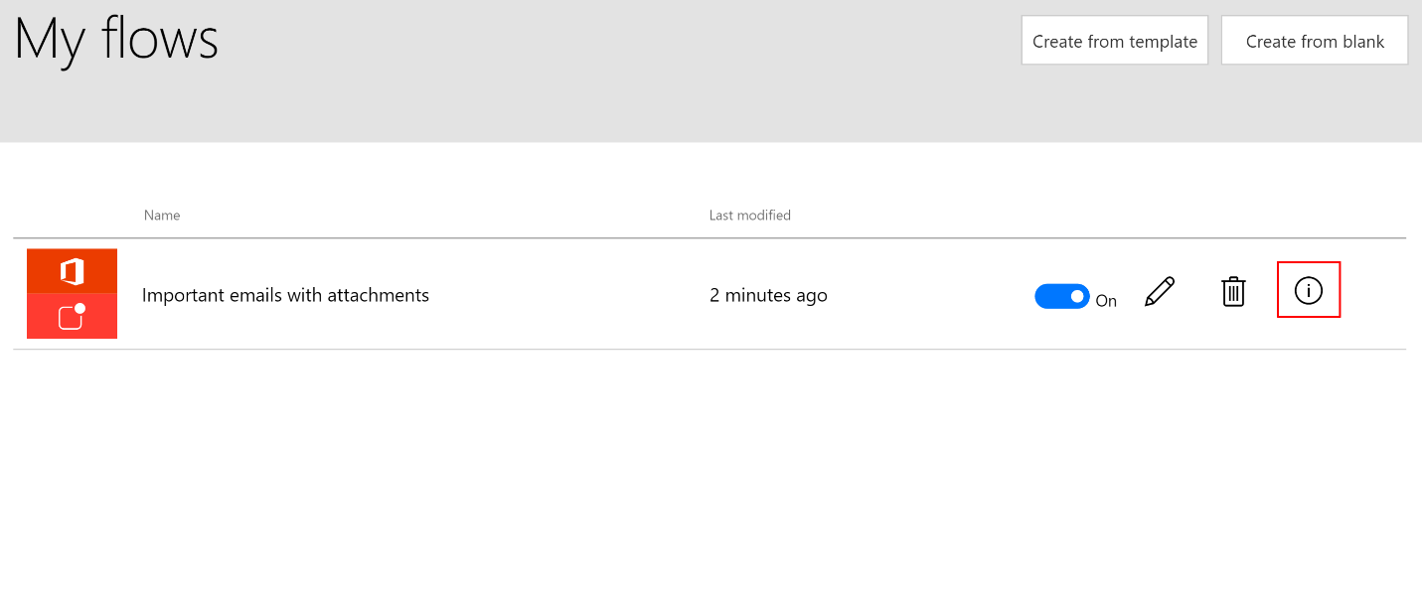

## Exercise 8: Create an app in PowerApps

### Overview

Since creating mobile apps is a long development cycle, Contoso is interested in using PowerApps to create mobile applications in order to add functionality not currently offered by their app rapidly. In this scenario, they want to be able to edit the Policy lookup values (Silver, Gold, Platinum, etc.), which they are unable to do in the current app.

Get them up and running with a new app created in PowerApps, which connects to the ContosoInsurance database and performs basic CRUD (Create, Read, Update, and Delete) operations against the Policies table.

### Help references

|  |  |
| --- | --- |
| PowerApps | <https://powerapps.microsoft.com/en-us/tutorials/getting-started/> |

### Task 1: Sign up for a PowerApps account

1. Go to <https://web.powerapps.com> and sign up for a new account, or sign in with an existing one.
2. Download and install the PowerApps Studio application from the Microsoft store: <https://www.microsoft.com/en-us/store/p/powerapps/9nblggh5z8f3>.

### Task 2: Create a new SQL connection

1. From the <https://web.powerapps.com> website, create a new SQL connection, entering the server name, database name, username, and password for the ContosoInsurance database hosted in Azure.

### Task 3: Create a new app

1. Launch the PowerApps desktop application and create a new app, using the SQL connection, pointing to the Policies table.

### Task 4: Design app

1. After the app has been generated, change the titles on each of the three screens to remove the database table name.
2. Remove any unneeded labels from the list view screen.
3. Rearrange the order of the fields within the details and the edit form screens.
4. Fix up the labels for the field names to make them more human readable.

### Task 3: Edit the app settings and run the app

#### Tasks to complete

* Change the name of the app.
* Save the app to the cloud.
* Run the app to test the app’s ability to display and edit the list of Policies.

#### Exit criteria

* The PowerApps Studio application comes with a powerful app simulator in which you can test the app against your data source in real time. You should be able to view all of the Policies, edit them, create new ones, and delete the newly created ones. You will be unable to delete existing Policies since they are being referenced by other table records.

# Modern cloud apps hackathon answers

## Overview

This portion of the lab is designed to help ***only*** if you are blocked or do not have any experience with Azure developer tools or services.

## Exercise 1: Environment setup

In this exercise, you will set up your environment for use for the rest of the exercises. This will involve downloading the sample application and creating a Visual Studio Online Team Project.

### Task 1: Setup a Development Environment

If you do not have a machine set up with Visual Studio 2015 Community and Azure SDK 2.9, complete this task.

1. Create a virtual machine (VM) in Azure using the Visual Studio Community 2015 Update 3 and SDK 2.9.1 on Windows Server 2012 R2 image. A Windows 10 image will work as well.



It is highly recommended to use a DS2 or D2 instance size for this VM.

If you decide to use a VM, you will not be able to run the Android emulator in later steps of the lab.

### Task 2: Disable IE Enhanced Security

Note: Sometimes this image has IE ESC disabled. Sometimes it does not.

1. On the new VM you just created, click the Server Manager icon.



1. Click Local Server.



1. On the right side of the pane, click **On** by IE Enhanced Security Configuration.



1. Change to **Off** for Administrators and click **OK**.



### Task 3: Install Xamarin and Android SDK

1. On the new VM, download and run the Xamarin Unified Installer. Indicate that you already have Visual Studio installed when filling out the download form.  
   <http://www.xamarin.com/Download>
2. Be sure to allot for extra time, since the Android SDK can be in excess of 3.0 GB.

### Task 4: Install SQL Server 2016 Express

1. On the new VM, download and install SQL Server 2016 Express.  
   <https://www.microsoft.com/en-us/download/details.aspx?id=54284>  
     
   **If you are using a machine that already has SQL Server installed**, make sure Mixed Mode authentication is enabled: <https://technet.microsoft.com/en-us/library/ms188670(v=sql.110).aspx>
2. Choose **custom** installation once the install dialog box appears.
3. Select **New SQL Server stand-alone installation**.  
   
4. Once installation starts, accept the default settings for each step until you reach the **Database Engine Configuration** section. At this step, select the **Mixed Mode** radio button under the Authentication Mode segment of the Server Configuration tab. Enter a password (such as P@ssword) for the SA account, and make sure your username is listed under Specify SQL Server administrators. **Please make note of the password you entered in this step**. This will be used later on when updating the connection strings in the project configuration files.  
   
5. Complete the installation, accepting defaults for the remaining steps.

### Task 5: Install SQL Server Management Studio

1. On the new VM, click on Start, then run the **SQL Server 2016 Installation Center**. When it launches, click on **Installation** on the left-hand pane, then **Install SQL Server Management Tools**.  
   
2. This will launch a web browser window, prompting you to download the latest SQL Server Management Studio version. Click on the **Download** link, and then run the executable file on completion.  
   
3. Once the SSMS installation begins complete the installation steps, selecting the default settings.

### Task 6: (optional) Create and Configure Self-Signed Certificate

Task 5 is **optional** for users who wish to run the PolicyConnect desktop application within its legacy configuration. SSL is used to encrypt communication between the desktop application and the WCF services, including SQL-based authentication. **This task is not required to complete the lab successfully.**

Subtask 1: Create self-signed certificate

1. On the new VM, run the **Developer Command Prompt** for VS2015 as an administrator from the Start menu.
2. Browse to a folder location you wish to store the certificate files, taking note of the path.
3. Run the following command to create the root CA, and execute:

makecert -n "CN=RootCATest" -r -sv RootCATest.pvk RootCATest.cer

By default, no **makecert** tool installed on Windows 10 PC. To install, you need to download Windows 10 SDK from here:

<https://developer.microsoft.com/en-us/windows/downloads/windows-10-sdk>

1. In the **Create Private Key Password** dialog box, click **None** without entering the password. Normally this is not recommended for security reasons, but is acceptable for test purposes only.
2. Now we will install the certificate in the Trusted Root Certification Authorities container.
3. Click **Start**, then type **MMC** and then click **OK**.
4. In the Microsoft Management Console (MMC), on the **File** menu, click **Add/Remove Snap-in**.
5. In the **Add Remove Snap-in** dialog box, click **Add**.
6. In the **Add Standalone Snap-in** dialog box, select **Certificates** and then click **Add**.
7. In the **Certificates snap-in** dialog box, select the **Computer account** radio button because the certificate needs to be made available to all users, and then click **Next**.
8. In the **Select Computer** dialog box, leave the default **Local computer: (the computer this console is running on)** selected and then click **Finish**.
9. In the **Add Standalone Snap-in** dialog box, click **Close**.
10. In the **Add/Remove Snap-in** dialog box, click **OK**.
11. In the left pane, expand the **Certificates (Local Computer)** node, and then expand the Trusted Root Certification Authorities folder.
12. Under **Trusted Root Certification Authorities**, right-click the Certificates subfolder, select **All Tasks**, and then click **Import**.
13. On the **Certificate Import Wizard** welcome screen, click **Next**.
14. On the **File to Import** screen, click **Browse**.
15. Browse to the location of the signed Root Certificate Authority RootCATest.cer file copied in Step 3, select the file, and then click **Open**.
16. On the **File to Import** screen, click **Next**.
17. On the **Certificate Store** screen, accept the default choice and then click **Next**.
18. On the **Completing the Certificate Import Wizard** screen, click **Finish**.  
    

### Subtask 2: Create and install your temporary service certificate

1. On the new VM, run the **Developer Command Prompt** for VS2015 as an administrator from the Start menu, or switch over to the command prompt if you had left it open from the previous steps.
2. Browse to the folder location you stored the certificate files.
3. Type in the following command, replacing the <<YOUR MACHINE NAME>> with your machine name, and execute:  
     
   makecert -sk ContosoInsurance -iv RootCATest.pvk -n "CN=<<YOUR MACHINE NAME>>" -ic RootCATest.cer -sr localmachine -ss my -sky exchange -pe
4. Keep the command prompt open.
5. We must now associate this certificate with all SSL transactions within IIS Express. To do this, **re-open the Certificates MMC snap-in** from the previous section.
6. Expand the Personal certificates node on the Certificates tree to the left. You should see a certificate issued to your machine name, and issued by RootCATest. **Double-click your certificate**, then select the **Thumbprint** field under the Details tab. **Copy the Thumbprint value**.  
   
7. Launch PowerShell from the start menu. We will run a command to remove the spaces from the Thumbprint value we copied on the previous step. We will also execute a command to generate a new Guid value.
8. From the PowerShell command prompt, paste your certificate’s thumbprint between double quotes, executing the following command (replacing the thumbprint value with your own):  
     
   "a1 b6 9e 7a be 27 fe 21 fa c7 21 f5 40 72 9f c1 f5 8c dc 4e" -replace " "
9. Copy the output value, which is your thumbprint with the spaces removed.
10. Go back to the Visual Studio command prompt you left open on step 4. Type in the following command, but **do not execute yet**:  
      
    netsh http add sslcert ipport=0.0.0.0:44321 appid={c19c7312-ffe4-48da-85e3-f302ad80a625} certhash=a1b69e7abe27fe21fac721f540729fc1f58cdc4e  
      
    Replace the **certhash** value with the thumbprint you copied in the previous step. Replace the **appid** value with a newly generated Guid. To generate a Guid, switch pack to PowerShell and execute the following command:  
      
    [guid]::NewGuid()  
      
    Paste the output Guid value in between the curly braces next to **appid** in the Visual Studio command prompt.
11. Execute the netsh command. If you receive an error stating that the “SSL Certificate add failed”, you may ignore it. The certificate is now associated with https communications over port 44321.

### Subtask 3: Configure the IIS Express self-signed certificate

On the new VM, verify that the IIS Express developer certificate bound to localhost is present:

1. Click **Start**, then type **MMC** and then click **OK**.
2. In the Microsoft Management Console (MMC), on the **File** menu, click **Add/Remove Snap-in**.
3. In the **Add Remove Snap-in** dialog box, click **Add**.
4. In the **Add Standalone Snap-in** dialog box, select **Certificates** and then click **Add**.
5. In the **Certificates snap-in** dialog box, select the **Computer account** radio button because the certificate needs to be made available to all users, and then click **Next**.
6. In the **Select Computer** dialog box, leave the default **Local computer: (the computer this console is running on)** selected and then click **Finish**.
7. In the **Add Standalone Snap-in** dialog box, click **Close**.
8. In the **Add/Remove Snap-in** dialog box, click **OK**.
9. In the left pane, expand the **Certificates (Local Computer)** node, and then expand the **Personal** folder.
10. You should see a certificate issued to and issued by “localhost”.  
      
    
11. If this certificate is not present, you will need to run a repair command for the IIS Express application. If it is present, continue to step 12.  
    1. Click on Start, then type in **Programs and Features**. Click on the Programs and Features application link.
    2. Find and right-click on the IIS Express application listing, then select **Repair**.  
       
    3. Once the repair has completed, go back to the Certificates MMC snap-in and verify that the localhost certificate is now present under the Personal folder.
12. From the Certificates MMC snap-in, right-click on the localhost certificate within the Personal certificates container, then choose All Tasks 🡪 Export…  
      
    
13. When the Certificate Export Wizard dialog appears, click on Next. Under **Export Private Key**, select **Yes, export the private key**, and then click Next.  
      
    
14. Make sure the **Personal Information Exchange – PKCS #12 (.PFX)** file format is selected, and that the first checkbox (Include add certificates in the certification path if possible) is checked, leaving the other two unchecked. Click Next.  
    
15. Enter and confirm a password on the next step. **Make note of the password** for the certificate import process. Click Next.
16. Specify the name of your exported file by browsing to a folder and typing in the name of the file (such as localhost). Click Next.
17. Click **Finish** on the confirmation screen.
18. After the export is complete, expand the **Trusted Root Certification Authorities** folder, then right-click on the Certificates subfolder and select **All Tasks…** 🡪 **Import**.
19. Click Next, and then browse to the exported certificate location. You may need to select **Personal Information Exchange (*.pfx,*.p12)** from the file types dropdown next to the File name field in order to see your certificate listed. Select the certificate, click Open, then Next.
20. Type the password you entered while exporting the certificate in step 15, then click Next.
21. Make sure that the **Trusted Root Certification Authorities** certificate store is selected, then click Next, then Finish.

### Task 7: Validate Connectivity to Azure

1. From within the virtual machine, Launch Visual Studio 2015 and validate that you can log in with your Microsoft Account when prompted.
2. Validate connectivity to your Azure subscription. Launch Visual Studio, open Server Explorer from the View menu, and ensure that you can connect to your Azure subscription.



### Task 8: Download and explore the ContosoInsurance sample

1. Create a new folder on your C: drive named **Hackathon**.
2. Download the sample application from here: <http://bit.ly/2j78DLy> and extract to the **Hackathon** folder.

Note: The link above is case sensitive.

1. From the **Contoso.Apps.Insurance.Data** folder under **Hackathon**, open the Visual Studio Solution file: **Contoso.Apps.Insurance.Data.sln**.
2. The solution contains the following projects:

|  |  |
| --- | --- |
| PolicyConnectDesktop | Contoso Insurance PolicyConnect desktop application |
| PolicyConnectDataService | Contoso Insurance data access WCF middle-tier service (legacy environment) |
| PolicyConnectManagementService | Contoso Insurance application management WCF middle-tier service (legacy) |
| Contoso.Apps.Insurance.Data | Data tier |
| Contoso.Apps.Common | Library containing methods common to the application tiers |
| CIMobile | Xamarin-based base mobile app (shared) |
| CIMobile.Droid | Xamarin-based Android app |
| Contoso.Apps.Insurance.Web | Modern PolicyConnect web application |
| Contoso.Apps.Insurance.WebAPI | Web API service |

### Task 9: Attach ContosoInsurance Database

1. Go to the Start menu and launch **SQL Server Management Studio** (SSMS) as an Administrator (right-click, **Run as administrator**).
2. Log in to the local SQLEXPRESS instance using default credentials.
3. Right-click on **Databases** on the left-hand menu, then select **Attach…**
4. In the Attach Databases dialog, click the **Add…** button and browse to C:\Hackathon\Database and select ContosoInsurance.mdf. Click OK, then OK once again.  
   
5. You should now see the ContosoInsurance database listed underneath the Databases folder.
6. Now we need to create the ContosoUser account. Click on the New Query button on the top tool bar, and paste the following command:  
     
   USE [master]

GO

CREATE LOGIN [ContosoUser] WITH PASSWORD=N'P@ss4now', DEFAULT_DATABASE=[master], DEFAULT_LANGUAGE=[us_english], CHECK_EXPIRATION=OFF, CHECK_POLICY=OFF  
  
Click the Execute button, or hit F5

1. You should now see a ContosoUser listed underneath the Security 🡪 Logins section of the left-hand menu.
2. Run another query to re-associate the ContosoUser login with the existing database user:  
     
   Use ContosoInsurance

EXEC sp_change_users_login 'Report'

EXEC sp_change_users_login 'Auto_Fix', 'ContosoUser'

EXEC sp_change_users_login 'Report'

### Task 10: Create a new Azure Resource Group

1. Within the Azure Management Portal, open the **Resource groups** tile and   
   click **Add**.



1. Specify the name of the resource group as **ContosoInsuranceHackathon**, and choose the Azure region you want to deploy the lab to. This resource group will be used throughout the rest of the lab. Click **Create** to create the resource group.



## Exercise 2: Azure data, storage, and app environment setup

### Overview

Contoso Insurance has asked you to provision the Web API, storage, and data services to Microsoft Azure, and then migrate their on-premises SQL database to Azure SQL Database. Ensure all resources use the same resource group that was created for the App Service Environment.

### Help references

|  |  |
| --- | --- |
| SQL firewall | https://azure.microsoft.com/en-us/documentation/articles/sql-database-configure-firewall-settings/ |

### Task 1: Create web app, SQL database, and storage instances and migrate SQL

In this exercise, you will provision a website via the Azure Web App template using the Microsoft Azure Portal. You will then provision storage instances for storing the PDF files. Next, you will migrate the on-premises SQL database to new Azure SQL instance you created.

#### Subtask 1: Create the web app instance

1. From the Azure Management portal <http://portal.azure.com>, using a new tab or instance, navigate to create a new **Web App**.
2. Click **New**, and in the Marketplace search text box enter **Web App**. Click the **Web App** item in the search results.

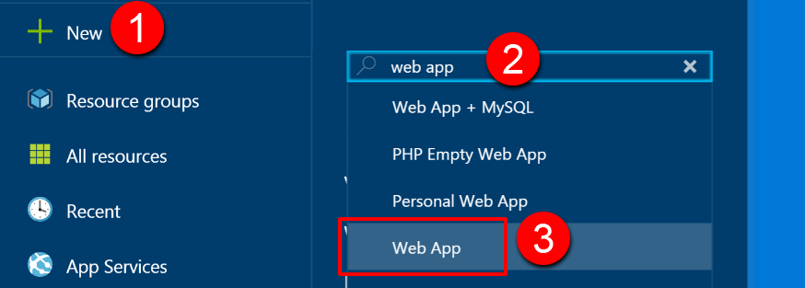

1. On the **Everything** blade, select **Web App**.

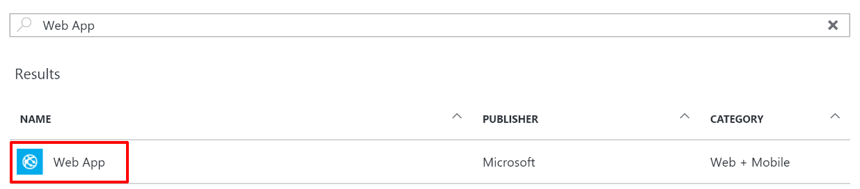

1. Click **Create**.



1. On the **Web App** blade, select **App Service name, *Configure   
   required settings***.

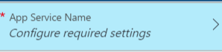

1. On the Web App blade, specify the following configuration:
   1. Specify a unique and valid URL (until the green check mark appears).
   2. Specify the **ContosoInsuranceHackathon** resource group.
   3. Specify the name **ContosoInsurancePlan** as the App Service plan and choose the same region as the Resource Group.

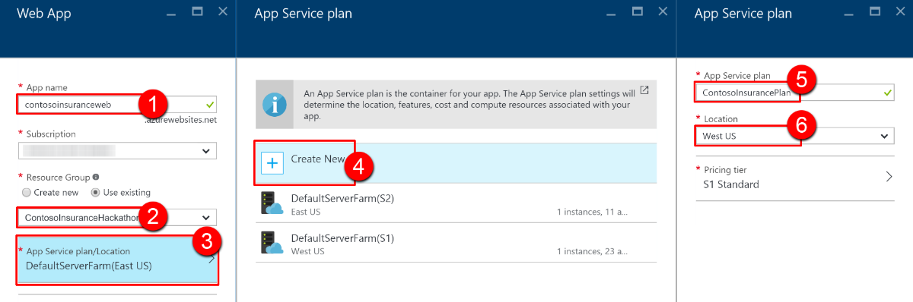

1. Click **OK** to save the configuration.



#### Subtask 2: Create the SQL server instance

We will not create the databases at this time, since it will be created during the database migration step.

1. From the Azure Management portal <http://portal.azure.com>, using a new tab or instance, navigate to create **SQL server (logical server)**.
2. Click **New**, and in the Marketplace search text box enter **SQL server**. Click the **SQL server (logical server)** item in the search results.

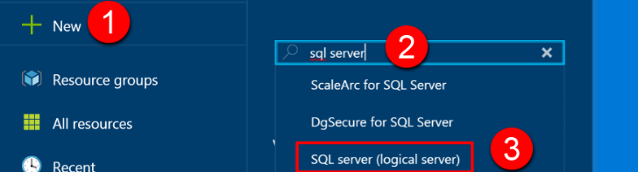

1. On the **Everything** blade, select **SQL server (logical server)**.

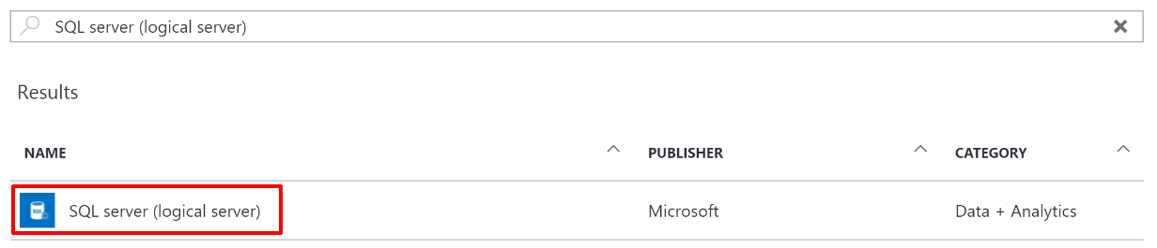

1. Click **Create**.



1. On the **SQL server (logical server)** blade, specify the following configuration:
   1. Server name: a unique value (ensure the green checkmark appears).
   2. Server admin login: **demouser**
   3. **Password** and **Confirm Password**: demo@pass123
   4. Specify the **ContosoInsuranceHackathon** resource group.
   5. Ensure the **Location** is the same region as the web app.

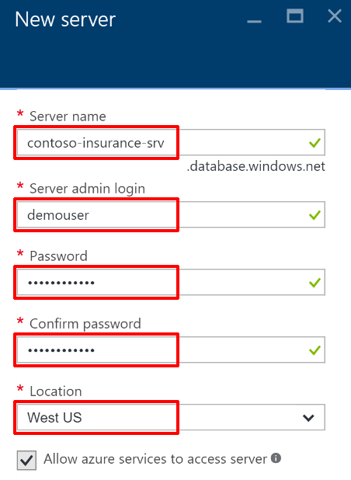

1. Once the values are accepted in the **New server** blade click **Create**.

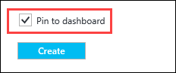

1. After the SQL Server is provisioned, browse the list of services from the portal navigation pane, then select **SQL servers** underneath DATABASES. Click the name of the SQL Server you just created.

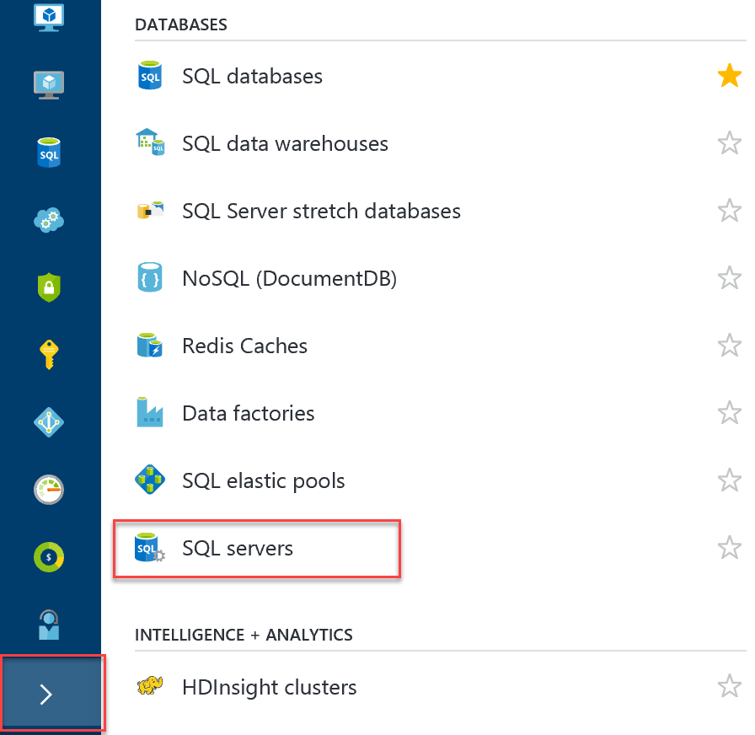

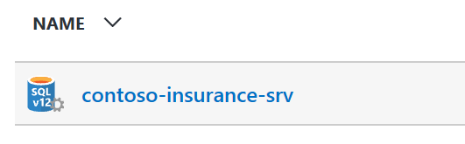

1. On the **SQL Server** blade under **Firewall**, click **Show firewall settings**.

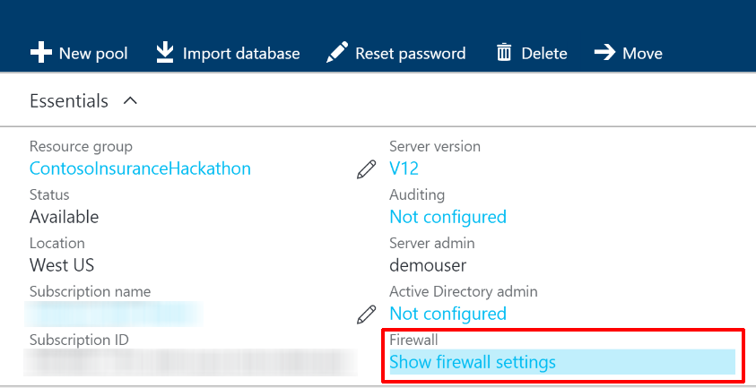

1. On the **Firewall Settings** blade, specify a new rule named **ALL**, with START IP **0.0.0.0**, and END IP **255.255.255.255**.

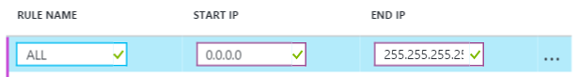  
  
**Please note:** Adding all IP address ranges as shown here is done for simplicity’s sake for this hackathon, and is **not recommended** in other cases. The correct approach is to add only the necessary IPs and consider limiting access to Azure SQL through AAD (<https://docs.microsoft.com/en-us/azure/sql-database/sql-database-aad-authentication>)

1. Click **Save**.

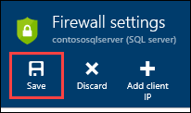

1. On the **Success!** dialog box, click **OK**.

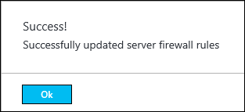

1. Close all configuration blades.

#### Subtask 3: Provision the storage account

1. Using a new tab or instance of your browser, navigate to the Azure Management portal, <http://portal.azure.com>.
2. Click **+New, Data + Storage, Storage account.**

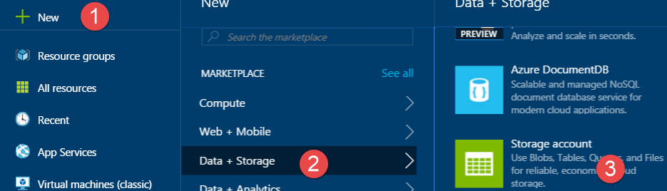

1. On the Create storage account blade, specify the following configuration options:
   1. Name: unique value for the storage account (ensure the green check   
      mark appears)
   2. Specify the Resource Group **ContosoInsuranceHackathon**.
   3. Specify the same **Location** as the resource group.

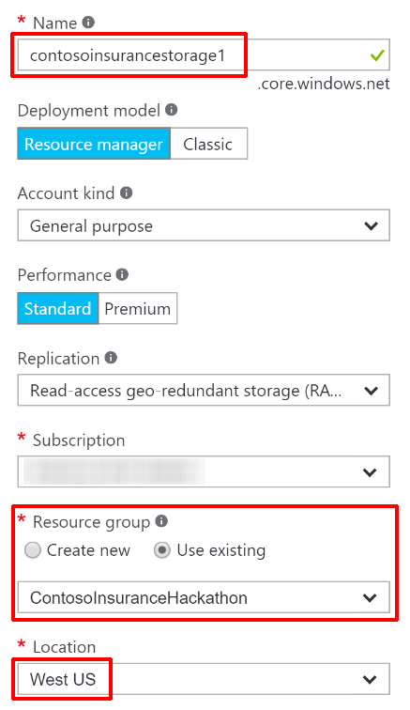

1. Click **Create**.



1. After the storage account has completed provisioning, open the storage account by clicking **Browse**, **Storage Accounts**, and then click the storage account name.



1. On the **Storage account** blade, click **All** **settings**.



1. On the **Settings** blade, select **Access Keys**.



1. On the **Access keys** blade, click the ellipse button by **key1.**

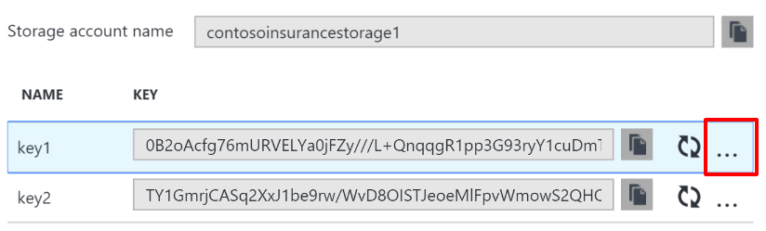

Then click **View Connection String**, and copy the value to the clipboard by selecting the value and pressing **CTRL-C**. Put the value in notepad for   
later reference.

#### Subtask 4: Provision the API App

1. Using a new tab or instance of your browser, navigate to the Azure Management portal, <http://portal.azure.com>.
2. Click **+New, Web + Mobile, API App.**

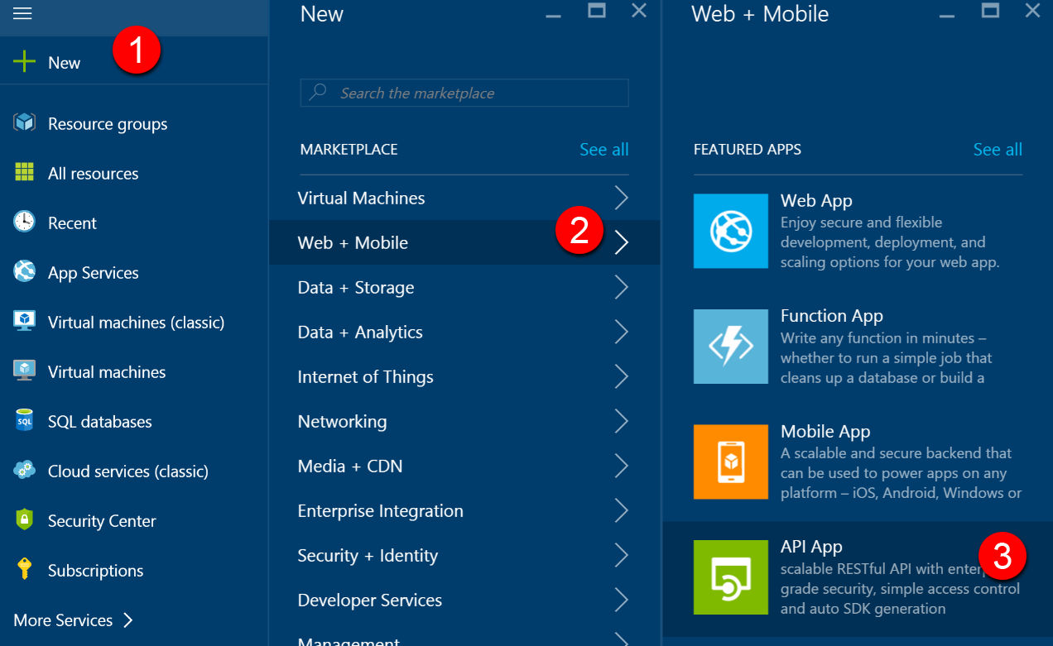

1. On the Create API App blade, specify the following configuration options:
   1. Name: unique value for the App name (ensure the green check   
      mark appears)
   2. Specify the Resource Group **ContosoInsuranceHackathon**.
   3. Select the **ContosoInsurancePlan** App Service plan.

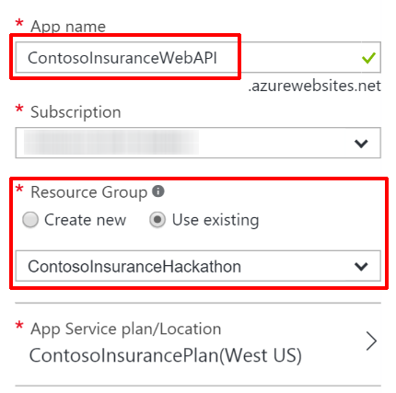

1. Click **Create**.



Subtask 5: Migrate the on-premises SQL database to Azure

1. From your VM, click on Start and then type SQL Server to select **Microsoft SQL Server Management Studio** (SSMS).
2. Once SSMS launches log in to your local SQL Express instance and expand the **Databases** node on the left-hand menu. Right-click on the **ContosoInsurance** database, then select **Tasks 🡪 Deploy Database to Microsoft Azure SQL Database…**  
   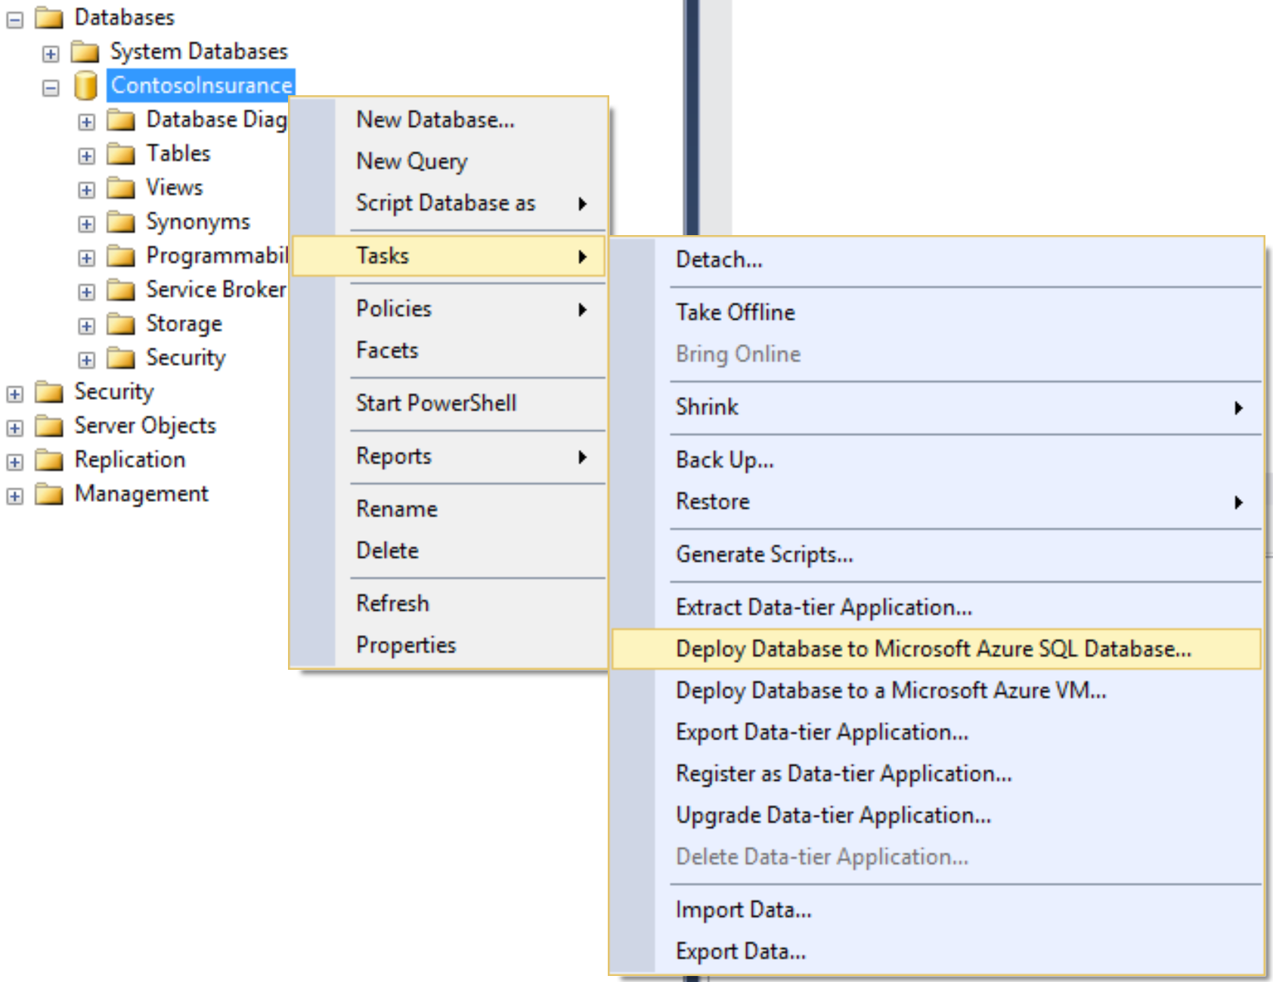
3. A dialog window named “Deploy Database ‘ContosoInsurance’” will appear. Click **Next** to begin.
4. Within the Deployment Settings section, click on the Connect button next to the Server connection box.

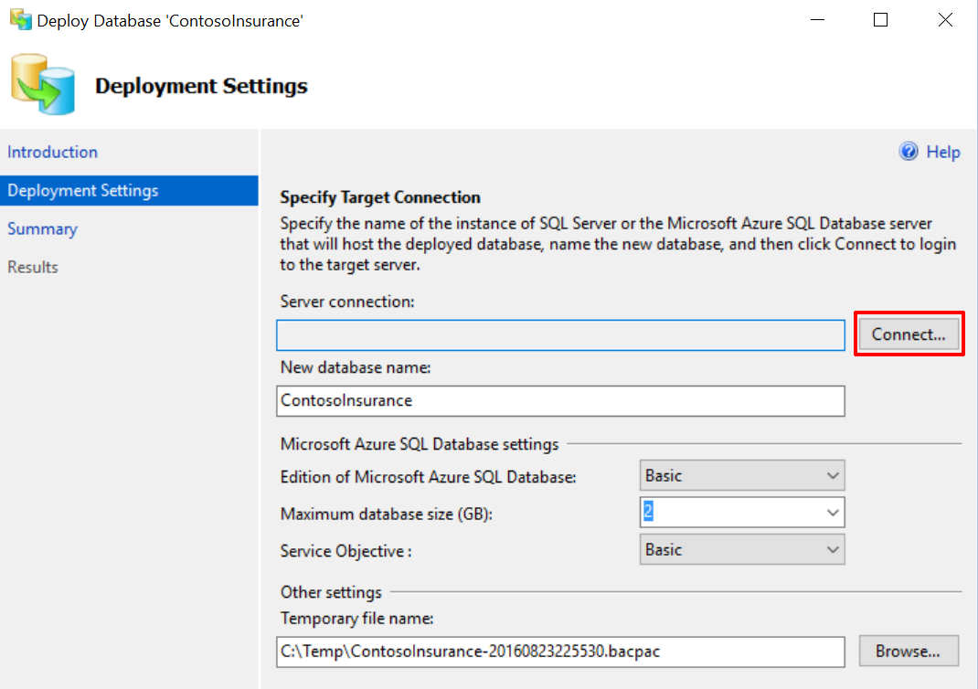

1. In the SQL Server connection dialog box, enter the Azure SQL server name you created in while provisioning the database. If in doubt, you can refer to the server name from your resources list in Azure.
   1. Enter the username: **demouser**
   2. Enter the password you created: **demo@pass123**  
        
      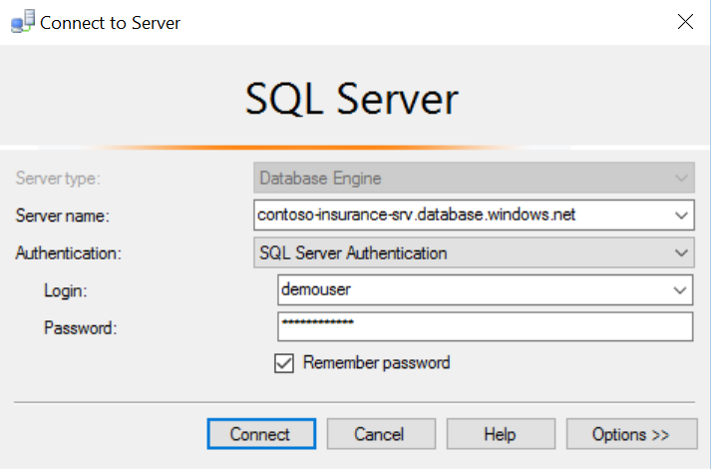
   3. Click **Connect**.
2. You should now see the Azure SQL server name in the Server connection box. Verify the new database name is **ContosoInsurance** and click **Next**.  
   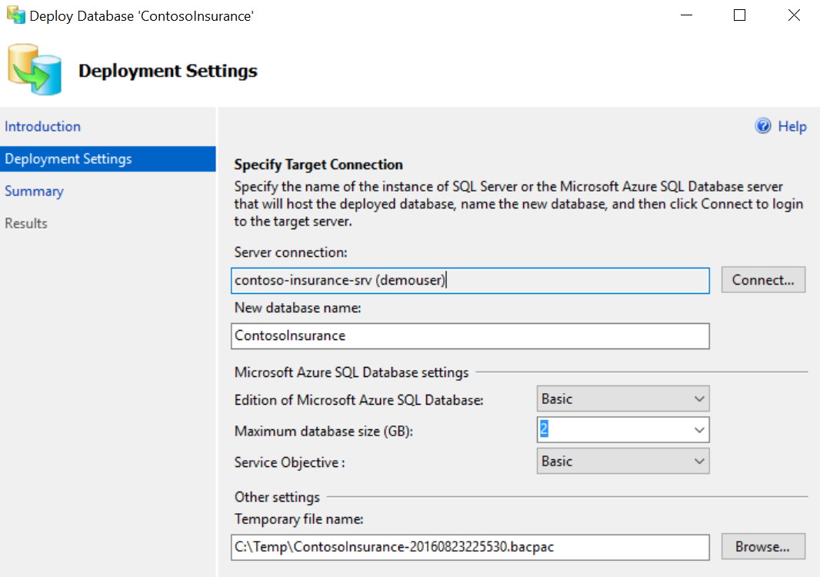
3. Verify the specified settings are correct, and then click **Finish**.
4. Once the operation has completed, close the database deployment dialog. You should see green checkmarks next to each completed step, along with a large checkmark next to “Operation Complete”.  
   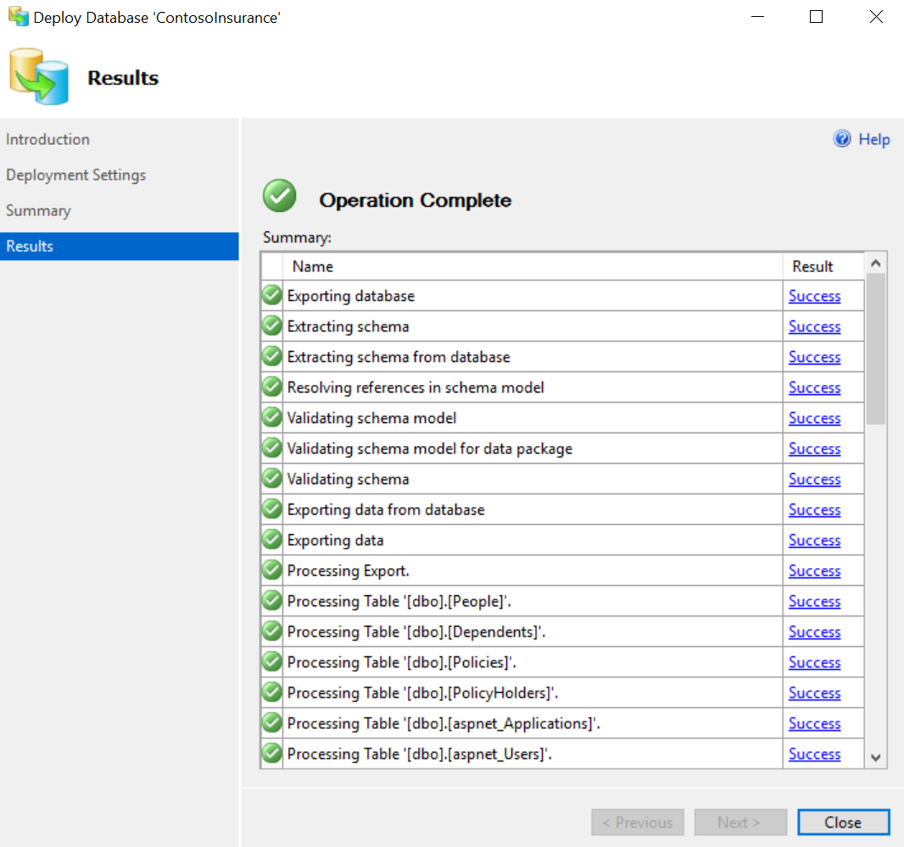
5. Verify that the database is operational and its tables populated by connecting to it through SSMS, using the same credentials used in Step 5 above.
6. Go back to the Azure Portal, and then find the ContosoInsurance database that was created during the migration, by going to **All resources**, then typing in **ContosoInsurance**.  
     
   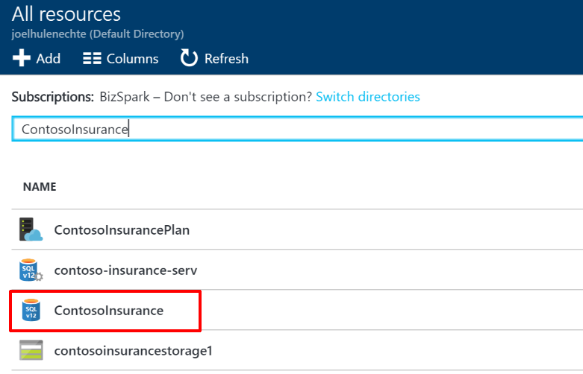
7. Click on **Show database connection strings**, and then click the **copy** button next to the ADO.NET connection string. Save the connection string for later.  
   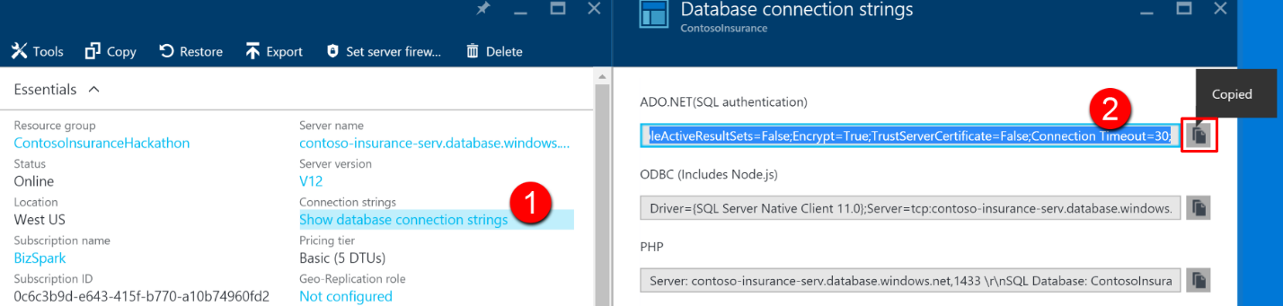

## Exercise 3: Identity and security

### Overview

Azure Active Directory will be used to allow users to authenticate to the web app, PolicyConnect desktop app, mobile apps, and PowerApps solutions. Azure AD will also be used to manage application access to Key Vault secrets. You have been asked to create a new Azure AD Tenant and secure the application so only users from the tenant can log on.

### Help references

|  |  |
| --- | --- |
| What is Azure AD? | <https://azure.microsoft.com/en-us/documentation/articles/active-directory-whatis/> |
| Azure Web Apps authentication | <http://azure.microsoft.com/blog/2014/11/13/azure-websites-authentication-authorization/> |
| View your access and usage reports | <https://msdn.microsoft.com/en-us/library/azure/dn283934.aspx> |

Note: Tasks 1 and 2 require global admin permissions on the Azure AD Tenant. Task 3 requires the permission to create an app in the Azure AD tenant. Task 1 and 2 cannot be completed if you use Microsoft’s Azure AD tenant.

### Task 1: Create a new Contoso user

Note: This task is valid only if you are a global administrator on the Azure AD tenant associated with your subscription.

1. Open the Azure Classic Portal by launching a browser and navigating to <https://manage.windowsazure.com>.
2. Select ACTIVE DIRECTORY from the left-hand menu.
3. Select your Active Directory Tenant for your subscription, for which you are a Global Administrator.  
   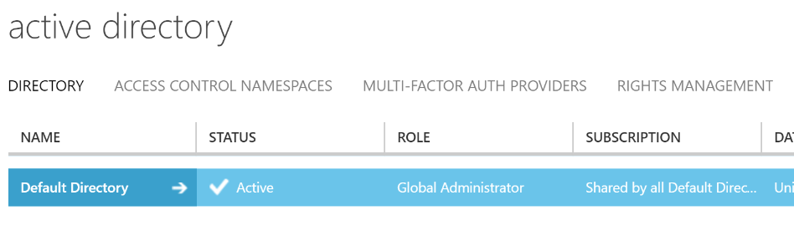
4. Within your new Active Directory Tenant, click **Users**.



1. Click **Add User**.  
   
2. Specify the user’s **User Name** and click the circled **next arrow** to continue.   
   Note the full user account for later use.   
   **Example:** contosouser@[your tenant].onmicrosoft.com.

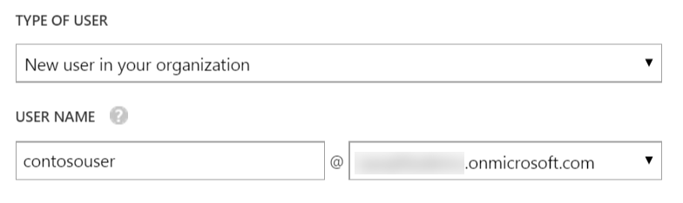

1. Specify user information for your user and click the **next arrow** to continue.

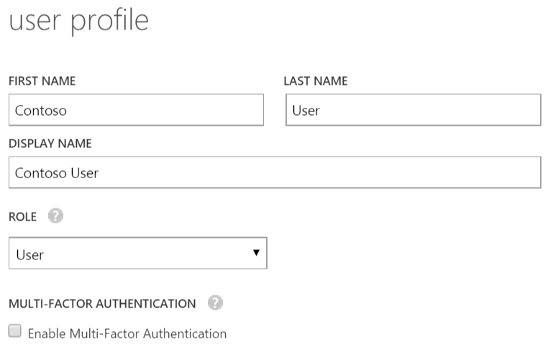

1. Click **Create** and note the temporary password for later reference.

  
Select the circled check mark to finish.

### Task 2: Add the Web API application

1. Within your Active Directory Tenant, click **Applications**.  
   
2. Click **Add** on the command bar.  
   
3. In the **ADD APPLICATION** wizard, on the **What do you want to do?** page, click **Add an application my organization is developing**.
4. On the **Tell us about your application** page, specify **Contoso Insurance Web API** for your application, and then select **WEB APPLICATION AND/OR WEB API** (the default). Click the **Next** icon.
5. On the **App properties** page, specify the **SIGN-ON URL** and **APP ID URI** for your web application. Since our application does not have these values, you can enter the App service URI. Enter http://<your web api name>.azurewebsites.net (replace **<your web api name>**) for both boxes. It does not matter if these paths are exact; what is important is that the app ID URI for each application is different for every application in your directory. The directory uses this string to identify your app.  
   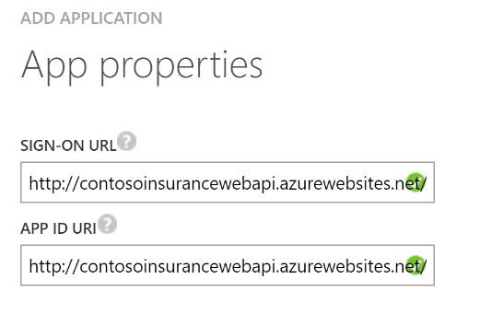
6. Click the **Complete** icon to save your changes in the wizard.
7. On the **Quick Start** page, click **CONFIGURE**.
8. Scroll to the **keys** section, select the duration and then click **SAVE**. The page refreshes and now shows a key value. You must configure your application with this key value and the **CLIENT ID** value. (Instructions for this configuration will be application-specific.)
9. Under the **single sign-on** section, copy the **APP ID URI** and **REPLY URL** values and save them for later.
10. Add another **REPLY URL**, this time with an https in front. This will allow access via https without throwing “*does not match the reply addresses configured for the application*” errors later on.  
    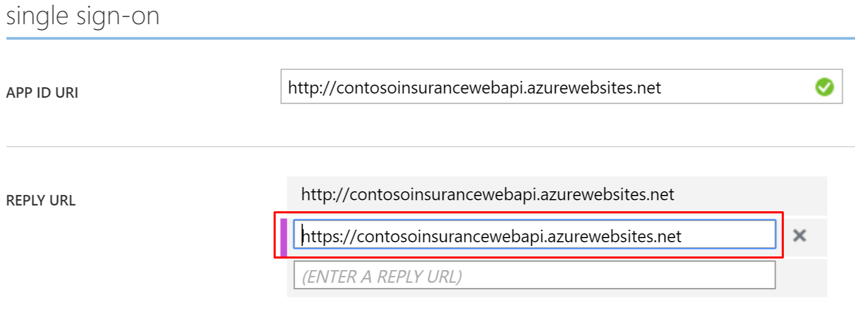
11. Click the **Save** button.
12. Copy the **Client ID** value from this page, as well as the generated **key**. **Save these values for later.**

DO NOT miss this step! You will not be able to retrieve the key value after leaving this page!

### Task 3: Expose Web API to other applications

In order to make the Web API accessible to other applications added to Azure Active Directory, we must define the appropriate permissions. We will modify the manifest for Web API to make configure these settings, since, as of now; the Azure management portal does not provide an interface for this.

1. Within your Active Directory Tenant, click **Applications**.  
   
2. Click on the name of the Web API application you just added (Contoso Insurance Web API).
3. At the bottom of the screen, click **MANAGE MANIFEST** and select the **Download Manifest** option to save it to your local computer.  
     
   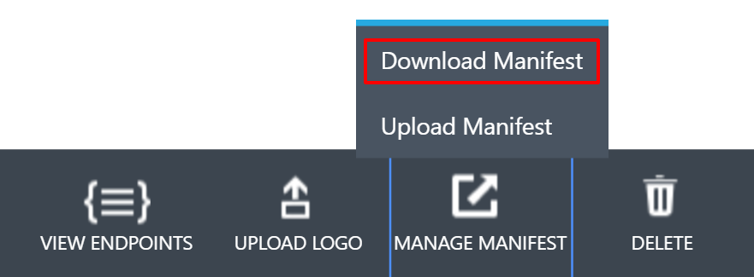
4. Open the downloaded manifest in a text editor, or Visual Studio.
5. Look for the **oauth2AllowImplicitFlow** setting. Change the value to **true**. This is required for our javascript web api service calls from the web application.
6. Look for the **oauth2Permissions** setting. Either this will be pre-populated with a value, or it will be empty.  
     
   Pre-populated:  
   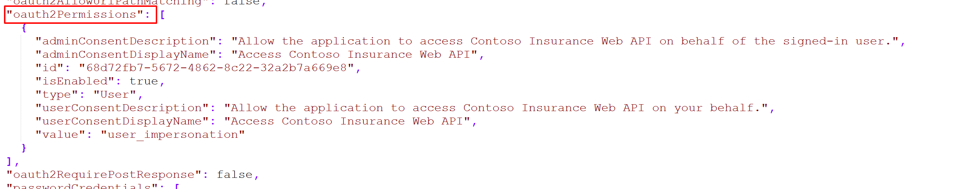  
     
   Empty:  
   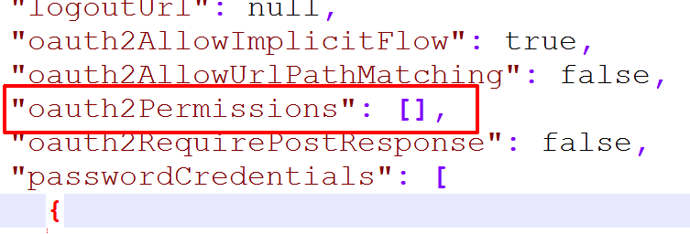  
     
   We need to add **one new permission** to this array:  
   {

"adminConsentDescription": "Allow read-write access to the Contoso Insurance Web API on behalf of the signed-in user",

"adminConsentDisplayName": "Read-Write access to Contoso Insurance Web API",

"id": "**494581dd-4bf5-451d-9bf8-487f4a43a09c**",

"isEnabled": true,

"origin": "Application",

"type": "User",

"userConsentDescription": "Allow read-write access to the Contoso Insurance Web API on your behalf",

"userConsentDisplayName": "Read-Write access to Contoso Insurance Web API",

"value": "Read_Write_ContosoInsurance_WebAPI"

}  
  
Make sure that you enter a new, generated Guid into the **id** property (in bold above). You can generate a new Guid by opening PowerShell and running the following command:  
  
[guid]::NewGuid()  
  
The final result should look like this:  
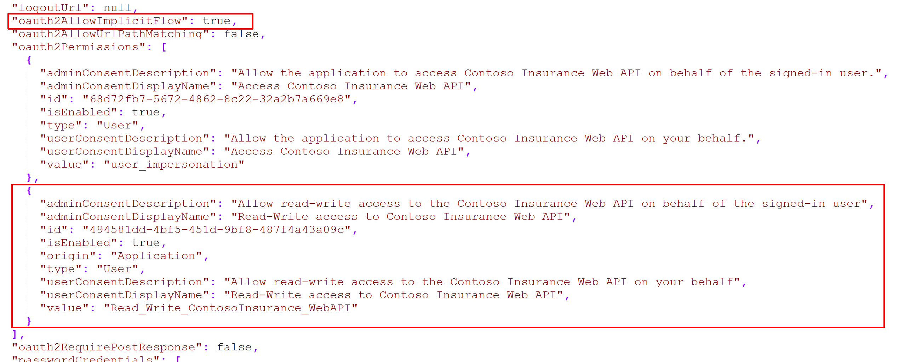

1. Save the file and upload it to Azure by clicking the **MANAGE MANIFEST** button and selecting the **Upload Manifest** option.  
   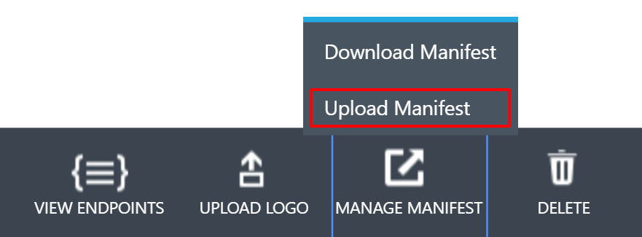

### Task 4: Add the ContosoInsurance Desktop (WinForms) application

1. Within your Active Directory Tenant, click **Applications**.  
   
2. Click **Add** on the command bar.  
     
   
3. In the **ADD APPLICATION** wizard, on the **What do you want to do?** page, click **Add an application my organization is developing**.
4. On the **Tell us about your application** page, specify **Contoso Insurance Desktop** for your application, and then select **NATIVE CLIENT APPLICATION** (the default). Click the **Next** icon.  
   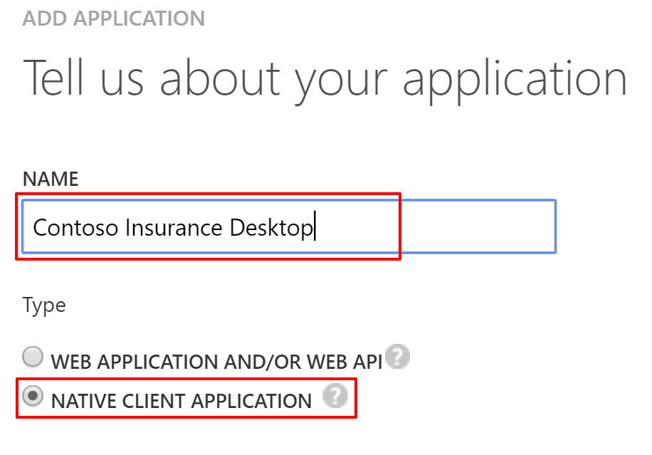
5. On the **App properties** page, specify the **REDIRECT URI** for your desktop application. Since our application does not have these values, you can enter the any unique URI. Enter http://contosoinsurance.desktop.client into the Redirect URI box. It does not matter if this path is exact; what is important is that the app ID URI for each application is valid and different for every application in your directory. The directory uses this string to identify your app.  
   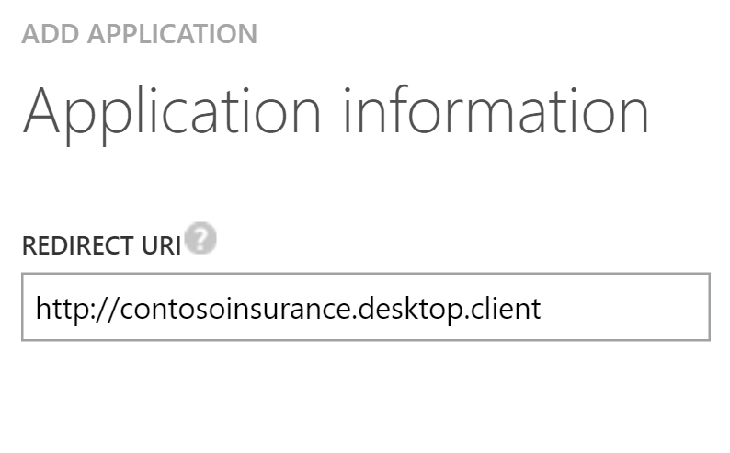
6. Click the **Complete** icon to save your changes in the wizard.
7. On the **Quick Start** page, click **CONFIGURES**.
8. Copy the **Client Id** and **Redirect URI** and save for later.
9. Scroll to the **permissions to other applications** section, and click on the **Add application** button.
10. In the **Permissions to other applications** window, select **ALL APPS** from the SHOW dropdown, type in **contoso** in the STARTING WITH field, then click the checkmark to the right to search. From the search results below, click on the **Contoso Insurance Web API** entry, then click the checkmark on the bottom of the form to finish.  
    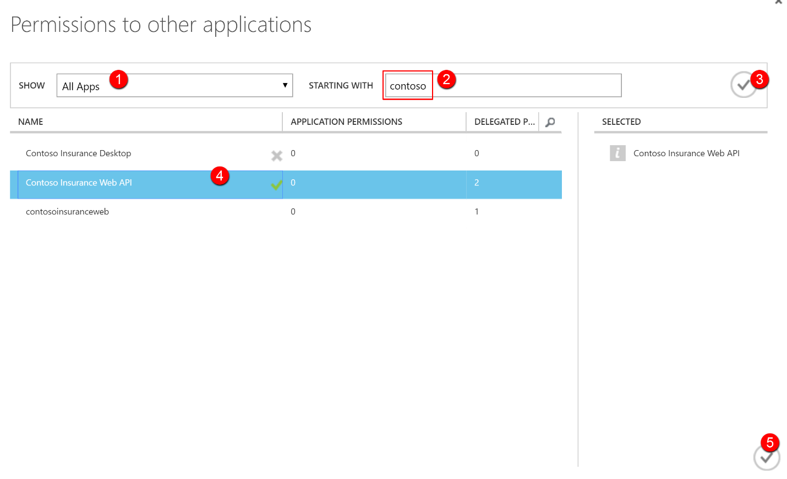
11. You will now see the Contoso Insurance Web API application listed underneath the permissions to other applications section. Click the dropdown next to the application name, and check the Read-Write access to Contoso Insurance Web API permission that we added through the manifest.  
    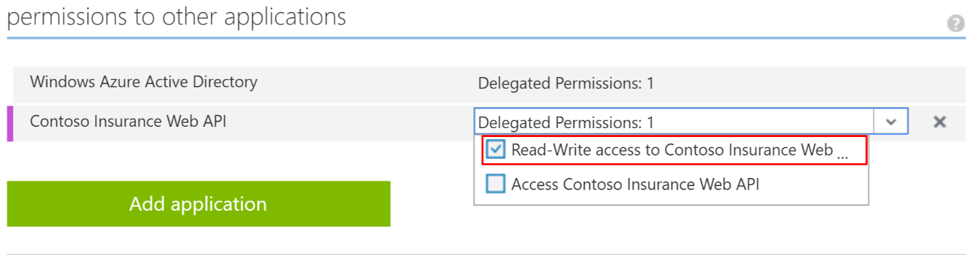
12. Click the Save button at the bottom of the screen.  
    
13. **BONUS:** From this screen, click the Upload Logo button.  
    

Browse to the Hackathon folder on your local drive (C:\Hackathon). Find the Graphics folder and select the file named **CI-Icon-215x215.png**. You will now have the Contoso Insurance logo associated with the Desktop application!

### Task 5: Add the mobile application

1. Within your Active Directory Tenant, click **Applications**.  
   
2. Click **Add** on the command bar.  
     
   
3. In the **ADD APPLICATION** wizard, on the **What do you want to do?** page, click **Add an application my organization is developing**.
4. On the **Tell us about your application** page, specify **Contoso Insurance Mobile** for your application, and then select **NATIVE CLIENT APPLICATION** (the default). Click the **Next** icon.  
   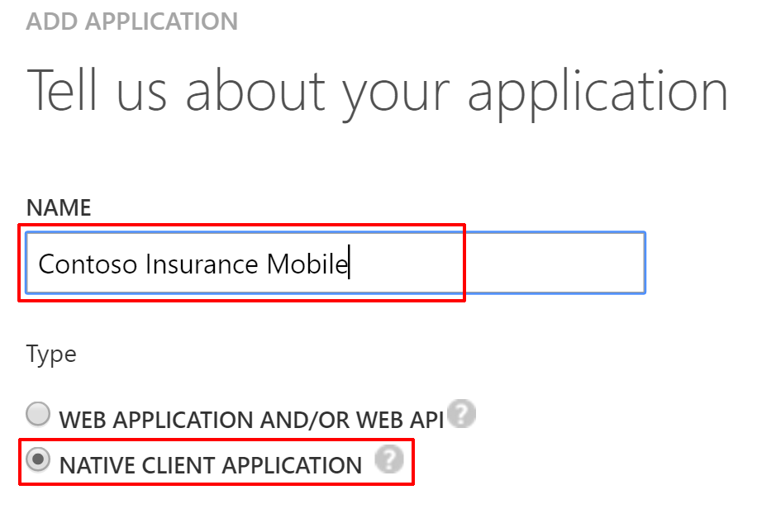
5. On the **App properties** page, specify the **REDIRECT URI** for your desktop application. Since our application does not have these values, you can enter the any unique URI. Enter http://contosoinsurance.mobile.client into the Redirect URI box. It does not matter if this path is exact; what is important is that the app ID URI for each application is valid and different for every application in your directory. The directory uses this string to identify your app.  
   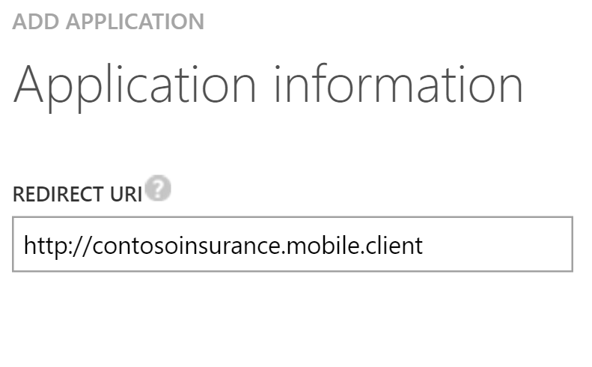
6. Click the **Complete** icon to save your changes in the wizard.
7. On the **Quick Start** page, click **CONFIGURES**.
8. Copy the **Client Id** and **Redirect URI** and save for later.
9. Scroll to the **permissions to other applications** section, and click on the **Add application** button.
10. In the **Permissions to other applications** window, select **ALL APPS** from the SHOW dropdown, type in **contoso** in the STARTING WITH field, then click the checkmark to the right to search. From the search results below, click on the **Contoso Insurance Web API** entry, then click the checkmark on the bottom of the form to finish.  
    
11. You will now see the Contoso Insurance Web API application listed underneath the permissions to other applications section. Click the dropdown next to the application name, and check the Read-Write access to Contoso Insurance Web API permission that we added through the manifest.  
    
12. Click the Save button at the bottom of the screen.  
    
13. **BONUS:** From this screen, click the Upload Logo button.  
    

Browse to the Hackathon folder on your local drive (C:\Hackathon). Find the Graphics folder and select the file named **CI-Icon-215x215.png**. You will now have the Contoso Insurance logo associated with the Mobile application!

### Task 6: Configure access control for the PolicyConnect web application

1. Open the Azure Management Portal, <https://portal.azure.com>.
2. On the left navigation, click **App Services** (or click Browse and then click   
   **App Services**.



1. On the **web apps** page select the **ContosoInsurance web app**.
2. Click the **Authentication / Authorization** tile underneath the list of settings.



1. Change **App Service Authentication to On**, change the dropdown to **Log in with Azure Active Directory**, and click the **Azure Active Directory Authentication Provider**.

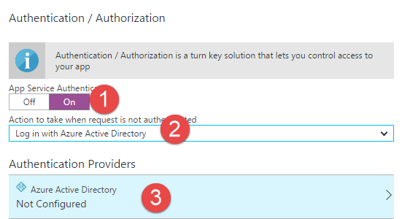

1. Change **Management mode** to **Express**, and then click **OK**.

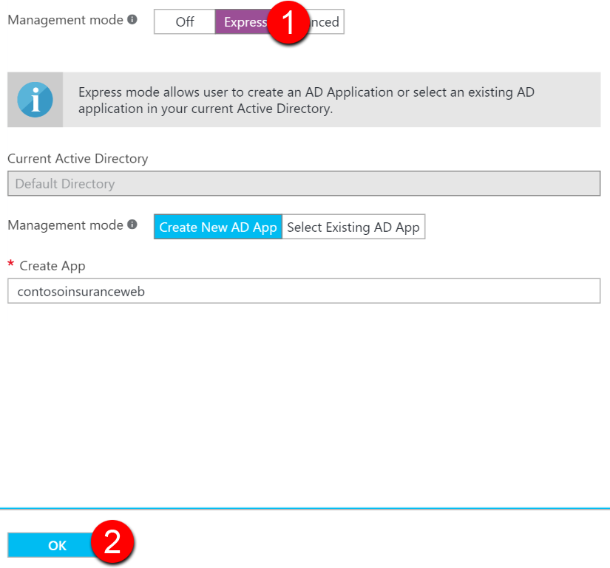

1. In the **Authentication / Authorization** blade click **Save**.

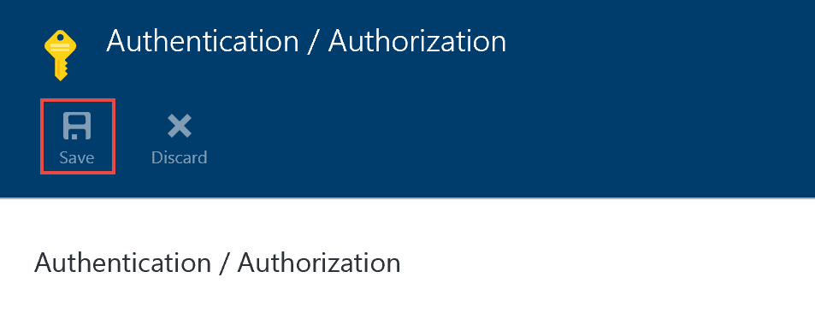

### Task 7: Grant the ContosoInsurance Web app permissions to the Web API app

1. Open the Azure Classic Portal by launching a browser and navigating to <https://manage.windowsazure.com>.
2. Select ACTIVE DIRECTORY from the left-hand menu.
3. Select your Active Directory Tenant.
4. Within your Active Directory Tenant, click **Applications**.  
   
5. Select your ContosoInsurance Web application, which was automatically added to AAD in the previous task.  
   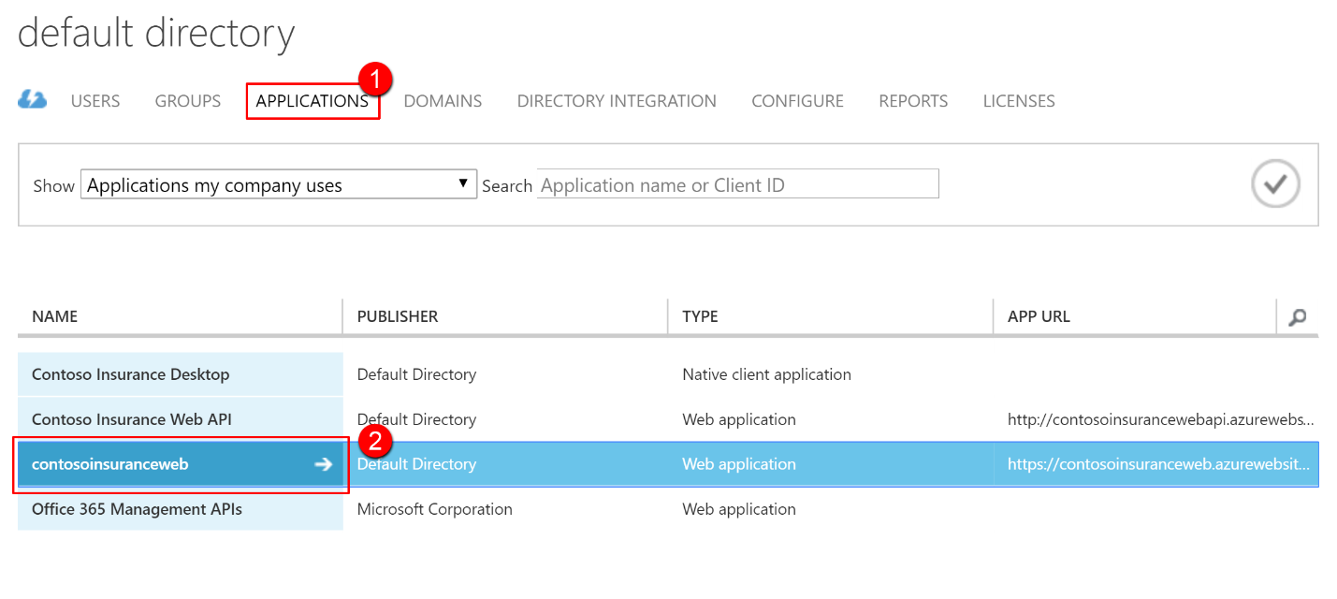
6. On the **Quick Start** page, click **CONFIGURES**.
7. Scroll to the **permissions to other applications** section, and click on the **Add application** button.
8. In the **Permissions to other applications** window, select **ALL APPS** from the SHOW dropdown, type in **contoso** in the STARTING WITH field, then click the checkmark to the right to search. From the search results below, click on the **Contoso Insurance Web API** entry, then click the checkmark on the bottom of the form to finish.  
   
9. You will now see the Contoso Insurance Web API application listed underneath the permissions to other applications section. Click the dropdown next to the application name, and check the Read-Write access to Contoso Insurance Web API permission that we added through the manifest.  
   
10. OPTIONAL: If you intend to debug the web app locally from within Visual Studio, you will need to add the **localhost** path (http://localhost:10421/static) to the list of REPLY URLs under the single sign-on section of this page. Otherwise, your AAD auth to the Web API will fail:  
    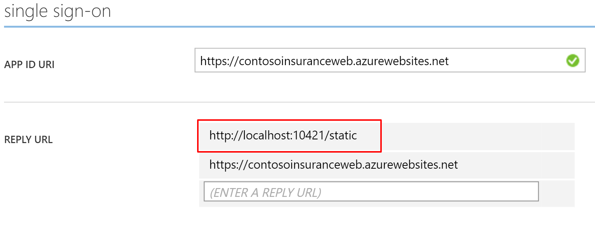
11. Click the Save button at the bottom of the screen.  
    

## Exercise 4: Configure blob storage and search indexing

### Overview

Contoso Insurance is currently storing all of their scanned PDF documents on a local network share. They have asked to enable full-text searching on the documents, and to be able to store them automatically from a workflow. We have already provisioned a storage instance that we will use to store the files in a blob container. First, we need a way to bulk upload their existing PDFs, then configure search indexing on that container.

### Help references

|  |  |
| --- | --- |
| Transfer data with the AzCopy command-line utility | [https://azure.microsoft.com/en-us/documentation/articles/storage-use-azcopy/#blob-upload](https://azure.microsoft.com/en-us/documentation/articles/storage-use-azcopy/%23blob-upload) |
| Download AzCopy | <http://aka.ms/downloadazcopy> |
| Create an Azure Search service using the Azure Portal | <https://azure.microsoft.com/en-us/documentation/articles/search-create-service-portal/> |
| Indexing Documents in Blob Storage | <https://azure.microsoft.com/en-us/documentation/articles/search-howto-indexing-azure-blob-storage/> |
| Portal support for Azure Search blob and table indexers | <https://azure.microsoft.com/en-us/blog/portal-support-for-azure-search-blob-and-table-indexers-now-in-preview/> |

### Task 1: Bulk upload PDFs to blob storage

1. Create a new container for the scanned PDF policy documents. From the new Azure portal, go to **All resources** and click on the Contoso Insurance storage account you created earlier. From the storage Overview page, click on **Blobs** under services.  
   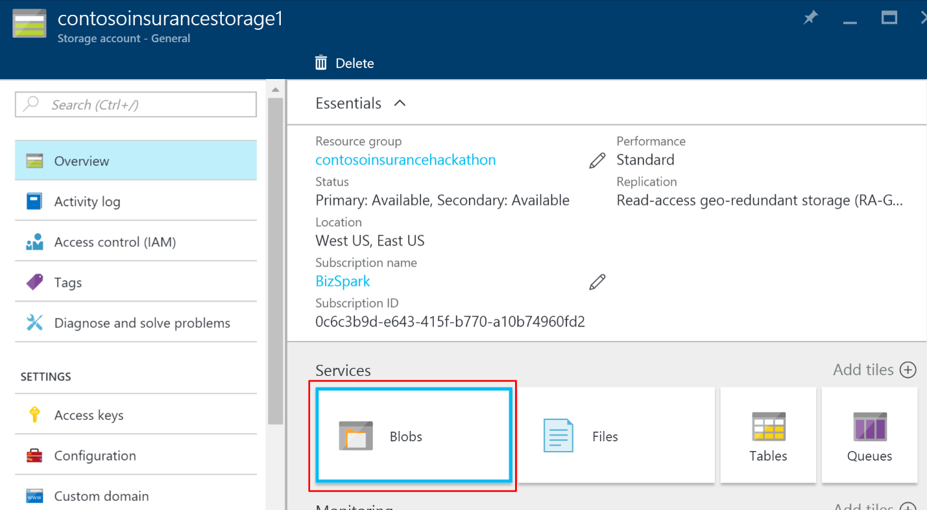
2. Click on the **+ Container** button to create a new container.
3. In the New Container window, type **policies** as your container name, and set the Access type as **Container** (set to Container for demo purposes; otherwise set to Private). Click **Create**.  
   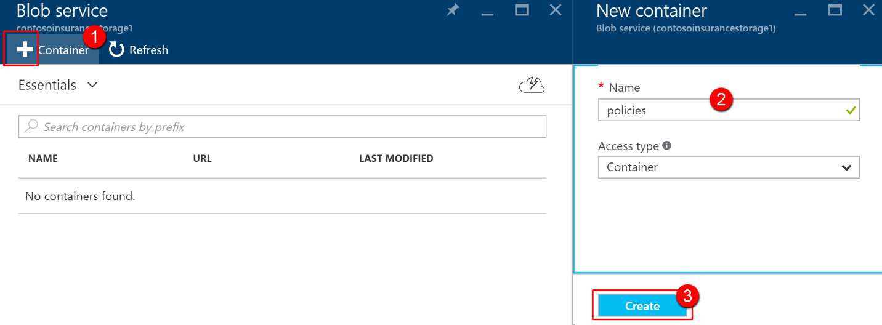
4. After the container has been created, click on the container name.
5. Click **Properties**.  
   
6. Click on the **copy** button next to the URL and **save it**.  
   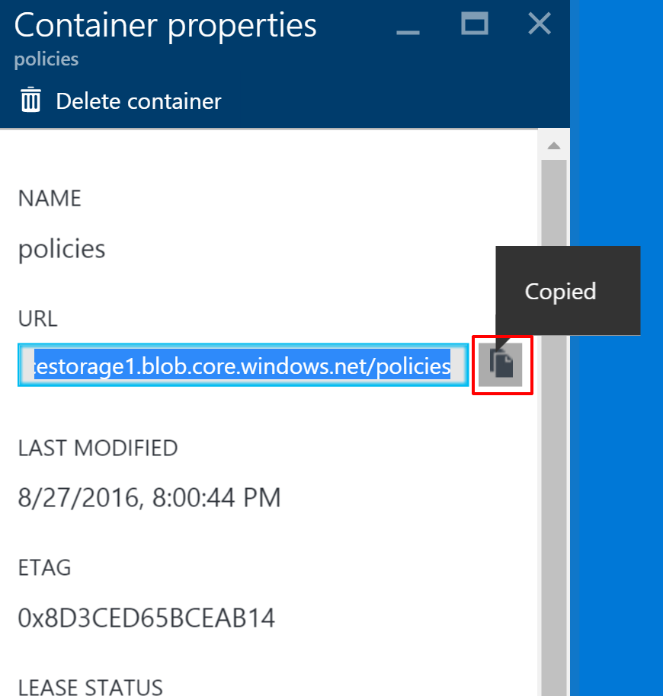
7. Download the latest version of AzCopy from <http://aka.ms/downloadazcopy>.
8. After installing, launch a new **command prompt** window (Click on Start, then type **cmd** and hit enter).
9. Browse to the AzCopy directory. By default, it is installed to %ProgramFiles(x86)%\Microsoft SDKs\Azure\AzCopy (64-bit Windows) or %ProgramFiles%\Microsoft SDKs\Azure\AzCopy (32-bit Windows).
10. Type in the following command, replacing the **bold** values with your own:  
      
    AzCopy /Source:**C:\Hackathon\Files** /Dest:**https://contosoinsurancestorage1.blob.core.windows.net/policies** /DestKey:**DaINeh6zmORuR+OOMDoG7SmtQSiJznk75hqFlB9b0kUVgyobb7y1Txzb1iQGjvdFDsgxLQtgVMBPy0h5ZEaHOw==** /S  
      
    The **Source** value is the current location of the PDF files. The **Dest** value is the URL for the blob container you copied on step 6. The **DestKey** is the blob storage Account Key you saved after creating the storage account. If you cannot find it, go to Access keys after opening your storage account on the new portal. Copy either key1 or key2.  
    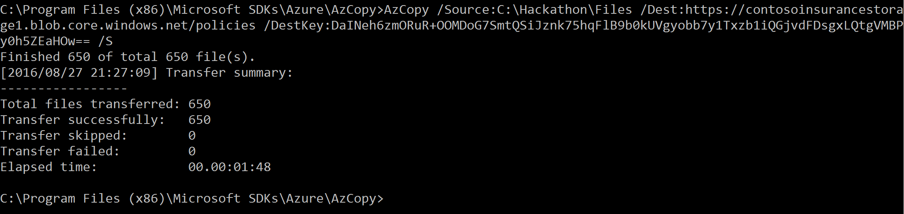

### Task 2: Create an Azure Search service

1. Using a new tab or instance of your browser, navigate to the Azure Management portal, <http://portal.azure.com>.
2. Click **+New, Data + Storage, Azure Search.**

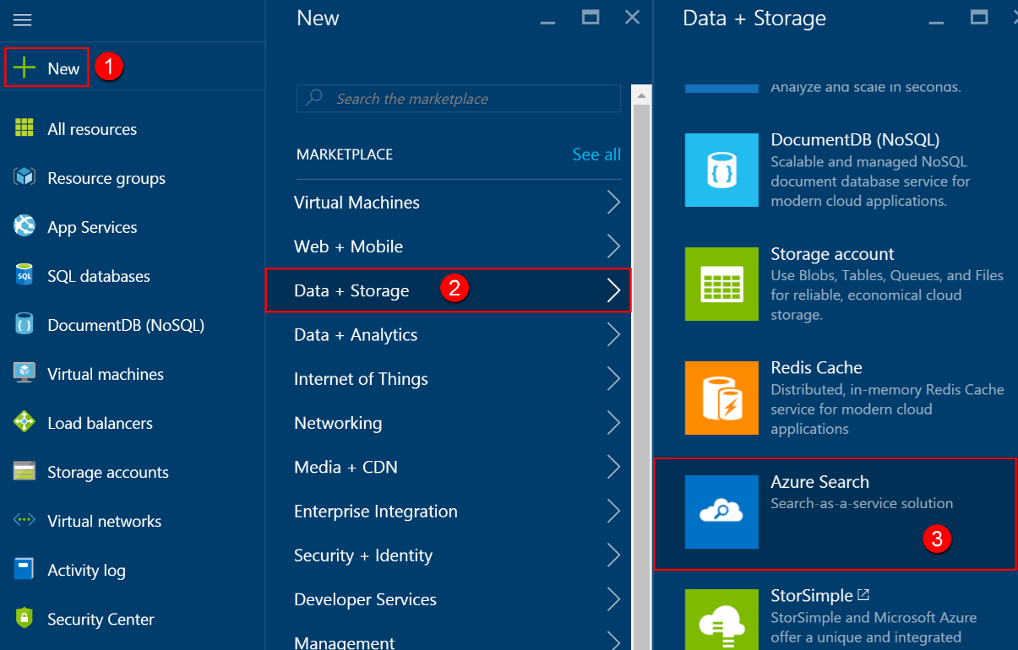

1. On the Create API App blade, specify the following configuration options:
   1. Name: unique value for the URL (ensure the green check   
      mark appears)
   2. Specify the Resource Group **ContosoInsuranceHackathon**.
   3. Select the same location as your other services within the Resource Group.  
      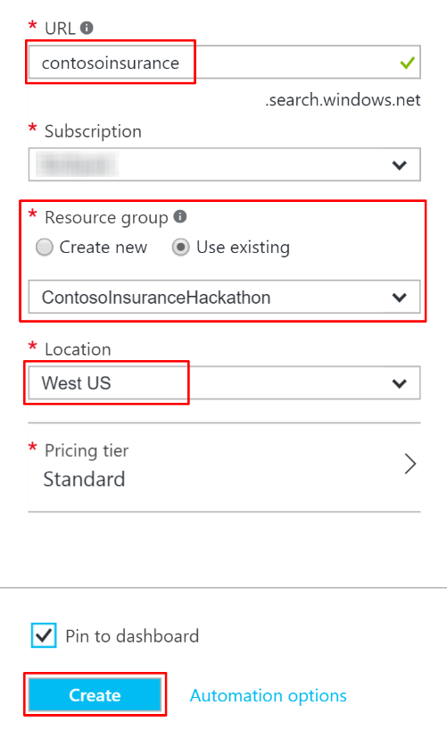
2. Click **Create**.

### Task 3: Configure full-text search indexing

1. Select the newly created search service, and then click on **Import data**.  
   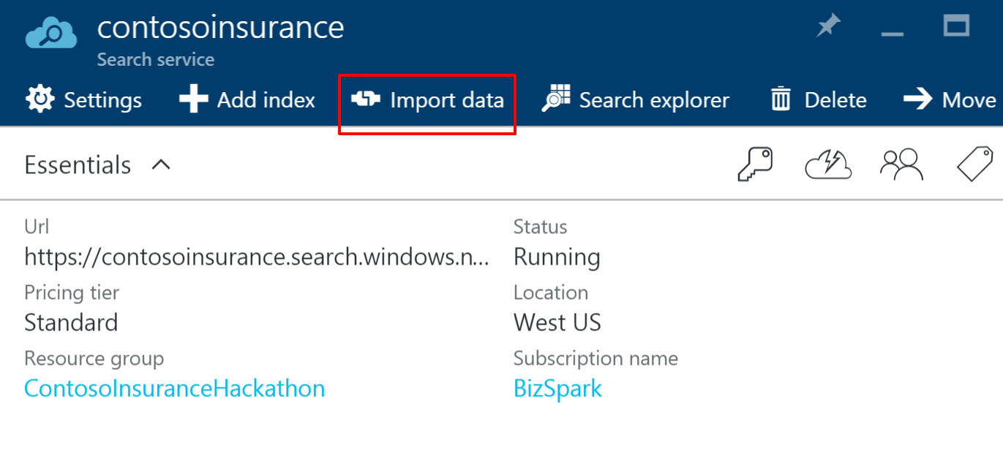
2. Within the Import data window, click on **Connect to your data**. Then, within the Data Source window, click on **Azure Blob Storage**. Now, within the New data source window, enter a unique, lowercased name, such as **scanned-policies**. Now, click on **Select an account and container**.  
   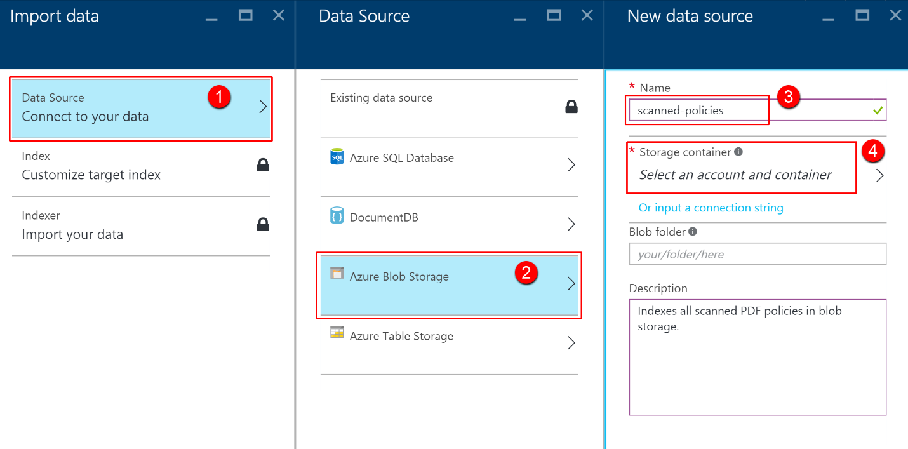
3. Under Storage accounts, click on the storage account you created earlier. Now click on the **policies** container under the Containers blade, and then **Select**.  
   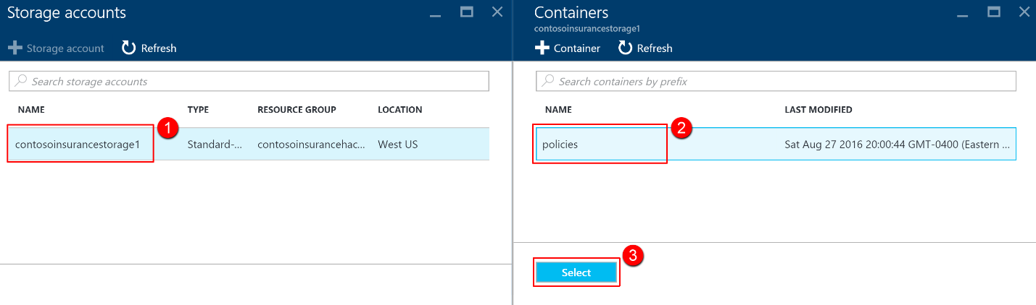
4. Now click **OK**.  
   
5. After the data source has been sampled, you will be presented with a new Index blade. During the sampling process, many of our metadata fields were detected, and now the suggested indexes are displayed. The blob indexer has the ability to crack open your documents and extract all text into the content field as well.  
     
   Within the Index blade, type in a name for the index, such as **policies**. Select **metadata_storage_path** for the Key, if not already selected.  
     
   Set the following fields as Retrievable, Filterable, and Searchable:  
   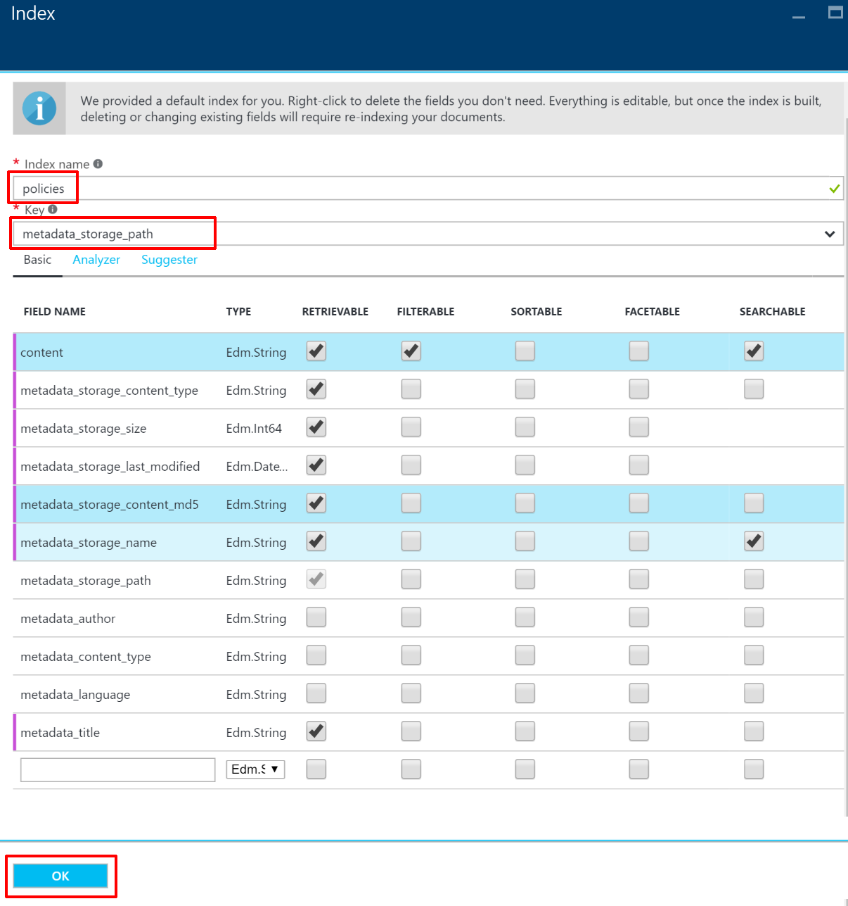
6. Click **OK**.
7. Within the Create an Indexer blade, type in a lower-case name, such as **policy-indexer**. Select **Custom** under Schedule, and then enter **5** as the interval in minutes (this is the minimum number, and will make testing easier later on). Enter **today’s date** as the Start date, and **12:00:00 AM** as the time. Click OK.  
   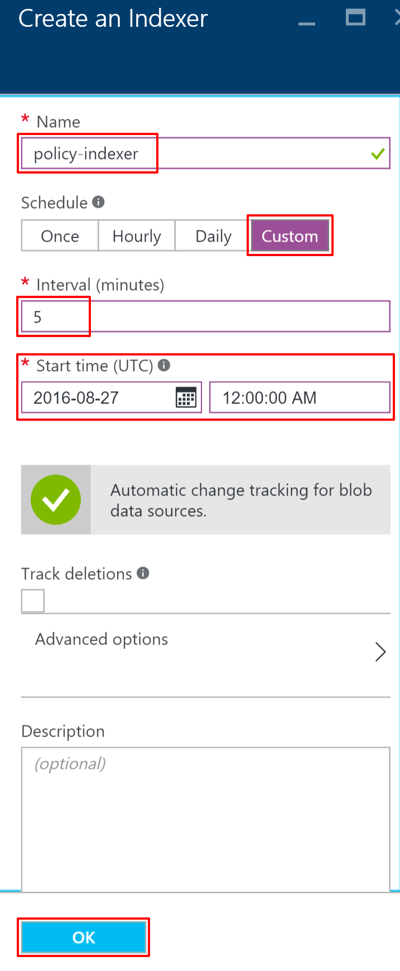
8. Click **OK** once again to complete your changes.  
   
9. After a few minutes, you should see a document count matching the number of PDFs next to the **policies** index you created, on the Search service home screen. Click on this index, and then click on the **Edit CORS options** menu item.  
   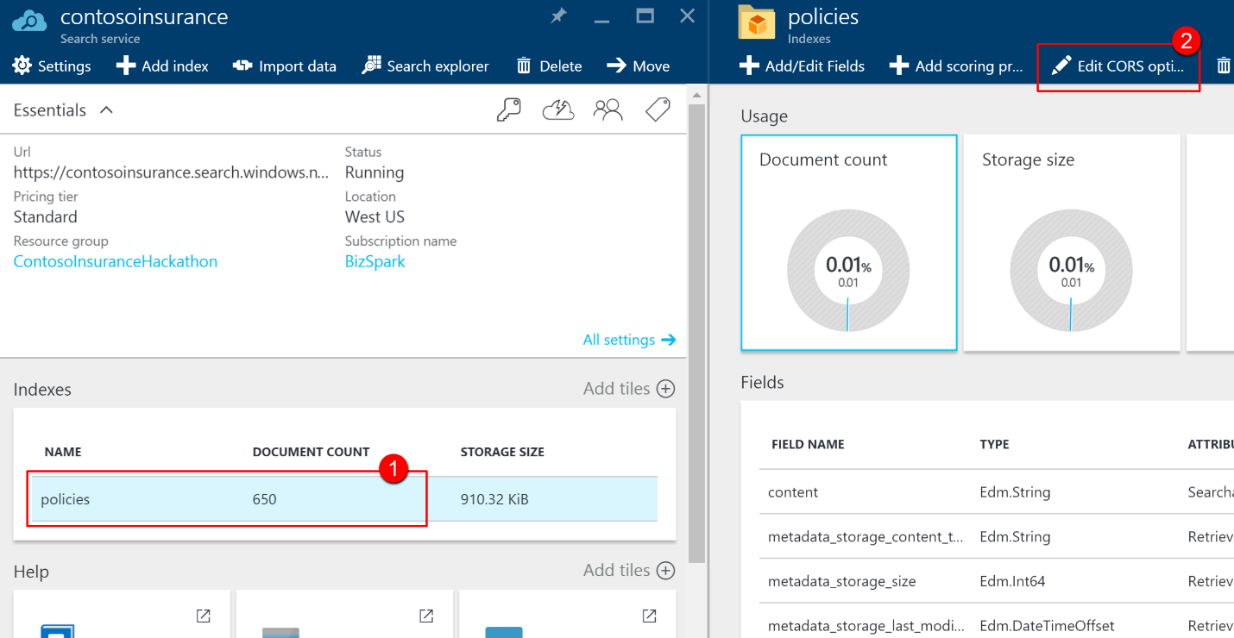
10. Select the Allowed origin type to **All**, then click **Save**. This will allow external applications to perform searches against the index. *When running in production, it is strongly recommended to select Custom and manually specify allowed sources by URL*.  
    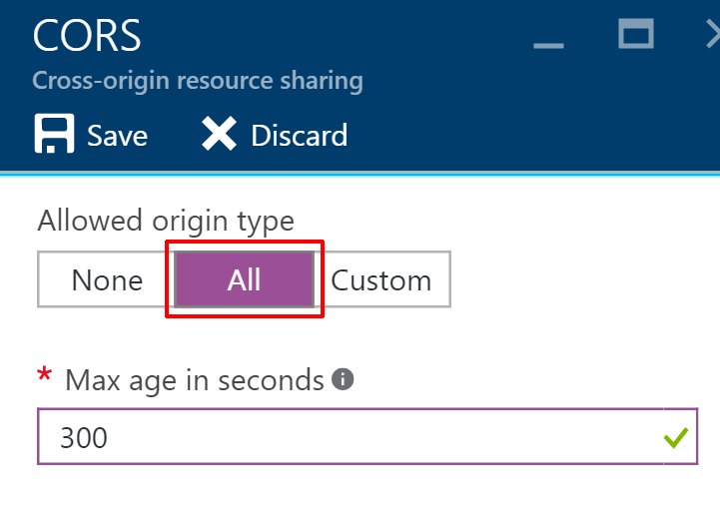
11. Back on the Search service home page, click the **policy** index once again, if all 600+ documents have been indexed. Now click on the **Search explorer** menu item on top.  
    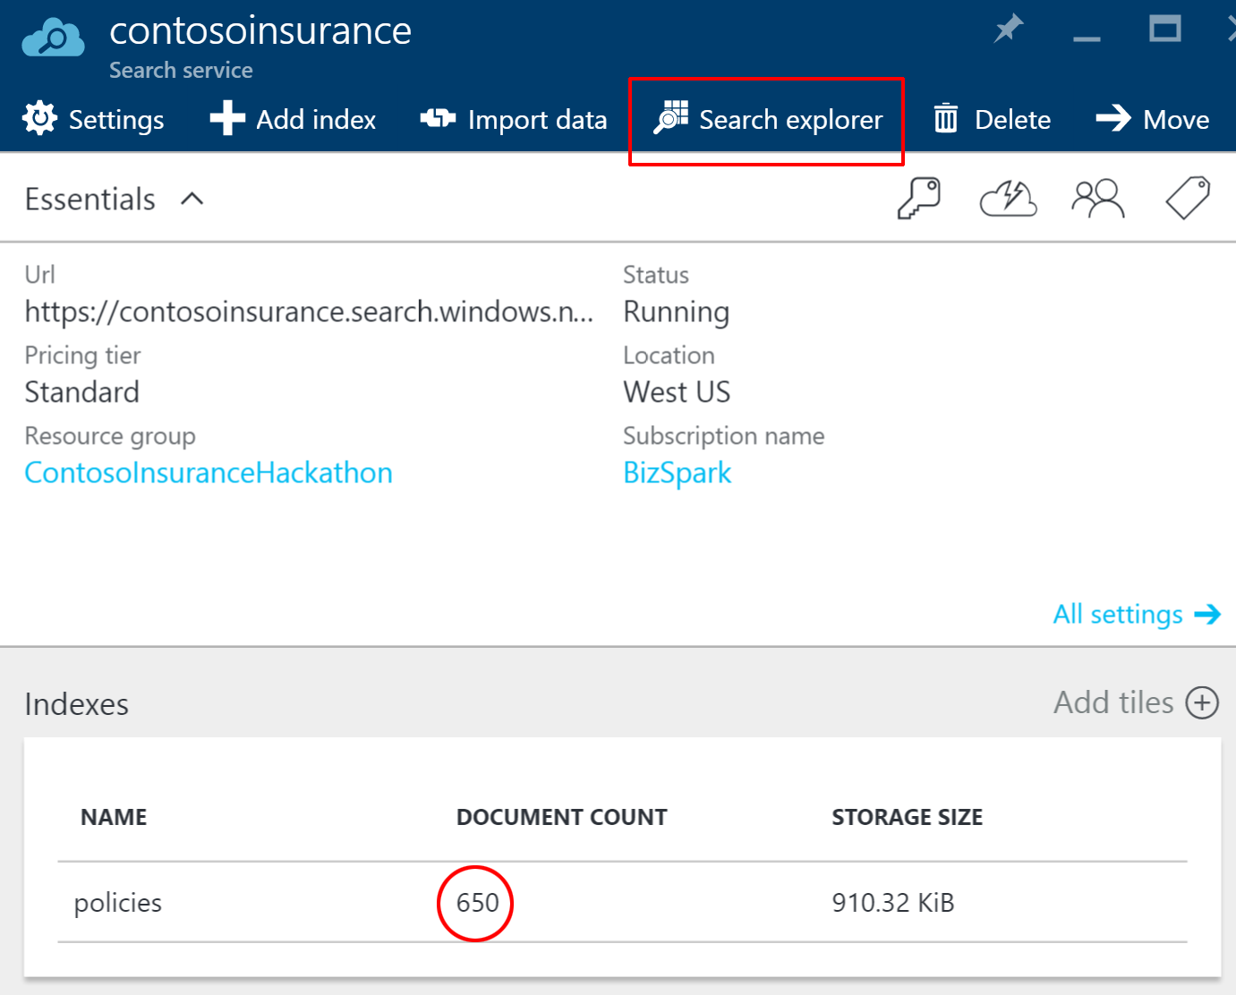
12. In the **Query string** field within the Search explorer, type in the following policy number: **DOW586IJCG493F**, then click on **Search**. You should see a single search result for a PDF file containing the policy number within its content. A successful result indicates that the index is working as expected.  
    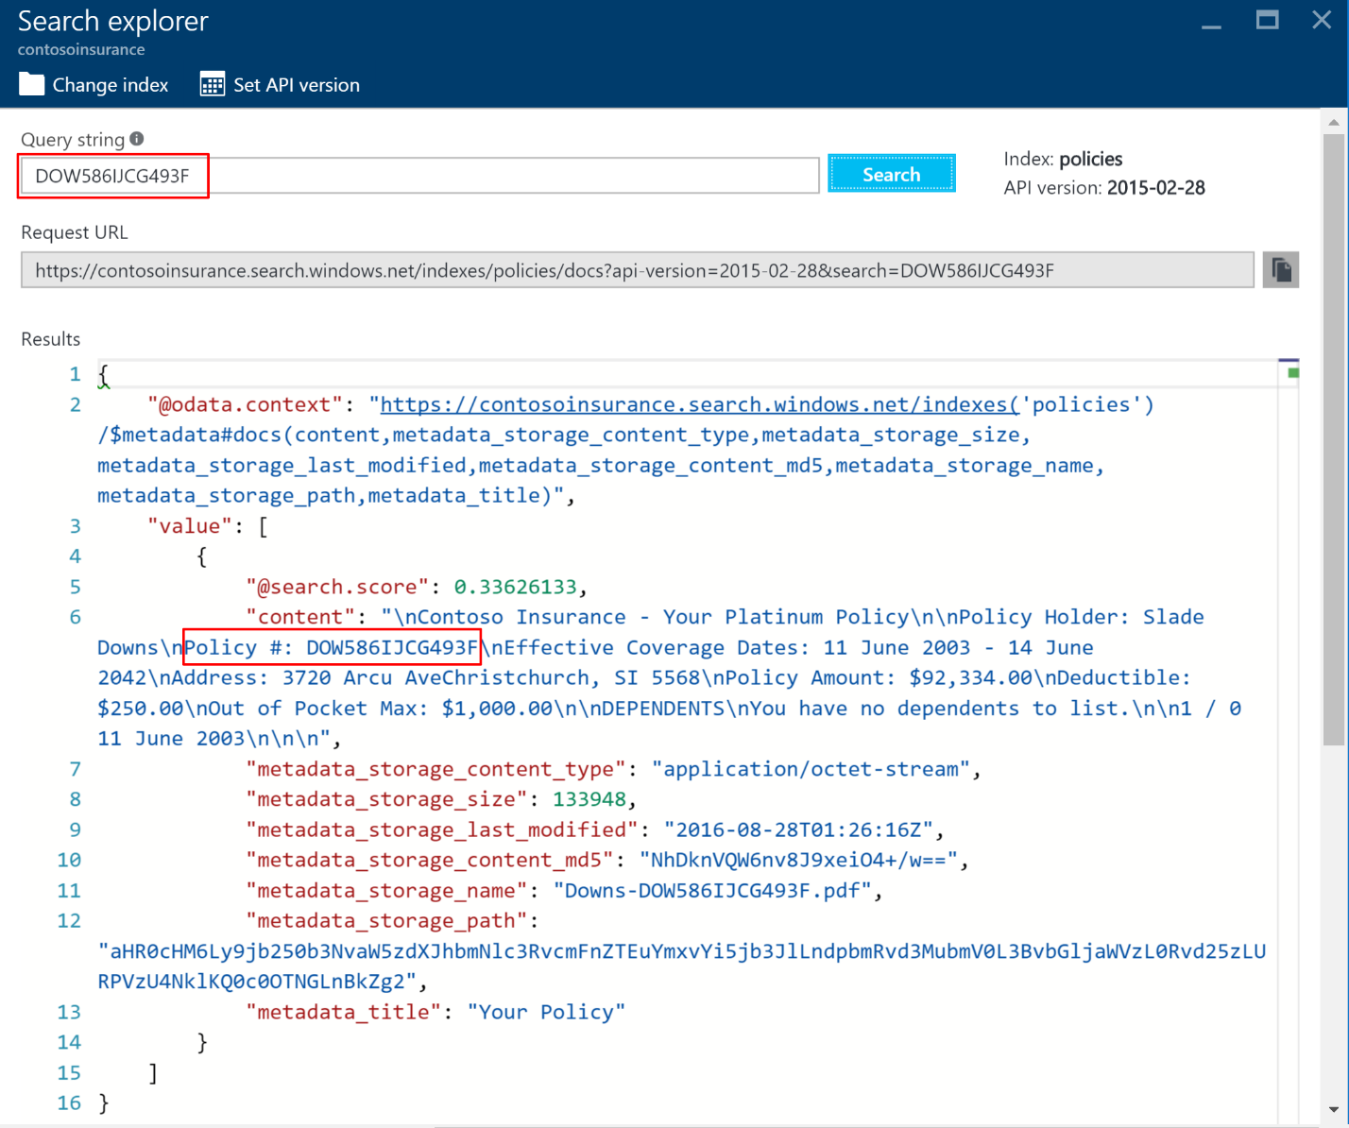
13. While in the Search explorer, copy the **Request URL** and save it for later.  
    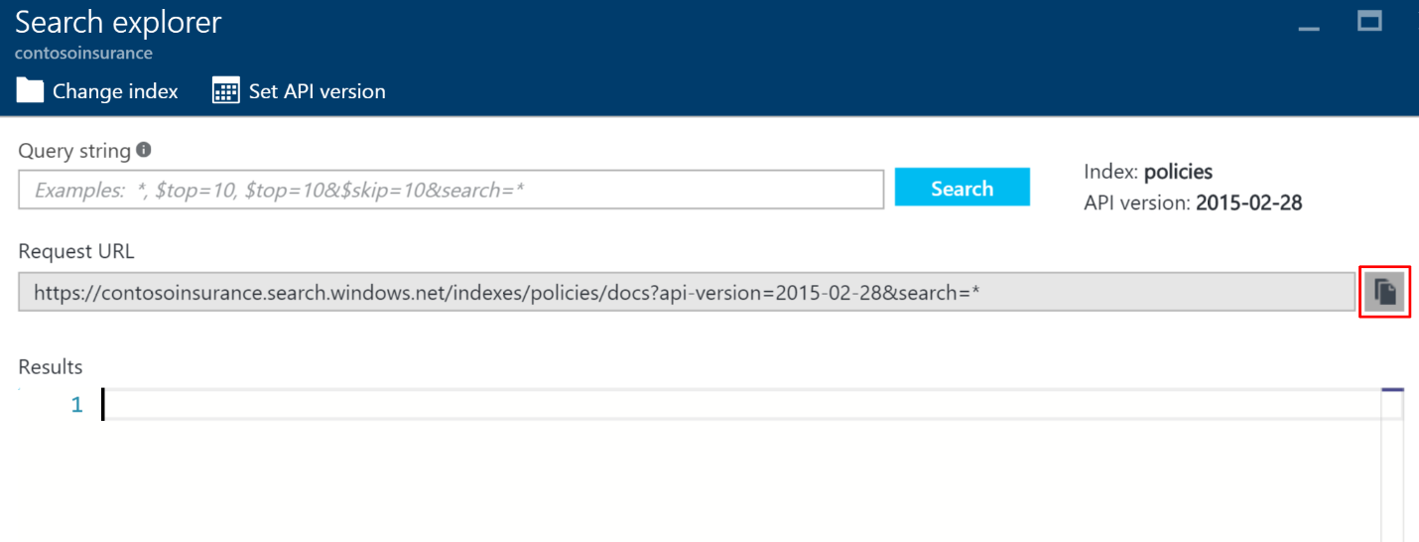
14. Go back to the main search service page, and then click on **Keys** on the left-hand menu pane, then **Manage query keys**. Copy the Key value within the Manage query keys blade. Save key for later.  
    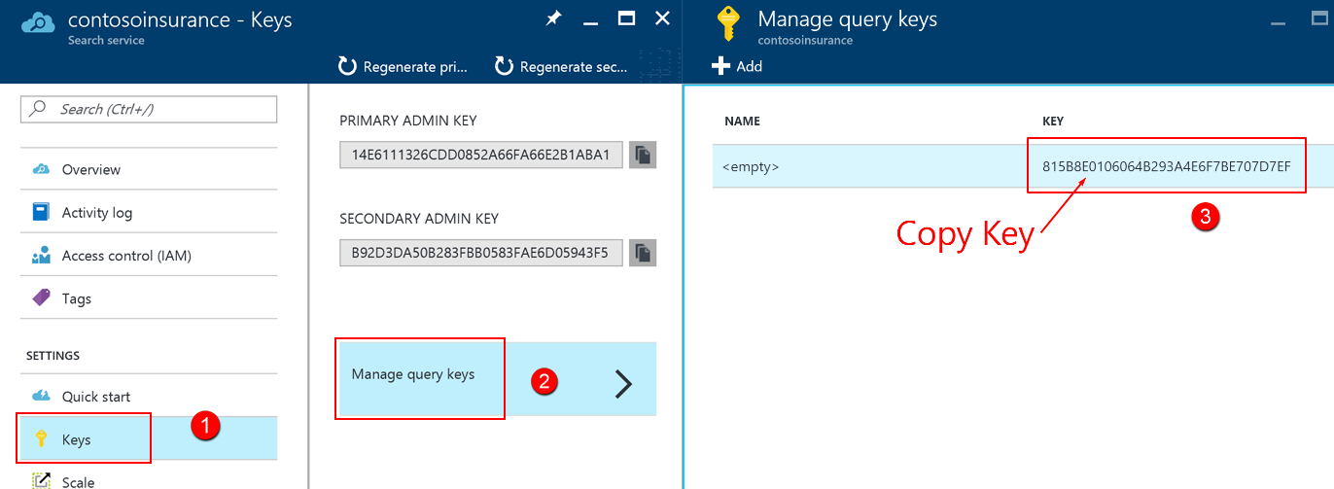

## Exercise 5: Configure Key Vault

### Overview

Key Vault will be used to protect sensitive information, such as database connection strings and storage account keys. Our application services that we have registered within Azure Active Directory will be granted access to the Key Vault secrets we create in this section. We have selected to use secrets instead of keys, due to the small size of the strings we are storing, as well as how often we need to retrieve the values. Retrieving secrets from Key Vault is a lower latency operation than retrieving keys, due to the real-time encryption and decryption involved.

### Help references

|  |  |
| --- | --- |
| What is Key Vault? | <https://azure.microsoft.com/en-us/documentation/articles/key-vault-whatis/> |
| About Keys and Secrets | <https://msdn.microsoft.com/library/dn903623.aspx> |
| Get Started with Azure Key Vault | <https://azure.microsoft.com/en-us/documentation/articles/key-vault-get-started/> |
| Use Azure Key Vault from a Web Application | <https://azure.microsoft.com/en-us/documentation/articles/key-vault-use-from-web-application/> |

### Task 1: Create a new Key Vault

1. Launch **PowerShell** from the Start Menu.
2. Within PowerShell type in the login command for Azure:  
     
   Login-AzureRmAccount
3. You will be prompted to log in with your Azure credentials. Be sure to sign in with the same Azure account you have been using throughout the hackathon.
4. If you have multiple subscriptions and want to specify a specific one to use for Azure Key Vault, type the following to see the subscriptions for your account:  
     
   Get-AzureRmSubscription  
     
   Then to specify the correct subscription to use, type:  
     
   Set-AzureRmContext -SubscriptionId <subscription Id>
5. Use the New-AzureRmKeyVault cmdlet to create your key vault. Enter a name for your vault, such as **ContosoInsuranceKeyVault** (the name needs to be unique; you may need to try different values if the below script fails). Enter the Resource Group name you created earlier, such as **ContosoInsuranceHackathon**. Be sure to enter the same region as your other services, such as **westus**:  
     
   New-AzureRmKeyVault -VaultName 'ContosoInsuranceKeyVault' -ResourceGroupName 'ContosoInsuranceHackathon' -Location 'westus'
6. After the vault has been created, make note of the **Vault URI** for later:  
   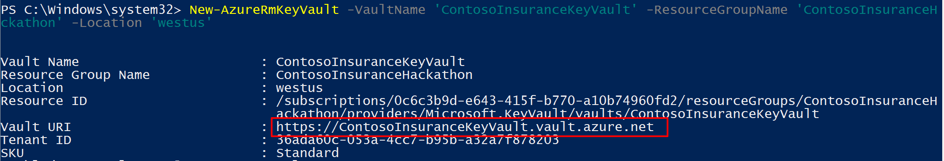

### Task 2: Create a new secret to store the SQL connection string

1. Now we will add a secret to the vault for our ContosoInsurance database connection string. Within the PowerShell window, convert the database connection string to a secure string by typing in the following ***(make sure to add in your SQL server username and password to the connection string first!):***  
     
   $secretvalue = ConvertTo-SecureString 'Server=tcp:**contoso-insurance-serv**.database.windows.net,1433;Initial Catalog=ContosoInsurance;Persist Security Info=False;User ID=**demouser**;Password=**demo@pass123**;MultipleActiveResultSets=False;Encrypt=True;TrustServerCertificate=False;Connection Timeout=30;' -AsPlainText -Force  
     
   Now type in the following, ***making sure to use your correct Vault Name***:  
     
   $secret = Set-AzureKeyVaultSecret -VaultName **'ContosoInsuranceKeyVault'** -Name **'SQLConnectionString'** -SecretValue $secretvalue
2. Obtain the URI for your new secret, and save it for later:  
     
   $secret.Id  
     
   You can use this URI to reference your SQLConnectionString secret from your applications. Use the URI, omitting the version number after “SQLConnectionString/”, in order to always obtain the latest version of the secret. Example: <https://contosoinsurancekeyvault.vault.azure.net:443/secrets/SQLConnectionString/>
3. We need to grant the Web API application access to the secret we just created. Refer to the Client Id you saved when adding the Web API to Azure AD. If in doubt, you can find it by going to the old portal (<https://manage.windowsazure.com>), selecting your Azure Active Directory instance, going to the Applications tab, selecting the Web API application entry, and clicking on Configure.  
     
   Within PowerShell, type in the following command, replacing the <Client Id> value with your own:  
     
   Set-AzureRmKeyVaultAccessPolicy -VaultName 'ContosoInsuranceKeyVault' -ServicePrincipalName **<Client Id>** -PermissionsToSecrets Get  
     
   

### Task 3: Add Client Id, Client Secret, and Secret URL to Web API’s app settings

To allow the Web API to access the Key Vault secret, we must add the Azure AD Client Id for the Web API app, along with the Client Secret and the Secret URL to the application settings on its app service instance.

1. Using a new tab or instance of your browser navigate to the Azure Management portal, <http://portal.azure.com>.
2. Click on **App Services** in the left-hand menu, and then click on the **Contoso Insurance Web API** instance within the App Services list.  
   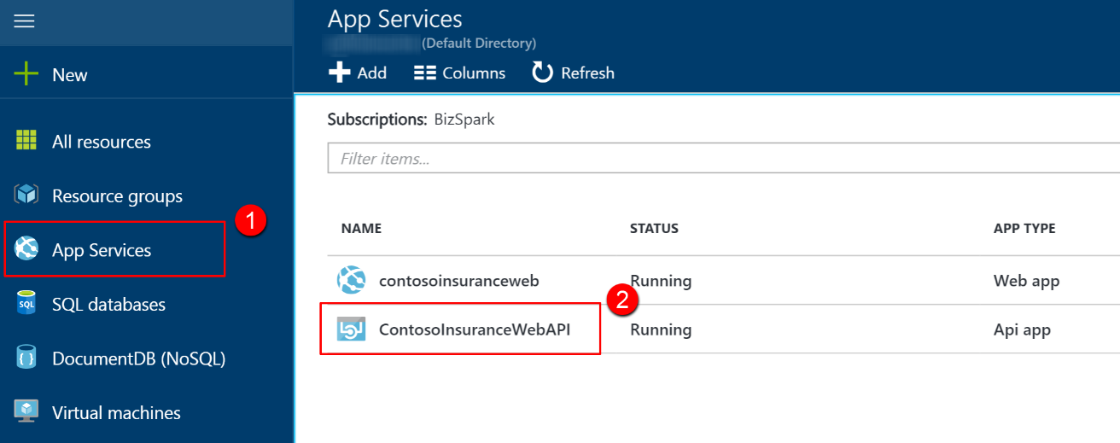
3. Click on **Application Settings**.  
   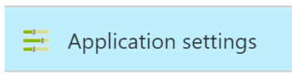
4. Scroll down to the **App settings** section, and create the following Key / Value pairs (the key names must exactly match those found in the Web.config file for the Contoso.Apps.Insurance.WebAPI project in Visual Studio):
   1. Key: **ClientId** Value: <AAD web app Client Id for Web API>
   2. Key: **ClientSecret** Value: <AAD web app Key for Web API>
   3. Key: **SecretUri** Value <Key Vault Uri for the SQLConnectionString secret>

Make sure that you exactly match the Key names to the App Settings keys in the Web.config file, including proper casing.  
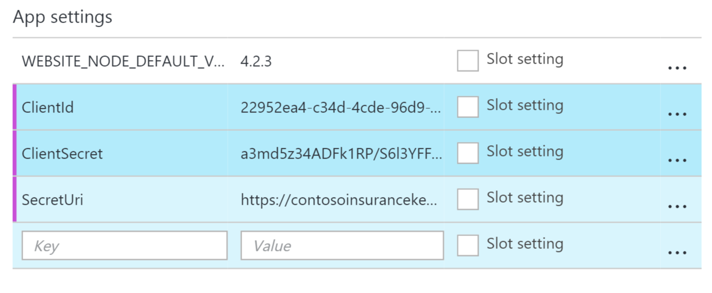

1. Click **Save**.  
   

## Exercise 6: Configure and Deploy the Contoso Insurance apps

### Overview

The developers at Contoso Insurance have been working toward migrating their apps to the cloud. As such, most of the pieces are already in place to deploy the apps to Azure, as well as configure them to communicate with the new app services, such as Web API. Since the required services have already been provisioned on Azure up to this point, what remains is applying application-level configuration settings, and then deploying any hosted apps and services from the Visual Studio Starter Project solution.

### Task 1: Deploy the Web API

In this exercise, the attendee will apply application settings using the Microsoft Azure Portal. The attendee will then deploy the Web API from the Starter Project.

#### Subtask 1: Configure application settings in Azure

1. Navigate to the **Contoso.Apps.Insurance.WebAPI** project located in the **Web** folder using the **Solution Explorer** of Visual Studio.  
   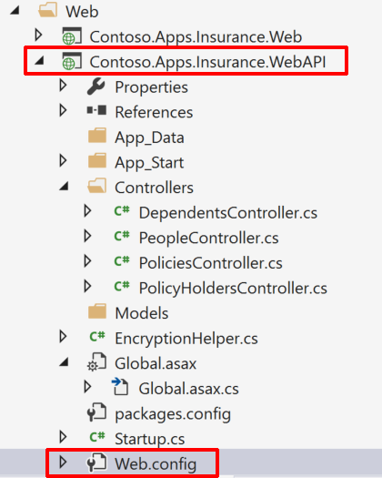
2. Open **Web.config** to use the **appSettings** keys as a reference. Instead of updating the application settings in the config file, we are setting them in the application service for Web API in the portal as an added security measure. If you would like to debug locally, you may place the values in the Web.config file as well.  
   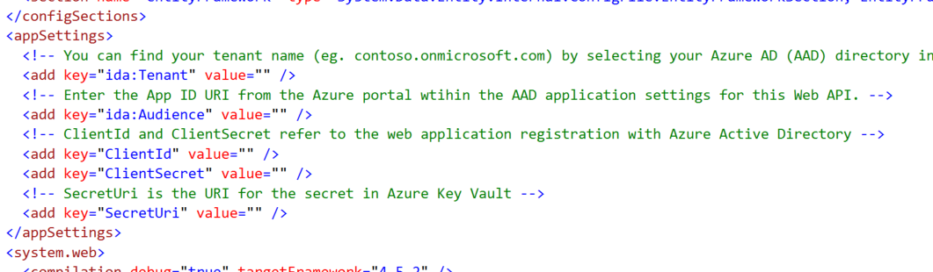
3. Using a new tab or instance of your browser navigate to the Azure Management portal, <http://portal.azure.com>.
4. Click on **App Services** in the left-hand menu, and then click on the **Contoso Insurance Web API** instance within the App Services list.  
   
5. Click on **Application Settings**.  
   
6. Scroll down to the **App settings** section. You should already have the Key / Value pairs that were created in the previous exercise for ClientId, ClientSecret, and SecretUri. Create the following additional Key / Value pairs (the key names must exactly match those found in the Web.config file for the Contoso.Apps.Insurance.WebAPI project in Visual Studio):
   1. Key: **ida:Tenant** Value: <AAD tenant name>
   2. Key: **ida:Audience** Value: <App ID URI within AAD application settings>  
        
      The **ida:Tenant** value is your Azure Active Directory (AAD) tenant name (e.g. contoso.onmicrosoft.com), which can be found by selecting your Azure AD (AAD) directory in the classic portal, then clicking on the DOMAINS tab.  
        
      The **ida:Audience** value is the App ID URI from the Azure portal within the AAD application settings for this Web API.
7. Make sure that you exactly match the Key names to the App Settings keys in the Web.config file, including proper casing.
8. Click **Save**.  
   

#### Subtask 2: Deploy the Web API app from Visual Studio

1. Navigate to the **Contoso.Apps.Insurance.WebAPI** project located in the **Web** folder using the **Solution Explorer** of Visual Studio.

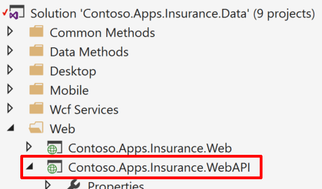

1. Right-click the **Contoso.Apps.Insurance.WebAPI** project and click **Publish**.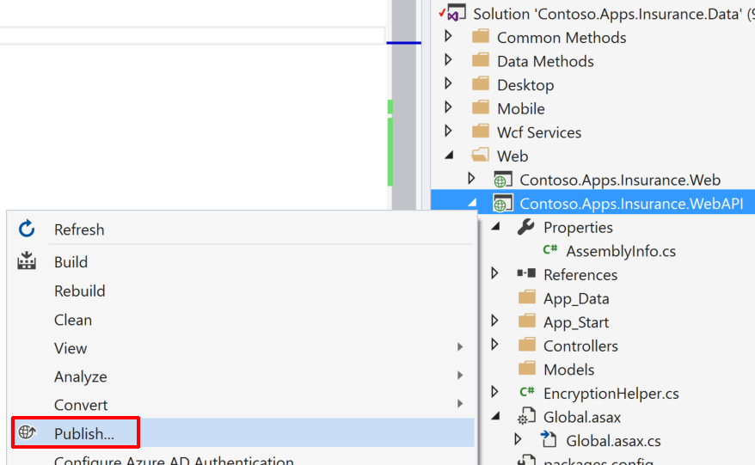
2. Choose **Microsoft Azure App Service** as the publish target.

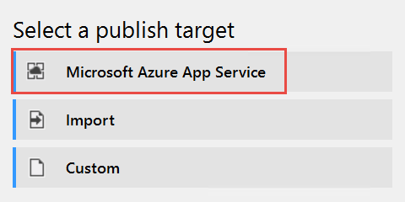

1. Log on with your credentials and ensure the subscription you published earlier is selected.

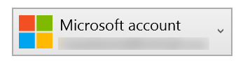

1. Select the Contoso Insurance Web API app.

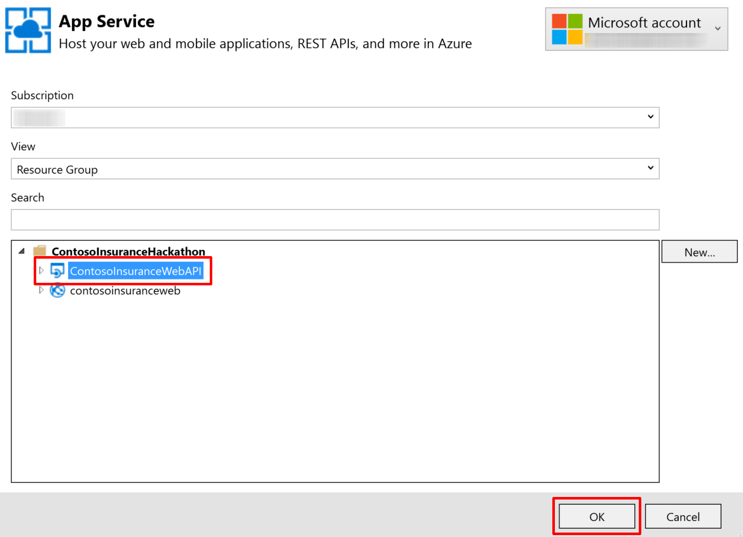

1. Click **OK**, and then click **Publish** to publish the web application.
2. In the Visual Studio **Output** view, you will see a status that indicates the web app was published successfully.

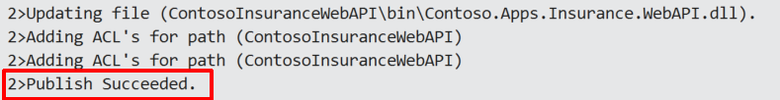

1. Validate the Web API by typing in /swagger to the end of its URL in your browser (e.g. http://contosoinsurancewebapi.azurewebsites.net/swagger). You should see a list of the available REST APIs. However, you will not be able to execute them from here, as they are protected by AAD application permissions, accepting only token-based calls from registered apps.  
   

### Task 2: Deploy the Contoso Insurance web app

#### In this exercise, the attendee will apply application settings using the Microsoft Azure Portal. The attendee will then edit a .js file in Visual Studio and deploy the Web API from the Starter Project. Subtask 1: Configure application settings in Azure

1. Navigate to the **Contoso.Apps.Insurance.Web** project located in the **Web** folder using the **Solution Explorer** of Visual Studio.  
   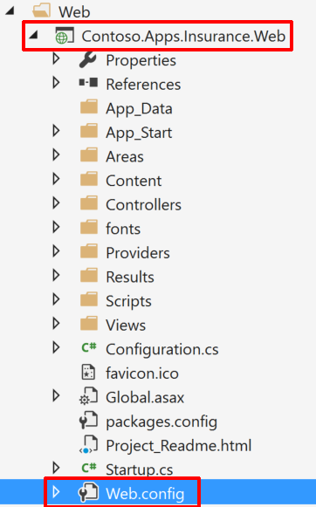
2. Open **Web.config** to use the **appSettings** keys as a reference. Instead of updating the application settings in the config file, we are setting them in the application service for Web API in the portal as an added security measure. If you would like to debug locally, you may place the values in the Web.config file as well.
3. Using a new tab or instance of your browser navigate to the Azure Management portal, <http://portal.azure.com>.
4. Click on **App Services** in the left-hand menu, and then click on the **Contoso Insurance Web** instance within the App Services list.  
   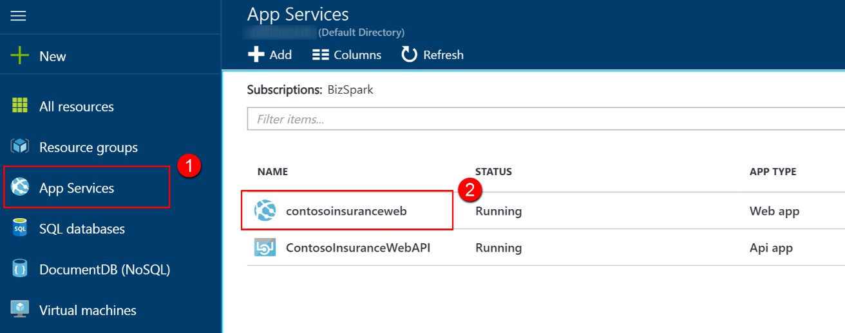
5. Click on **Application Settings**.  
   
6. Scroll down to the **App settings** section. Create the following additional Key / Value pairs (the key names must exactly match those found in the Web.config file for the Contoso.Apps.Insurance.Web project in Visual Studio):
   1. Key: **RootWebApiPath** Value: <URL to published Web API>
   2. Key: **Tenant** Value: <AAD tenant name>
   3. Key: **WebClientId** Value: <App’s AAD Client Id>
   4. Key: **WebApiAppId** Value: <Web API’s APP ID URI from AAD>  
        
      The **RootWebApiPath** value is the URL to the published Web API, such as http://contosoinsurancewebapi.azurewebsites.net/  
        
      The **Tenant** value is your Azure Active Directory (AAD) tenant name (e.g. contoso.onmicrosoft.com), which can be found by selecting your Azure AD (AAD) directory in the classic portal, then clicking on the DOMAINS tab.  
        
      The **WebClientId** value is the Client Id in Guid format from the Azure Active Directory application settings for this web application.  
        
      The **WebApiAppId** value is from the AAD application settings for the Web API, under single sign-on, named APP ID URI.
7. Make sure that you exactly match the Key names to the App Settings keys in the Web.config file, including proper casing.
8. Open the **app.js file**, located within the Contoso.Apps.Insurance.Web project under the Scripts > app folder.  
   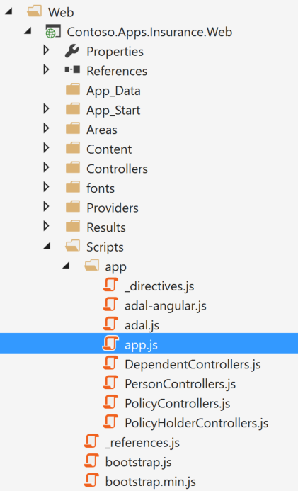
9. Scroll down to the bottom of the file where you see the line (126) that begins with **var endpoints = {**. Change the URL in quotes to the same URL you entered for the RootWebApiPath application variable, which is the root location of your Web API, (e.g. https://contosoinsurancewebapi.azurewebsites.net)  
   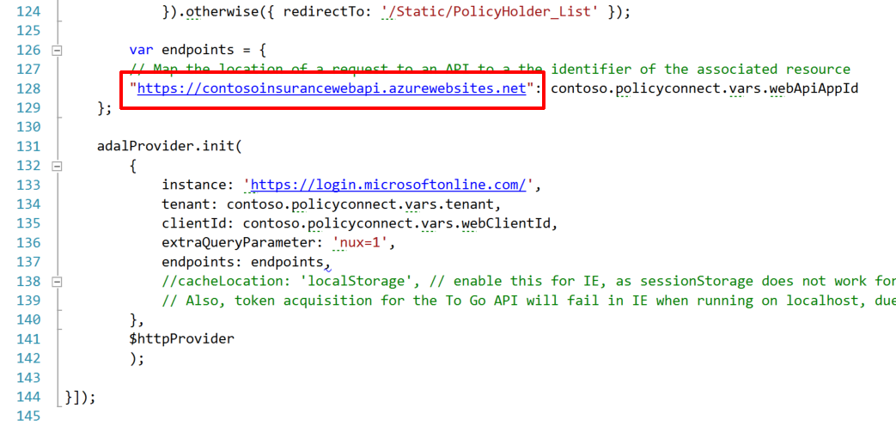

#### Subtask 2: Deploy the Contoso Insurance web app from Visual Studio

1. Navigate to the **Contoso.Apps.Insurance.Web** project located in the **Web** folder using the **Solution Explorer** of Visual Studio.

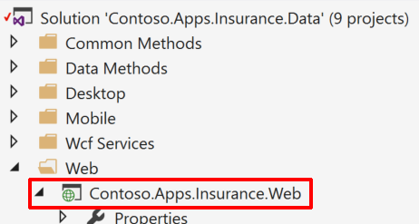

1. Right-click the **Contoso.Apps.Insurance.WebAPI** project and click **Publish**.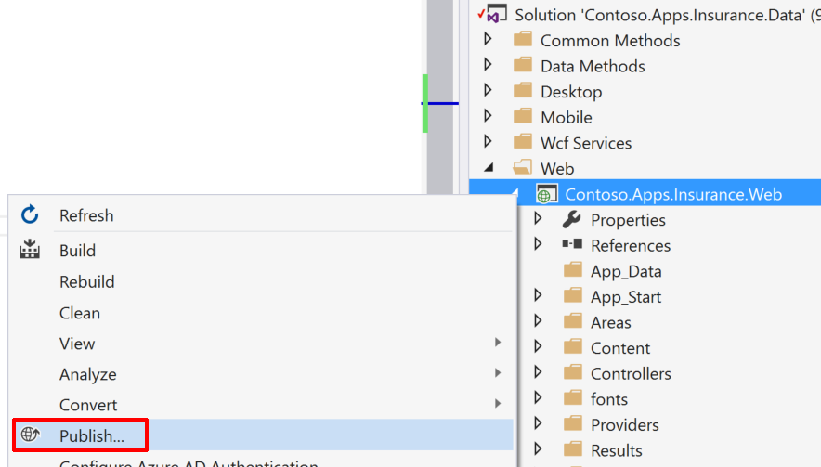
2. Choose **Microsoft Azure App Service** as the publish target.



1. Log on with your credentials and ensure the subscription you published earlier is selected.



1. Select the Contoso Insurance Web app.

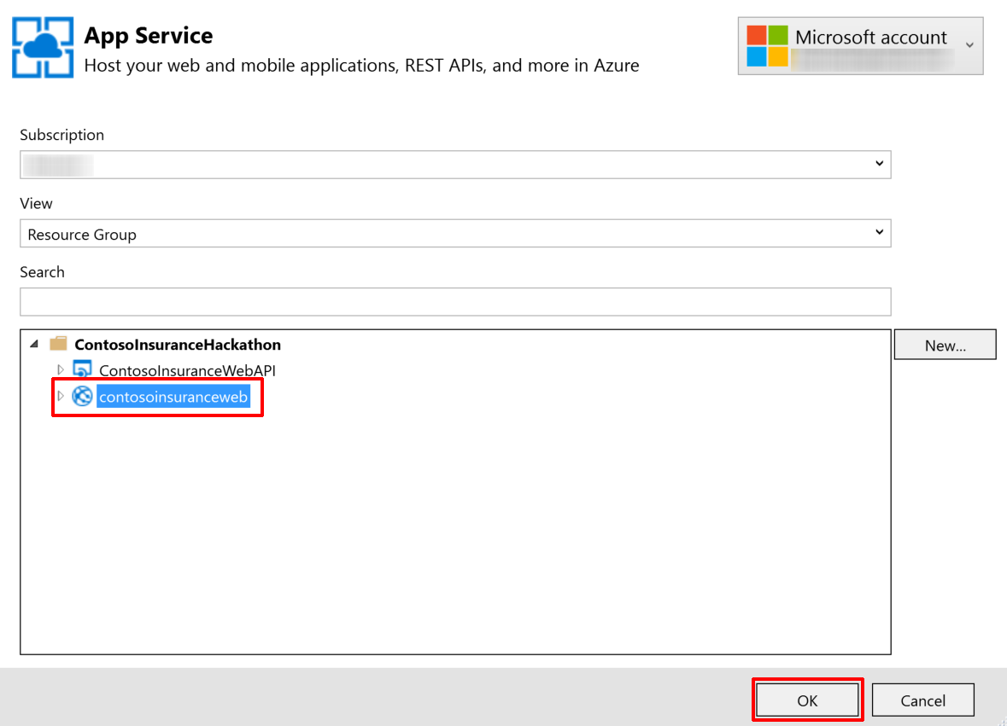

1. Click **OK**, and then click **Publish** to publish the web application.
2. In the Visual Studio **Output** view, you will see a status that indicates the web app was published successfully.

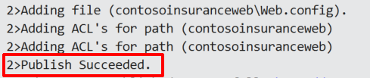

Validate the website by browsing to it, if it did not automatically launch after publishing.  


Click on the **Policies** link. You will likely be prompted to log in to AAD if you do not already have a cached authentication token. When you log in, do so with the **Contoso User** account you created earlier. Username is **contosouser@<your tenant>.onmicrosoft.com** and the password is **demo@pass123**. After authentication is complete, you should see a list of policies, and you should have a Logout link on the upper-left.  


### Task 3: Configure and run the legacy desktop (Windows Forms) application

#### Contoso Insurance has created a web and mobile version of their desktop application, but they have opted to update it to communicate with the new Web API service for business and data functionality, doing away with their old WCF services (also included in the solution). They have also replaced their SQL membership-based user authentication with Azure Active Directory (AAD).

#### If you would like to run the desktop application in its original configuration, make sure you have set up your local self-signed certificates, as outlined in Exercise 1, Task 5. Also, make sure that you run both WCF services when debugging the desktop application by right clicking on the Solution, then clicking on Select StartUp Projects… From here, select the Multiple startup projects radio button, then select the Start action for the following projects, moving them from top to bottom in this order: PolicyConnectDataService, PolicyConnectManagementService, and PolicyConnectDesktop. Also, make sure that the UseWebApi app setting is set to false in App.config.

#### In this exercise, the attendee will update the application settings in the App.config file, allowing the desktop application’s updated code to take advantage of the new Azure services. Subtask 1: Configure application settings in App.config

1. Navigate to the **PolicyConnectDesktop** project located in the **Desktop** folder using the **Solution Explorer** of Visual Studio, and open the **App.config** file.  
   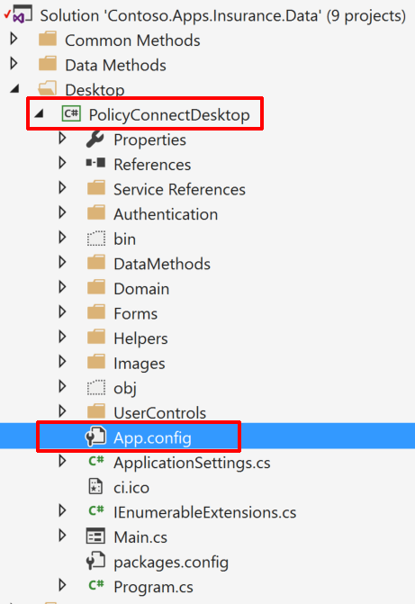
2. Scroll down to the **appSettings** section, and modify the values for the following keys:  
     
   The **PdfRootPath** is the root folder of the Pdf files. The path should point to the Files folder within the Hackathon directory you created at the beginning of this hackathon (e.g. C:\Hackathon\Files\).  
     
   The **RootWebApiPath** value is the URL to the published Web API, such as http://contosoinsurancewebapi.azurewebsites.net/  
     
   **UseWebApi** needs to be set to **true** in order to communicate with the new Web API, and authenticate through AAD instead of the old method.  
     
   The **DesktopClientId** value is the Client Id in Guid format from the Azure Active Directory application settings for this desktop application.  
     
   The **DesktopRedirectUri** value is also from the AAD application setting for this desktop application, named *Redirect URIs*.  
     
   The **WebApiAppId** value is from the AAD application settings for the Web API, under single sign-on, named APP ID URI.

The **AzureADLoginUrl** is the URL of your Azure Active Directory tenant, which should be: https://login.windows.net/<tenantID>. You can find your Tentant Id by going to the Azure AD Quick Start Page, selecting 'Develop Applications', then selecting View Authentication and Authorization Endpoints. The Tenant Id is the Guid value that follows 'login.microsoftonline.com/’  
  
The **AzureADTenantId** is the Guid value of your tenant, which was applied to the AzureADLoginUrl key above.

#### Subtask 2: Running the desktop application

1. Navigate to the **PolicyConnectDesktop** project located in the **Desktop** folder using the **Solution Explorer** of Visual Studio, and right-click on the project.
2. Select Debug, and then click on **Start new instance**.  
   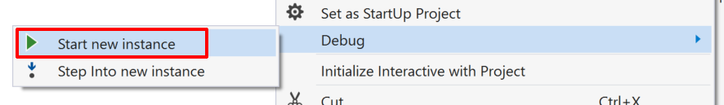
3. Click the **Log in…** button to begin.
4. You will be presented with an AAD login window. Enter the login credentials for the Contoso User account you created in your AAD directory. Username is **contosouser@<your tenant>.onmicrosoft.com** and the password is **demo@pass123**. After authentication is complete, you should see a list of policyholders, and you should see a label on the upper-right saying you are logged in as your Contoso User account. Feel free to explore the different capabilities of the application. Some functionality is intentionally left out. To open a policyholder record, simply double-click on any of the rows.  
   

### Task 4: Configure and run the mobile application

#### The mobile application was built using Xamarin Forms, capitalizing on the .NET expertise of the Contoso Insurance development team. As a bonus, they can easily add additional platforms, such as iOS and Windows phone, as well as target multi-platform desktop environments. For now, their focus has been on deploying to Android, since they can run the Android emulator right from their development machines, which are Windows-based. You will need to have completed the Xamarin installation steps outlined at the beginning of this hackathon guide.

#### In this exercise, the attendee will update the application settings in the ApplicationSettings.cs file, and then run the mobile application within the Android emulator. Subtask 1: Configure application settings in ApplicationSettings.cs

1. Navigate to the **CIMobile** project located in the **Mobile** folder using the **Solution Explorer** of Visual Studio, and open the **ApplicationSettings.cs** file.  
   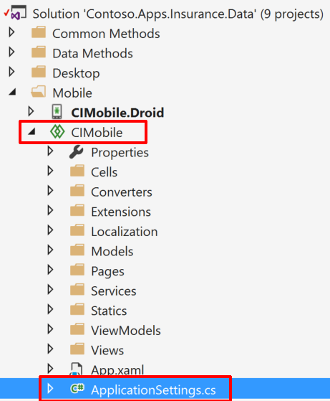
2. Modify the values for the following properties:  
     
   The **RootWebApiPath** value is the URL to the published Web API, such as http://contosoinsurancewebapi.azurewebsites.net/  
     
   For the **BlobContainerUrl**, enter the blob container Url where the policy PDF files are kept. You can find this by navigating to your Storage account in Azure, clicking on Blobs on the Overview blade, then selecting the container (such as "policies") within the Blob service blade, and finally clicking Properties, then the copy button next to the URL.  
     
   The **MobileClientId** value is the Client Id in Guid format from the Azure Active Directory application settings for this mobile application.  
     
   The **MobileRedirectUri** value is also from the AAD application setting for this mobile application, named *Redirect URIs*.  
     
   The **WebApiAppId** value is from the AAD application settings for the Web API, under single sign-on, named APP ID URI.  
     
   The **WebApiReplyUrl** is retrieved from the AAD application settings for the Web API, under single sign-on. It is the REPLY URL.  
     
   The **AzureADLoginUrl** is the URL of your Azure Active Directory tenant, which should be: https://login.windows.net/<tenantID>. You can find your Tentant Id by going to the Azure AD Quick Start Page, selecting 'Develop Applications', then selecting View Authentication and Authorization Endpoints. The Tenant Id is the Guid value that follows 'login.microsoftonline.com/’  
     
   **GraphResourceUri** should be set to https://graph.windows.net.  
     
   The **AzureADTenantId** is the Guid value of your tenant, which was applied to the AzureADLoginUrl key above.  
     
   To find the **AzureSearchServiceUrl** value, go to Azure and select your search service, then the "policies" index, then "Search explorer". Copy the full URL within the URL field. Make sure to include the entire path, even the "&search=*" at the end. For example: https://contosoinsurance.search.windows.net/indexes/policies/docs?api-version=2015-02-28&search=*  
     
   The **AzureSearchQueryApiKey** value can be found by selecting your search service in Azure, then clicking on Keys, click on Manage query keys, then copy the displayed key (or create one if none exist).

#### Subtask 2: Running the mobile application

1. Navigate to the **CIMobile.Droid** project located in the **Mobile** folder using the **Solution Explorer** of Visual Studio, and click to select the project.
2. On the top tool bar of Visual Studio, select Debug from the first dropdown, then Any CPU in the second, and then select **CIMobile.Droid** as the application to be debugged. Click on the green play button next to the Android emulator name to launch the application.  
   

Alternately, right-click on the CIMobile.Droid project, select Debug, then click **Start new instance**.

1. The Android emulator should appear, and then launch the PolicyConnect app within.  
   
2. Click the **Sign In…** button to begin.
3. You will be presented with an AAD login window. Enter the login credentials for the Contoso User account you created in your AAD directory. Username is **contosouser@<your tenant>.onmicrosoft.com** and the password is **demo@pass123**. After authentication is complete, you should see a list of policyholders. You cannot interact with the records in any way for this demo.  
     
   Click on the menu button on the upper-left to explore other parts of the app.  
   
4. Click on the menu and choose **Search Policy #**.  
     
   
5. You can either enter a full policy #, or perform a partial search of all content and metadata fields within the search field. Type in at least 3 characters to activate the search button. Try searching with the letters **MON**. The most relevant search results will appear first. Now try searching by an exact policy number, such as **DOW586IJCG493F**. You should see a single result matching that policy number.  
   
6. Click on a search result to view the content that was extracted by the Azure Search indexer. There is a link to download the actual PDF at the bottom of the result page. This will display the file that is stored in Blob storage.  
     
   

## Exercise 7: Create a Flow app that sends push notifications when important emails arrive

### Overview

Contoso wants to receive push notifications when important emails arrive, since any newly scanned policies that are emailed to the data entry employees are marked as important. Since they use Office 365 for their email services, you can easily meet this requirement with Flow.

### Task 1: Sign up for a Flow account

1. Go to <https://flow.microsoft.com> and sign up for a new account, using the same account you have been using in Azure.
2. You may receive an email asking you to verify your account request, with a link to continue the process.
3. Download the Microsoft Flow mobile app to your phone or mobile device.

### Task 2: Create new flow

1. With your Flow account created and logged into the Flow website, click on the **My flows** link on top of the page.  
   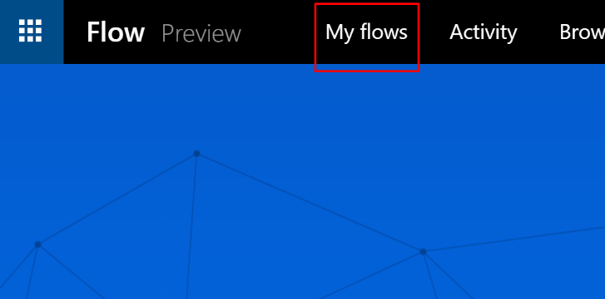
2. Click on the **Create from blank** button.
3. Type **email** into the trigger search box to find the **Office 365 Outlook – When a new email arrives** trigger. Click on it to continue.  
   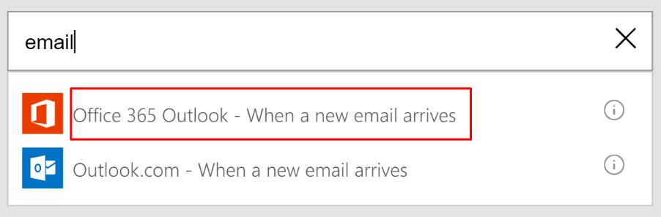
4. When prompted, sign in to create a connection to Office 365 Outlook.
5. Within the When a new email arrives trigger configuration box, click on **Show advanced options**.  
   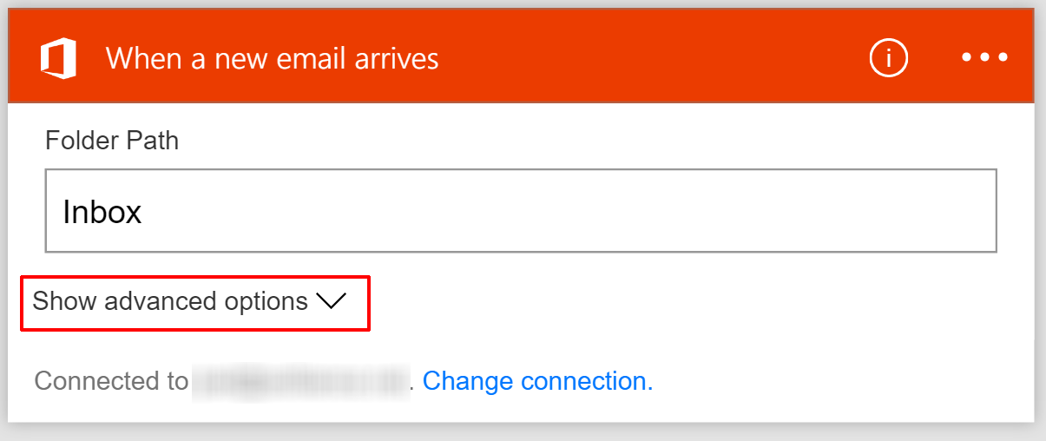
6. Within the advanced options, set the **Importance** to High and set **Has Attachments** to True.  
   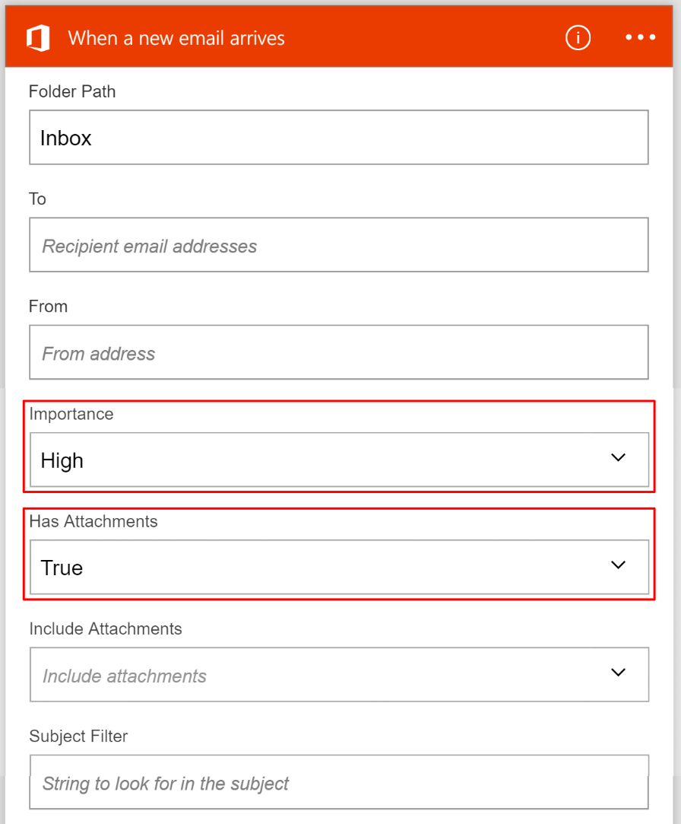
7. Click on **+ New step**, then on **Add an action** to continue.  
   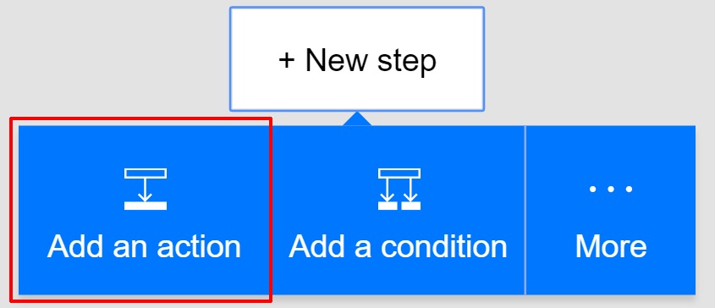
8. Type **push** into the action search box, then select **Push notification – Send a push notification**.  
   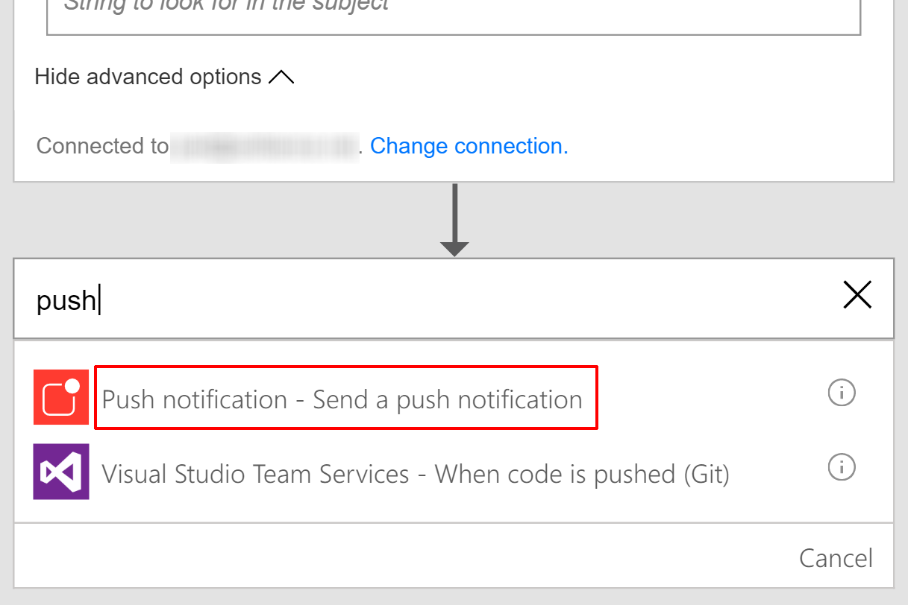
9. Within the Send a push notification action box, type in a notification in the **Text** field: Important email with attachment:
10. Click on the **Subject** tag to insert it after your notification text.
11. Type <https://outlook.office365.com/> into the **Link** field.
12. Type **Go to Outlook Office 365** as the **Link label**.  
      
    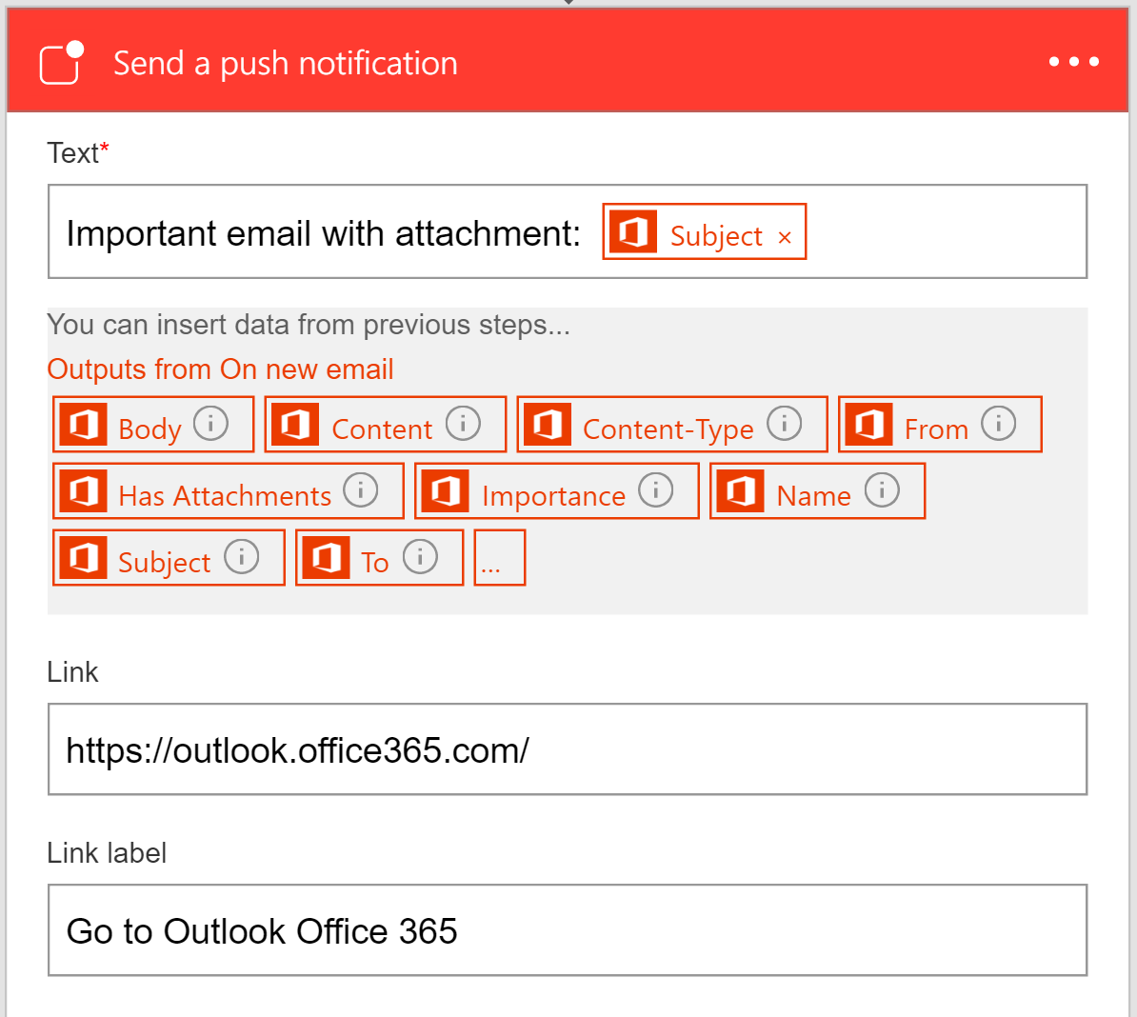
13. Click on the **Create flow** button, and type in **Important emails with attachments** as the flow name, when prompted.

### Task 3: Test your flow

1. Send an email to your O365 account marked as **High Importance**, with a test Policy PDF file attached. You can find some test files that are not stored in Blob storage (for additional testing later on) within the **C:\Hackathon\New Policies** folder.
2. If you have the Flow app installed on your phone, you should receive a push notification (iOS support only at this time).
3. You can check the status of the flow by clicking on **My flows** from the flow website. Click on the info icon next to the **Important emails with attachments** flow you created.  
     
   
4. You will see each time the flow was run, along with its status. Click on the line item to view more details.  
   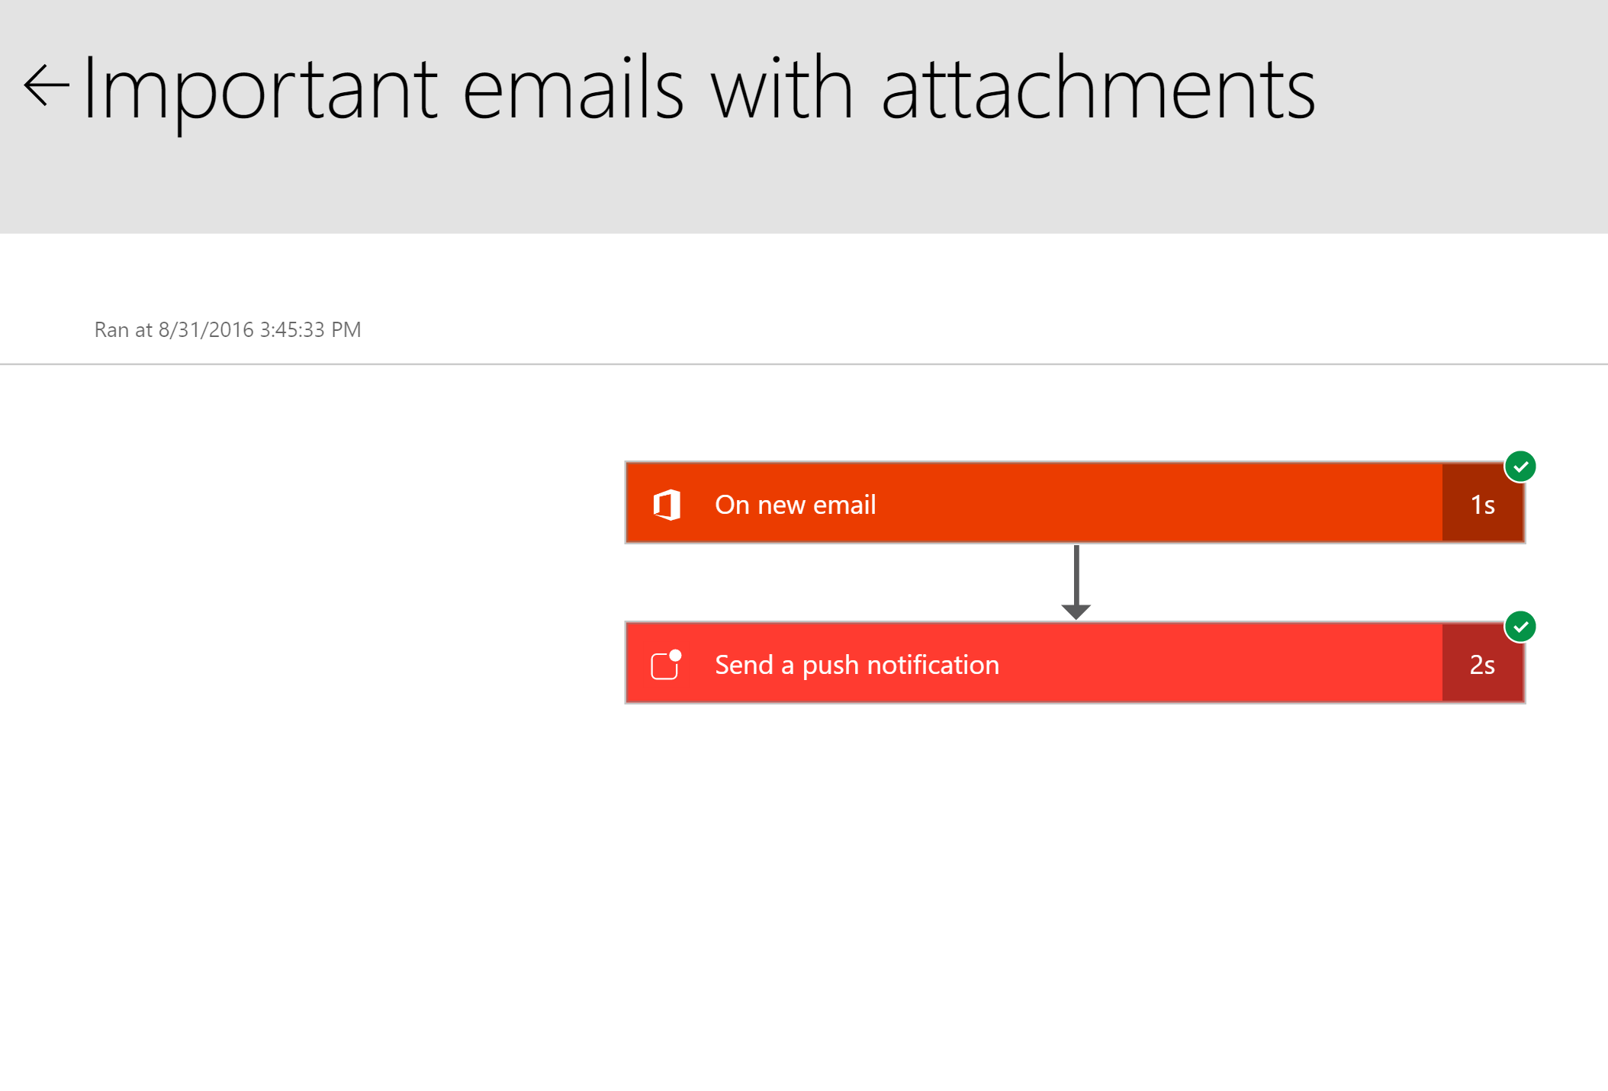

## Exercise 8: Create an app in PowerApps

### Overview

Since creating mobile apps is a long development cycle, Contoso is interested in using PowerApps to create mobile applications in order to add functionality not currently offered by their app rapidly. In this scenario, they want to be able to edit the Policy lookup values (Silver, Gold, Platinum, etc.), which they are unable to do in the current app.

Get them up and running with a new app created in PowerApps, which connects to the ContosoInsurance database and performs basic CRUD (Create, Read, Update, and Delete) operations against the Policies table.

### Help references

|  |  |
| --- | --- |
| PowerApps | <https://powerapps.microsoft.com/en-us/tutorials/getting-started/> |

### Task 1: Sign up for a PowerApps account

1. Go to <https://web.powerapps.com> and sign up for a new account, using the same account you have been using in Azure.
2. You may receive an email asking you to verify your account request, with a link to continue the process.
3. Download and install PowerApps Studio from the Microsoft store: <https://www.microsoft.com/en-us/store/p/powerapps/9nblggh5z8f3>

### Task 2: Create new SQL connection

1. With your PowerApps account created and logged into the PowerApps website, click on the **Connections** link on left menu of the page.
2. Click on the **New connection** button on top of the page.
3. Type **SQL** into the search box, and then click on the **SQL Server** item in the list below.  
     
   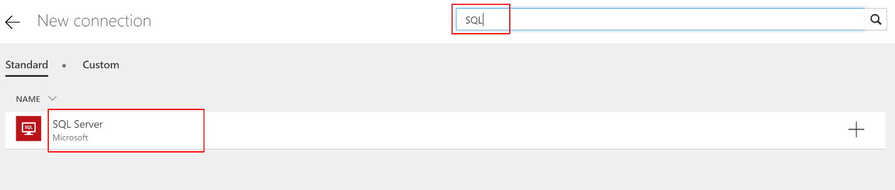
4. Within the SQL Server connection dialog, select the **Connect directly (cloud services)** radio button.
5. Consult your saved SQL Server connection string (or locate it in Azure) to fill in the **SQL server name**, **Username**, and **Password** values. The **SQL Database name** should be **ContosoInsurance**.  
   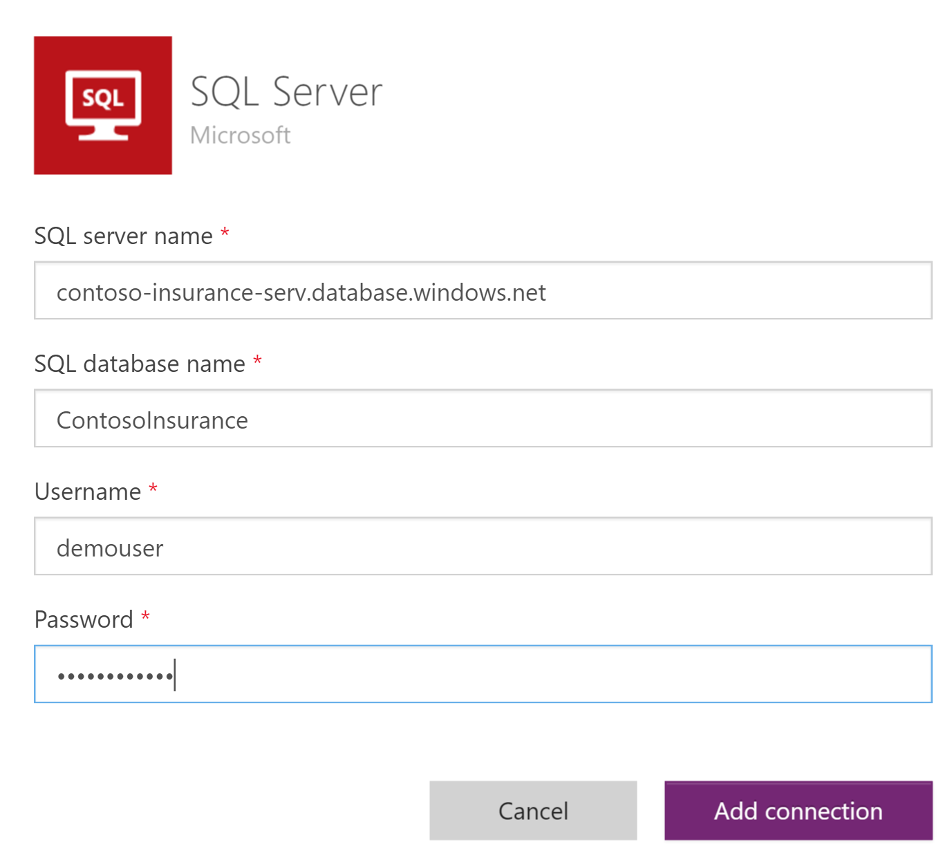

### Task 3: Create new app

1. Open PowerApps Studio and sign in with the same account.
2. Click **New** on the left-hand menu, and then **click the right arrow** next to the list below the **Create an app from your data** heading.  
   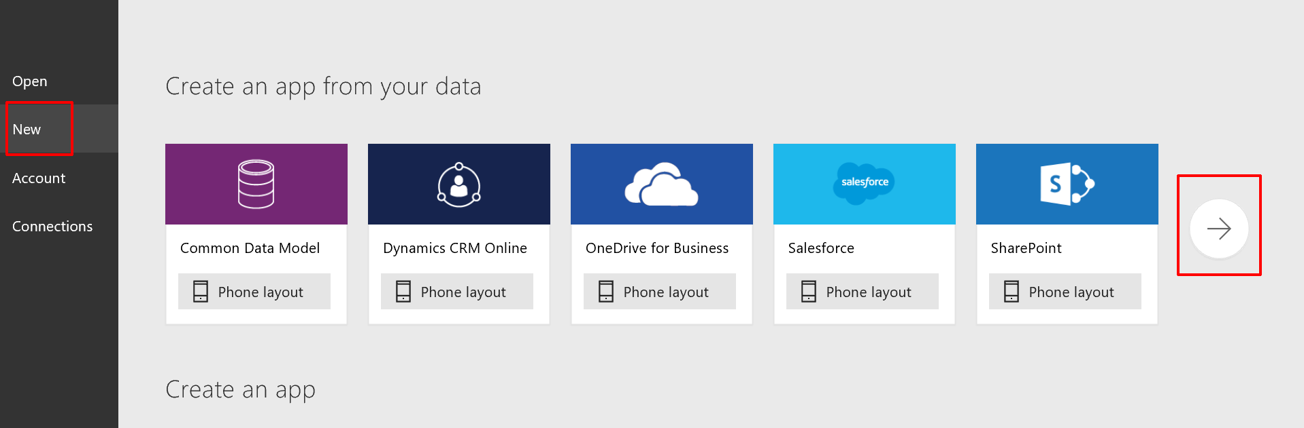
3. Click on the **SQL Server connection** you created in the previous task.  
     
   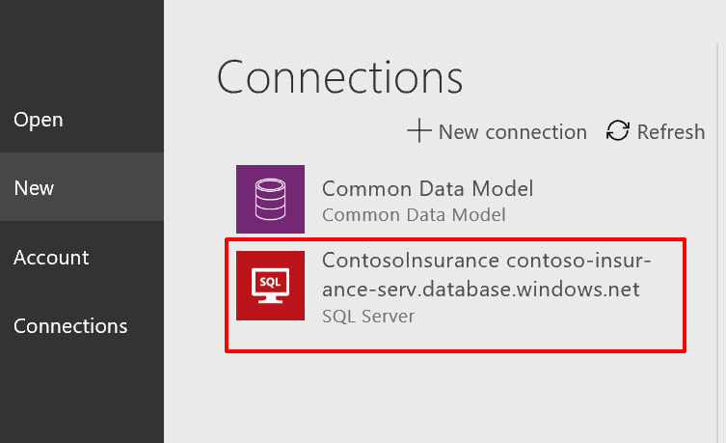
4. Click **default** under Choose a dataset.
5. Click on **Policies** under Choose a table.  
     
   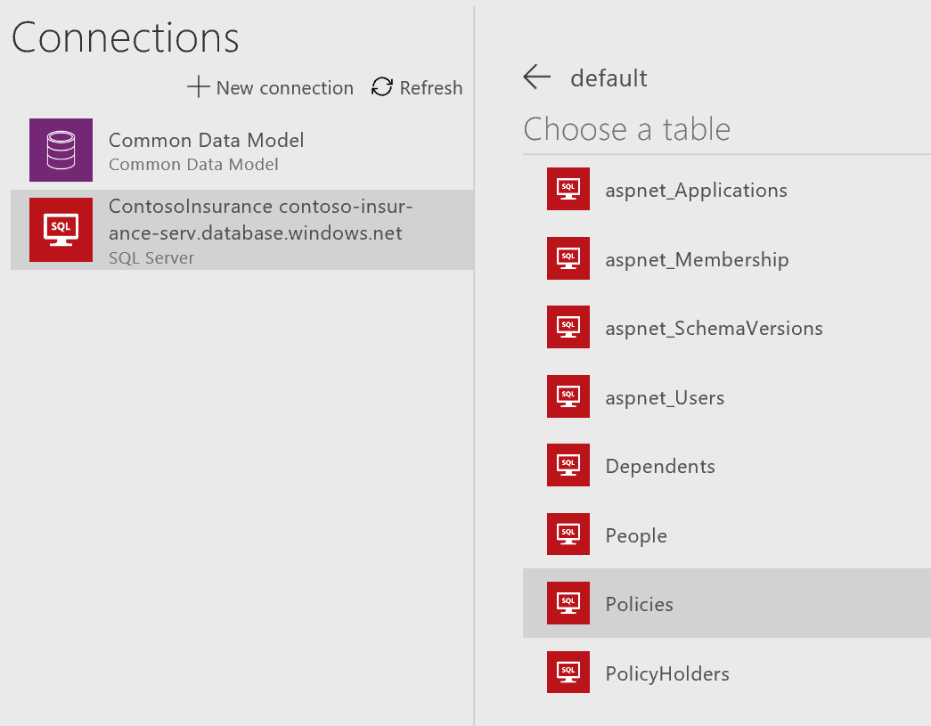
6. Click **Connect**.

### Task 4: Design app

1. The new app will automatically be created and displayed within the designer. Click on the title for the first page (currently named [dbo].[Policies]) and edit the text in the formula field to read **“Policies”** in quotes.  
   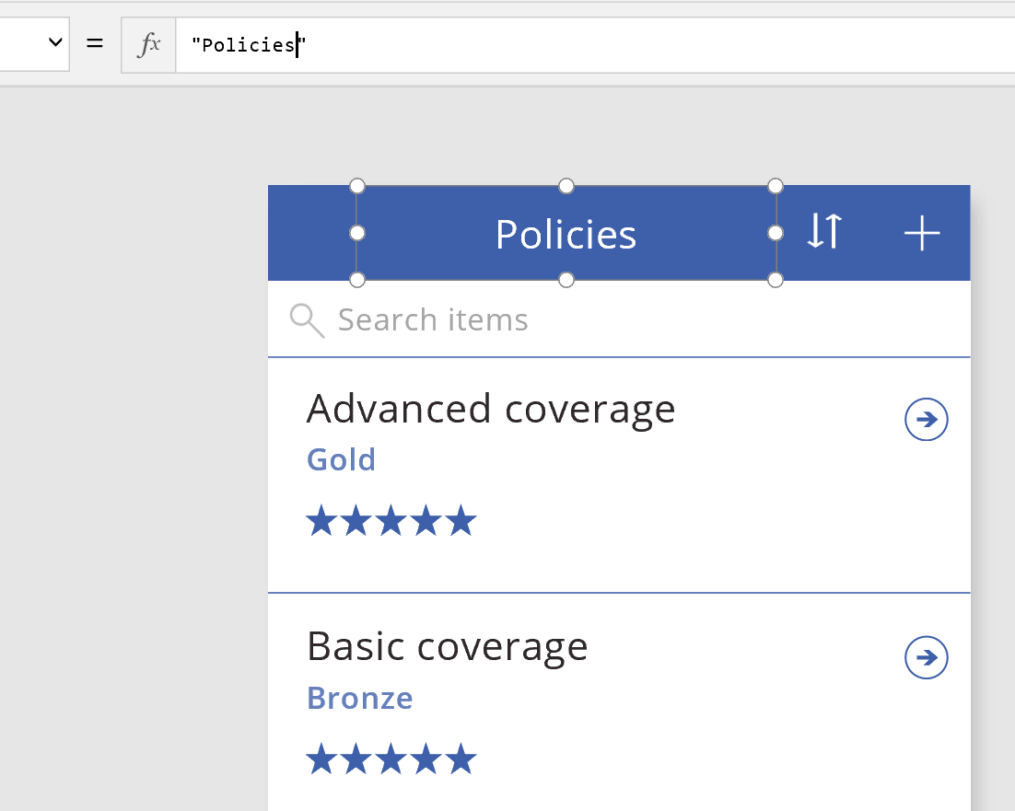
2. Click on the stars displayed on the first item (Advanced coverage), and delete the label.
3. Click on the DetailScreen screen on the left-hand side.  
     
   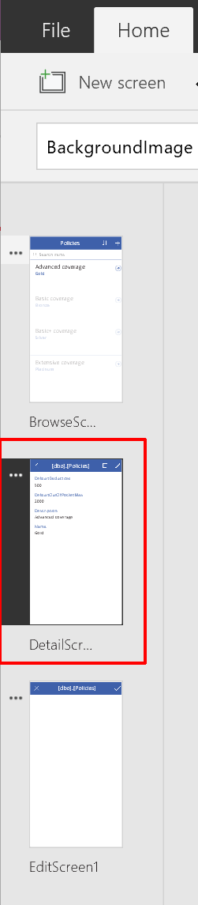
4. Reorder the fields on the form by clicking and dragging them in the Fields list on the right.  
     
   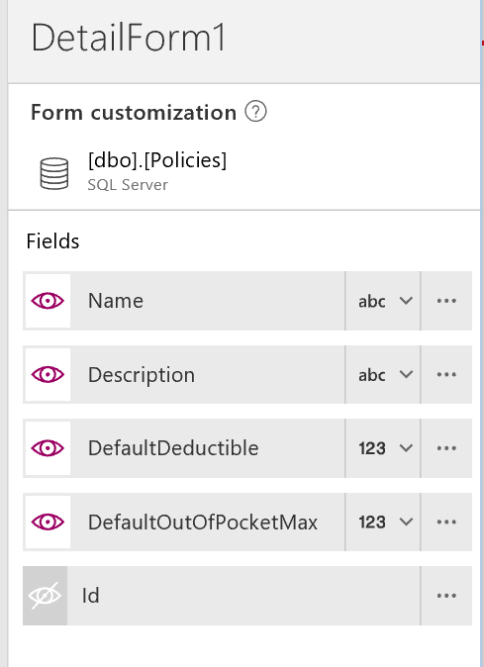
5. On the form, edit the **DefaultDeductible** and **DefaultOutOfPocketMax** labels to be **Default Deductible** and **Default Out of Pocket Max**, respectively.
6. Rename the screen title to Policy by typing “Policy” in quotes within the formula field.  
     
   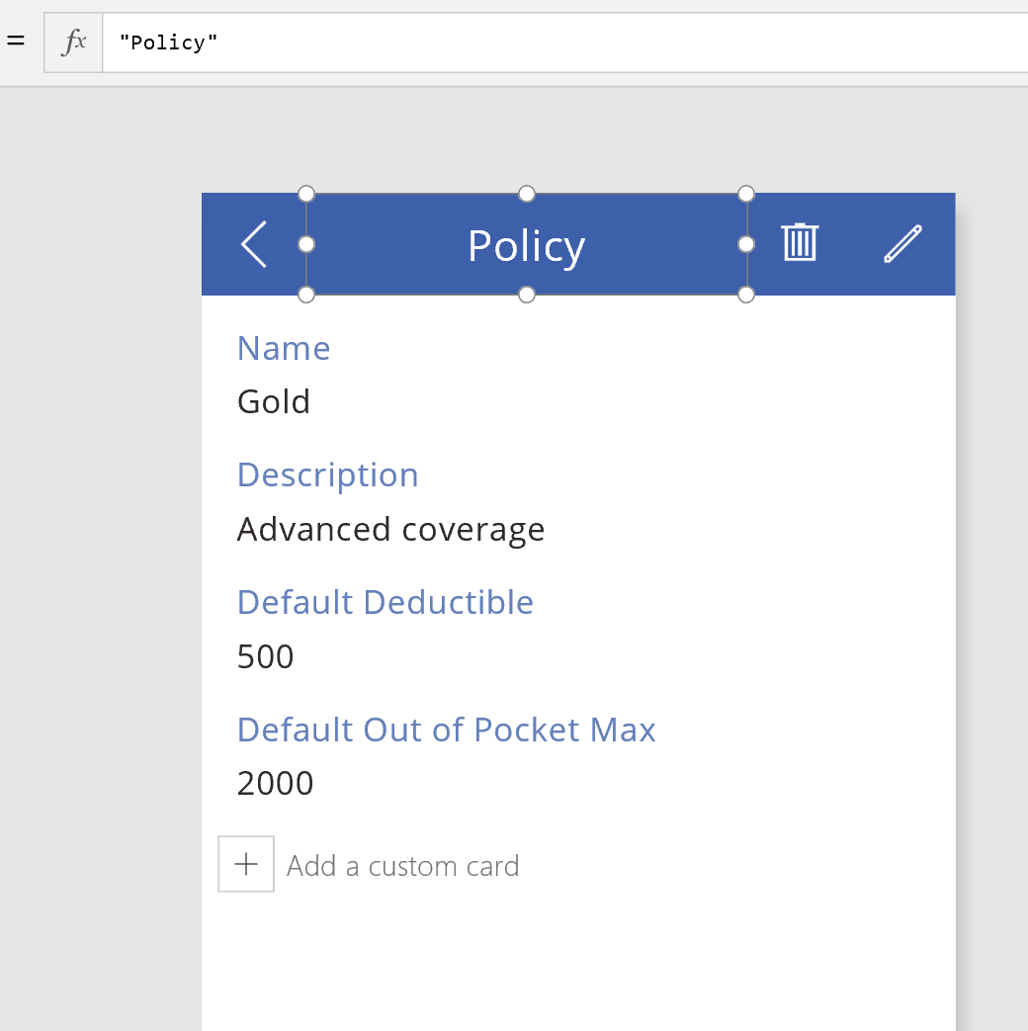
7. Click on the EditScreen on the left-hand menu.
8. Repeat steps 4 – 6 on the edit screen.

### Task 5: Edit the app settings and run the app

1. Click on **File** on the top menu. Click on **Rename this app** and type in a new name, such as PolicyConnect Plus.
2. Click **Save** on the left-hand menu to save the app to the cloud, then click the **Save** button below.
3. After saving, click the **Run** button on the top menu to preview the app. You should be able to view the current policies, edit their values, and create new policies.  
   

## Exercise 9: Cleanup

Duration: 10 mins

Synopsis: In this exercise, attendees will deprovision any Azure resources that were created in support of the lab.

1. Delete the Resource Group in which you placed all of your Azure resources.
   1. From the Portal, navigate to the blade of your Resource Group and click Delete in the command bar at the top.
   2. Confirm the deletion by re-typing the resource group name and clicking Delete.